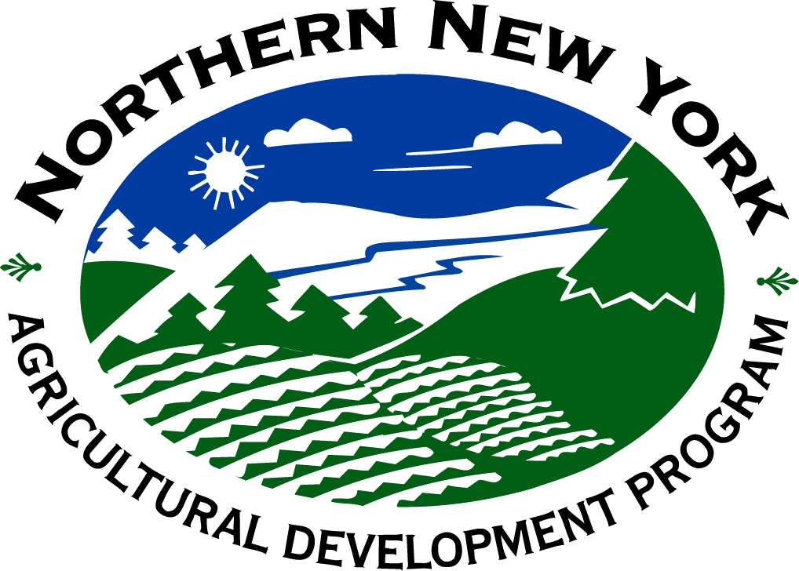

NNY Agricultural Development Program

2007-08 Project Report

Management of Brown Root Rot of Alfalfa and Forage Grasses

Project Leader(s):
- Michael J. Wunsch, graduate research assistant, 607-255-8393 (lab), 607-351-4234 (cell), mjw55@cornell.edu
- Gary C. Bergstrom, professor, Cornell University Department of Plant Pathology and Plant-Microbe Biology, 334 Plant Science, Ithaca, NY 14853, lab: 607-255-8393, office: 607-255-7849, gcb3@cornell.edu

Collaborator(s):
- Peter Barney, private crop consultant, Canton, NY (St. Lawrence County)
- Anita Deming, Cornell Cooperative Extension Essex County
- Michael Hunter, Cornell Cooperative Extension Jefferson County
- Joe Lawrence, Cornell Cooperative Extension Lewis County
- Everett Thomas, W. H. Miner Institute, Chazy, NY
- Carl Tillinghast, Cornell Cooperative Extension Franklin County

Cooperating Producers:
Clinton County: W.H. Miner Institute; Chazy, NY
Essex County: Pat Bennett; Westport, NY
Lee Garvey; Willsboro, NY
Erik Leerkes; Ticonderoga, NY
Franklin County: Rod and Doug Mallette; Chateaugay, NY
Randy Ooms; Constable, NY
Jim and Keith Woodworth; Constable, NY
Jefferson County: Dan Reed, Reedhaven Farm; Adams Center, NY
Lewis County: Glen Beller; Croghan, NY
Kevin Sullivan; Denmark, NY
Shawn Bender; Martinsburg, NY
St. Lawrence County: Cornell Cooperative Extension of St. Lawrence County
Learning Farm and Education Center; Canton, NY

Background:
Phoma sclerotioides, causal agent of brown root rot (BRR), is a soil-borne fungus causing root and crown rot of alfalfa, other perennial legumes, and overwintering grasses. Primarily active during late winter and early spring (Cormack, 1934), it is associated with yield loss, winterkill, slow emergence from winter dormancy, and stand decline of alfalfa (Berkenkamp et al., 1991; Hollingsworth et al., 2003) and with winterkill of overwintering grasses (Larsen et al., 2007).

BRR was first detected in the eastern United States in 2003 in Clinton County, NY on alfalfa. The results of subsequent surveys of alfalfa production fields conducted in Clinton County in 2004 and in New York, Vermont and New Hampshire in 2005 suggest that BRR may be a serious factor impacting the health and persistence of alfalfa in the region. BRR was found on a high percentage of plants in many fields (Wunsch et al., 2007), and most of the lesions caused by the disease progressed into the cortical (internal) tissues of roots and crowns (Wunsch et al., 2006; Wunsch et al., 2007). The BRR incidence observed in New York, Vermont and New Hampshire is similar to that observed in Saskatchewan, Canada (Wunsch, unpublished), where the disease has long been recognized as a serious problem for alfalfa production.

BRR can have severe effects on alfalfa yields. In Saskatchewan fields with heavy BRR disease pressure, BRR-resistant alfalfa produces yields 40 to 65 percent higher than BRR-susceptible alfalfa (second and third production years, three cuts per year); alfalfa moderately resistant to BRR produces yields 23 to 43 percent higher than BRR-susceptible alfalfa (Berkenkamp et al., 1991).

No management tools currently exist for BRR in New York. Peace, the BRR-resistant alfalfa variety grown in Saskatchewan and Alberta, performs poorly in New York; it is highly susceptible to other alfalfa root rots common in New York, and preliminary results suggest that it is also highly susceptible to some New York strains of P. sclerotioides. Crop rotation is not an effective alternative; P. sclerotioides produces resting stuctures that can persist extended periods in the soil without a suitable substrate (Cormack, 1934), and P. sclerotioides can survive on organic matter in the soil (Davidson, 1990).

Significant differences in BRR resistance have been observed among alfalfa varieties grown in Saskatchewan and in Wyoming (Berkenkamp et al., 1991; Hollingsworth et al., 2005). If significant differences in BRR resistance are also observed among alfalfa varieties grown in New York, adoption of the most resistant varieties by growers in fields with high BRR pressure would be expected to increase forage yields. The most resistant varieties would also serve as sources of BRR resistance for alfalfa breeding.

P. sclerotioides is a recognized pathogen of certain overwintering grasses and cereals (Larsen et al., 2007; Smith, 1987), and it is frequently the predominant fungus isolated from diseased roots of perennial grasses in the early spring (Davidson, 1990). However, pathogenicity of P. sclerotioides to forage grasses has never been studied. If there are significant differences in susceptibility to P. sclerotioides among forage grass species, use of the most resistant grasses in mixed alfalfa-grass stands may reduce the inoculum density of P. sclerotioides within such stands, thereby minimizing losses of alfalfa to BRR in the stands.

Methods:
Replicated field experiments were established at the W.H. Miner Institute in Chazy, NY and at the Cornell Baker Research Farm in Willsboro, NY to test the relative susceptibility of 11 alfalfa varieties to BRR.
Nine alfalfa varieties commercially available in New York were tested:
- 54V46 (Pioneer)
- 361 HY (Preferred Seed)
- Guardsman II (Seedway)
- Mariner III (Allied Seed)
- ReGen (Seedway)
- Oneida Ultra (Seedway)
- Seedway 9558 (Seedway)
- Starbuck (Pickseed), and
- WL 347 LH (W-L Research).

Two additional varieties, Peace (Richardson Seeds) and Vernal (University of Wisconsin), were included as resistant and susceptible checks.

The field experiment in Chazy was seeded in May 2006 and inoculated in September 2006; the experiment in Willsboro, NY was seeded in May 2007 and inoculated at seeding. Each plot included five replicates. A third field experiment (not funded by NNYADP) was established in Bath, NY in May 2006 and inoculated in October 2006.

In April and May 2008, 125 plants of each variety were collected from each plot and assessed for BRR in the laboratory. A plant was only considered positive for BRR if P. sclerotioides was successfully isolated from a root or crown lesion. Incidence of BRR was recorded.

Susceptibility of perennial forage grasses to P. sclerotioides was assessed with a combination of surveys of production fields and replicated field experiments. Three production fields seeded to perennial forage grasses were sampled in each Clinton, Essex, Franklin, Jefferson, Lewis, and St. Lawrence Counties; 10 to 36 plants were sampled per field. Bromegrass, tall fescue, orchardgrass, reed canary, and timothy were collected, and all stands were at least two years old. The fields were randomly selected, and none had previously been evaluated for brown root rot of alfalfa.

Replicated field experiments evaluating the susceptibility of bromegrass, tall fescue, orchardgrass, reed canary, perennial rye, and timothy to P. sclerotioides were established at the W.H. Miner Institute in Chazy, NY and at the Cornell Baker Research Farm in Willsboro, NY in August 2007. Uninoculated (plants exposed only to native P. sclerotioides populations) and inoculated (plants exposed to elevated P. sclerotioides populations) treatments were evaluated.

In April 2008, 24 to 36 plants of each grass species were collected from each treatment (inoculated or uninoculated) and assessed for infection by P. sclerotioides in the laboratory. The roots were washed and visually assessed for root rot severity, and isolation of P. sclerotioides was attempted for each root. Incidence of infection by P. sclerotioides and incidence of winterkilled plants were recorded.

Results:
Alfalfa variety trial
Results of the replicated alfalfa variety trials differed by location. In Bath, Guardsman II, 361 HY, WL347 LH, 54V46, Oneida Ultra, Starbuck, and ReGen were significantly more resistant than Peace in 2007, but only Starbuck was significantly more resistant in 2008 (Table 1). In Willsboro, Peace was significantly more resistant than Starbuck, 361 HY, and Guardsman II, the opposite of what was observed in Bath (Table 1). In Chazy, ReGen was more resistant than WL347 LH and Peace in 2007, but no statistically significant difference was observed among these varieties in 2008 (Table 1).

The variable results from the variety trials were likely caused by genetic differences among isolates of P. sclerotioides. Research conducted in the last year indicates that P. sclerotioides is represented by at least four biotypes in New York. In Bath, only biotype 5 is present. In Chazy, biotypes 1, 2, 3, and 5 are present, and biotypes 1 and 5 predominate. In Willsboro, biotypes 1, 3, and 5 are present, and biotype 1 predominates. P. sclerotioides isolates of local origin were used to inoculate the plots; isolates of biotype 5 were used in Bath and Chazy, and an isolate of biotype 1 was used in Willsboro.

The variety trials suggest that resistance to BRR may differ by P. sclerotioides biotype. In previous research conducted in Wyoming with P. sclerotioides biotype 1, Peace was resistant to BRR. Likewise, in Willsboro, where P. sclerotioides biotype 1 predominates and an isolate of biotype 1 was used for inoculation, Peace was the most resistant. In Bath, however, where only P. sclerotioides biotype 5 is present and an isolate of biotype 5 was used for inoculation, Peace was consistently one of the most susceptible varieties. In Chazy, where both biotypes 1 and 5 are common and biotype 5 was used for inoculation, Peace was one of the most susceptible varieties the first year (when the laboratory-grown P. sclerotioides biotype 5 would have been most important) but not the second year (when the native P. sclerotioides, including biotype 1, would have been more important).

Susceptibility of perennial forage grasses to P. sclerotioides
The results indicate that perennial forage grasses can serve as an alternate host for P. sclerotioides. P. sclerotioides was isolated from roots of tall fescue, orchardgrass, reed canary, perennial rye, and timothy in both the Chazy and Willsboro field experiments, and it was isolated from roots of bromegrass in the Willsboro plot (Table 2). In surveys of northern New York forage production fields, P. sclerotioides was isolated from roots of bromegrass in one of two fields sampled, roots of orchardgrass in two of five fields sampled, roots of reed canary in one of six fields sampled, and roots of timothy in one of three fields sampled (Table 3).

P. sclerotioides does not, however, appear to be an economically important pathogen of perennial forage grasses. Incidence of infection by P. sclerotioides was low in the forage grasses sampled in northern New York production fields (Table 3). In the replicated field experiments conducted in Chazy and Willsboro, inoculation with P. sclerotioides (supplementing native P. sclerotioides populations with laboratory-grown P. sclerotioides) caused an increase in the incidence of infection by P. sclerotioides but not an increase in either winterkill losses or root necrosis (Table 2), suggesting that P. sclerotioides colonized the roots without causing much disease.

Conclusions/Outcomes/Impacts:
Brown root rot (BRR) of alfalfa must be managed by host resistance. Crop rotation with perennial grasses is unlikely to be an effective technique for managing the disease. The results of the present study indicate that perennial forage grasses serve as an alternate host for P. sclerotioides and can act as reservoirs for the pathogen even when alfalfa is not grown in mixtures with the grasses.

In mixed seedings of alfalfa and perennial grasses, the severity of BRR of alfalfa is unlikely to be affected by the type of perennial grass planted. All of the perennial forage grasses commonly planted in northern New York appear to be moderately susceptible to P. sclerotioides, suggesting that each may have a similar effect on P. sclerotioides inoculum density and, consequently, the severity of alfalfa BRR.

It is unclear which alfalfa varieties are best suited for fields with high BRR disease pressure. Ranking of varieties for relative resistance to BRR was inconsistent among field trials at Bath, Chazy, and Willsboro, likely a reflection of biological variation in the pathogen at these locations. There are at least four genetically distinct biotypes of P. sclerotioides present in New York, and the relative resistance of alfalfa varieties to BRR appears to differ by P. sclerotioides biotype.

Outreach:
Gary Bergstrom is presenting the results of this project at Crop Congresses in the Northern New York communities of Watertown, Chazy, Madrid, and Carthage on February 2, 2009 and March 3, 4, and 5, 2009. An extension handout summarizing the results from this study was prepared for the meetings. Additional outreach on brown root rot was conducted for northern New York growers at Crop Congresses Carthage and Madrid in March 2008, and for Cornell Cooperative Extension field crop educators at in-service training sessions in March and November 2008.

Extension publications:
Bergstrom, G.C. and M.J. Wunsch. 2008. Assess alfalfa stands for brown root rot this spring. What's Cropping Up? (Cornell Cooperative Extension) Volume 18, No. 2:1. http://css.cals.cornell.edu/cals/css/extension/upload/WCUvol18no2mar-apr2008.pdf

Publications in the popular press:
Ohler, Amy. Brown root rot research underway. News 10 Now. May 13, 2008. Online: http://news10now.com/Default.aspx?ArID=116026
Reiner, Alvin. Getting to the root of rot. Plattsburgh Press Republican. June 21, 2008. Online: http://www.pressrepublican.com/archivesearch/local_story_173231620.html
Anonymous. Researchers Hunt Killer Fungus. Watertown Daily Times. May 15, 2008. Online: http://www.watertowndailytimes.com/section/archive

Peer reviewed journal articles:
Wunsch, M. J., Baker, A. H., Larsen, R. C., and Bergstrom, G. C. 2006. Distribution and prevalence of brown root rot of forage legumes in the northeastern United States. Phytopathology 96:S125.
Wunsch, M. J., Schindelbeck, R. R., van Es, H. M., and Bergstrom, G. C. 2007. Distribution, impact and soil environment of Phoma sclerotioides in northeastern U.S. alfalfa fields. Plant Dis. 91:1293-1304.

Next steps
(1) The results from the variety trial in Willsboro suggest that Peace, as suggested by previous studies, is relatively resistant to P. sclerotioides biotype 1 and that Starbuck is relatively susceptible. A second year of data is needed to confirm this result. The additional data on the relative susceptibility of alfalfa varieties to P. sclerotioides biotype 1 will be valuable for breeding alfalfa resistant to BRR.
(2) Identification of alfalfa variety recommendations for fields with severe BRR disease pressure will require the establishment of a new field experiment. The plot will need to be inoculated with all four biotypes of P. sclerotioides common in New York. In order to provide more relevant data to growers, yield, not BRR incidence, should be recorded. If both inoculated and inoculated treatments are included, the experiment could also help clarify the economic impact of BRR to northern New York producers. The effect of BRR on alfalfa yields in northern New York is currently unclear.

Acknowledgments: In addition to NNYADP, partial funding support for this project was from Hatch project NYC153-433.

Person(s) to contact for more information:
- Michael J. Wunsch, graduate research assistant, 607-255-8393 (lab), 607-351-4234 (cell), mjw55@cornell.edu
- Gary C. Bergstrom, professor, Cornell University Department of Plant Pathology and Plant-Microbe Biology, 334 Plant Science, Ithaca, NY 14853, lab: 607-255-8393, office: 607-255-7849, gcb3@cornell.edu

Photos 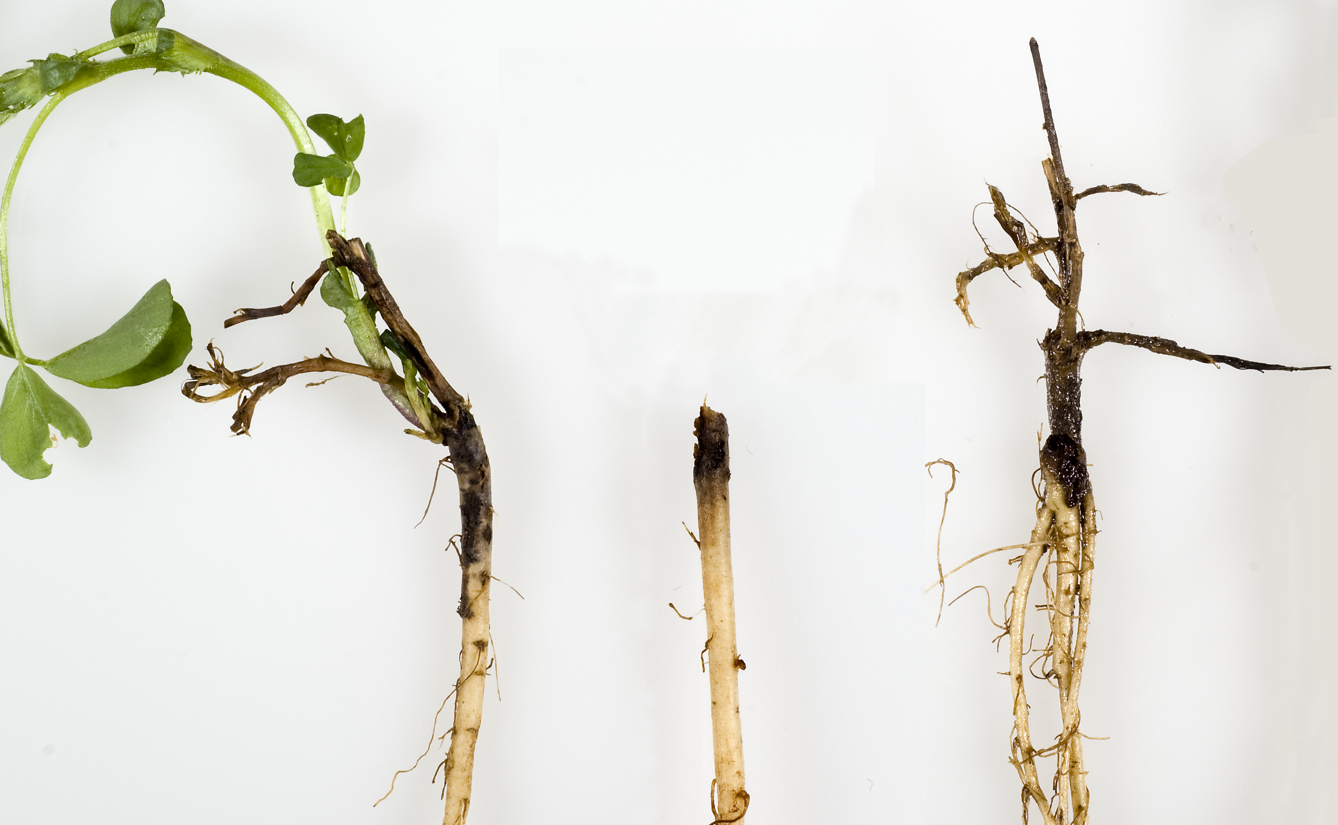
Alfalfa with brown root rot collected from the field experiment in Willsboro. Note that the BRR lesions completely girdled the crowns of the two plants on the right.
Appendix
Table 1. Relative resistance of alfalfa varieties to brown root rot.
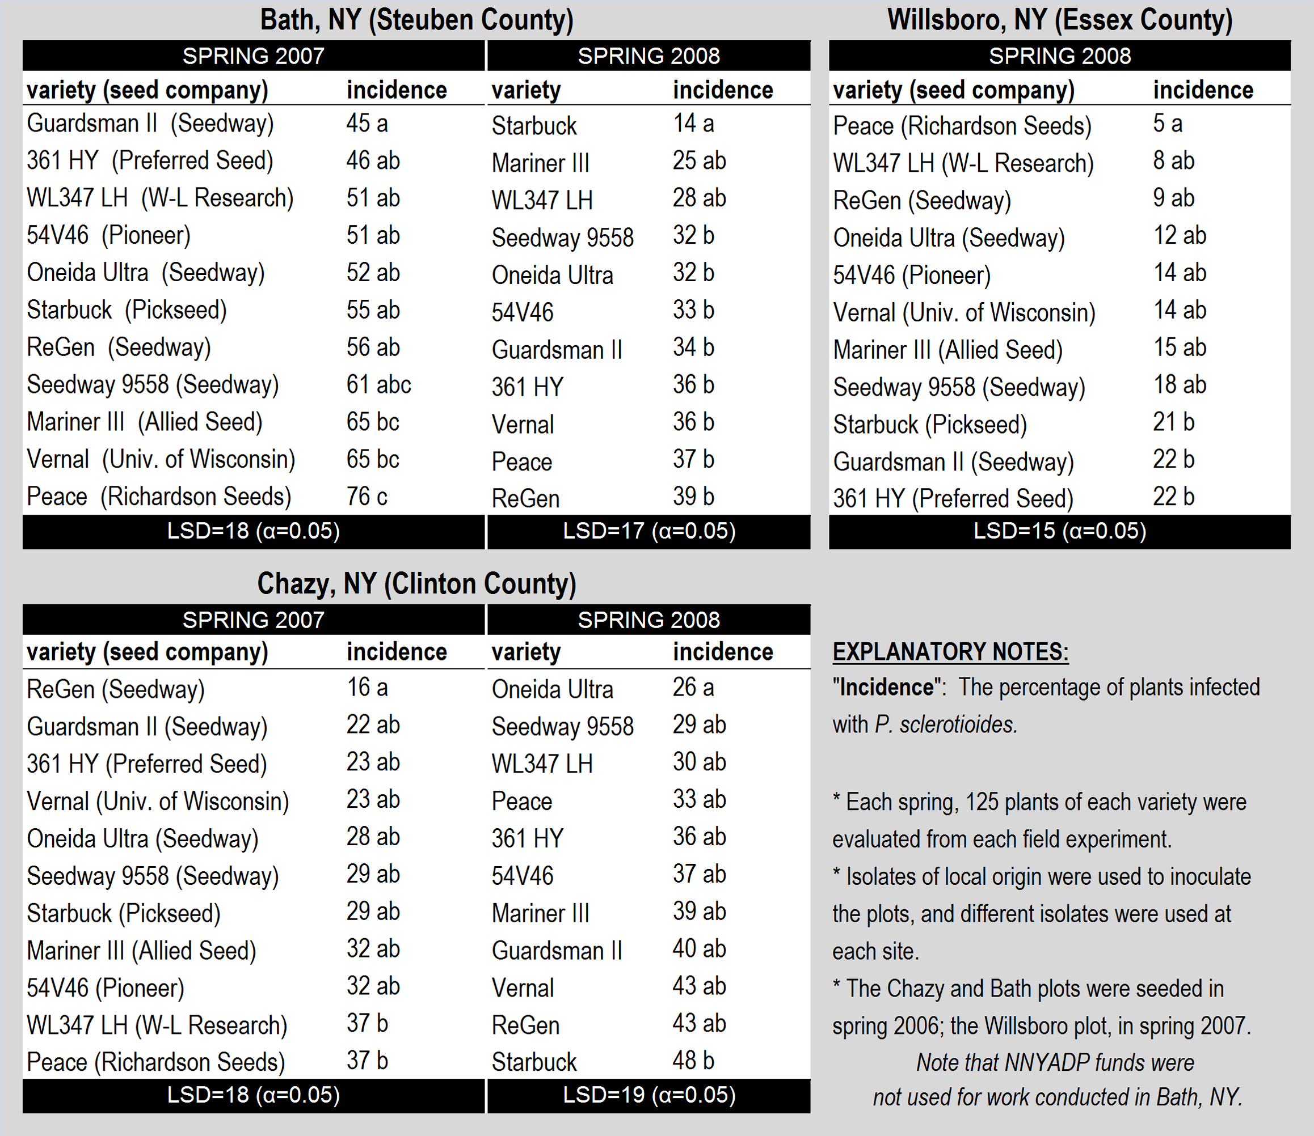
Table 2. Susceptibility of perennial forage grasses to P. sclerotioides and effect of increased P. sclerotioides inoculum density on infection by P. sclerotioides, winterkill, and root necrosis.
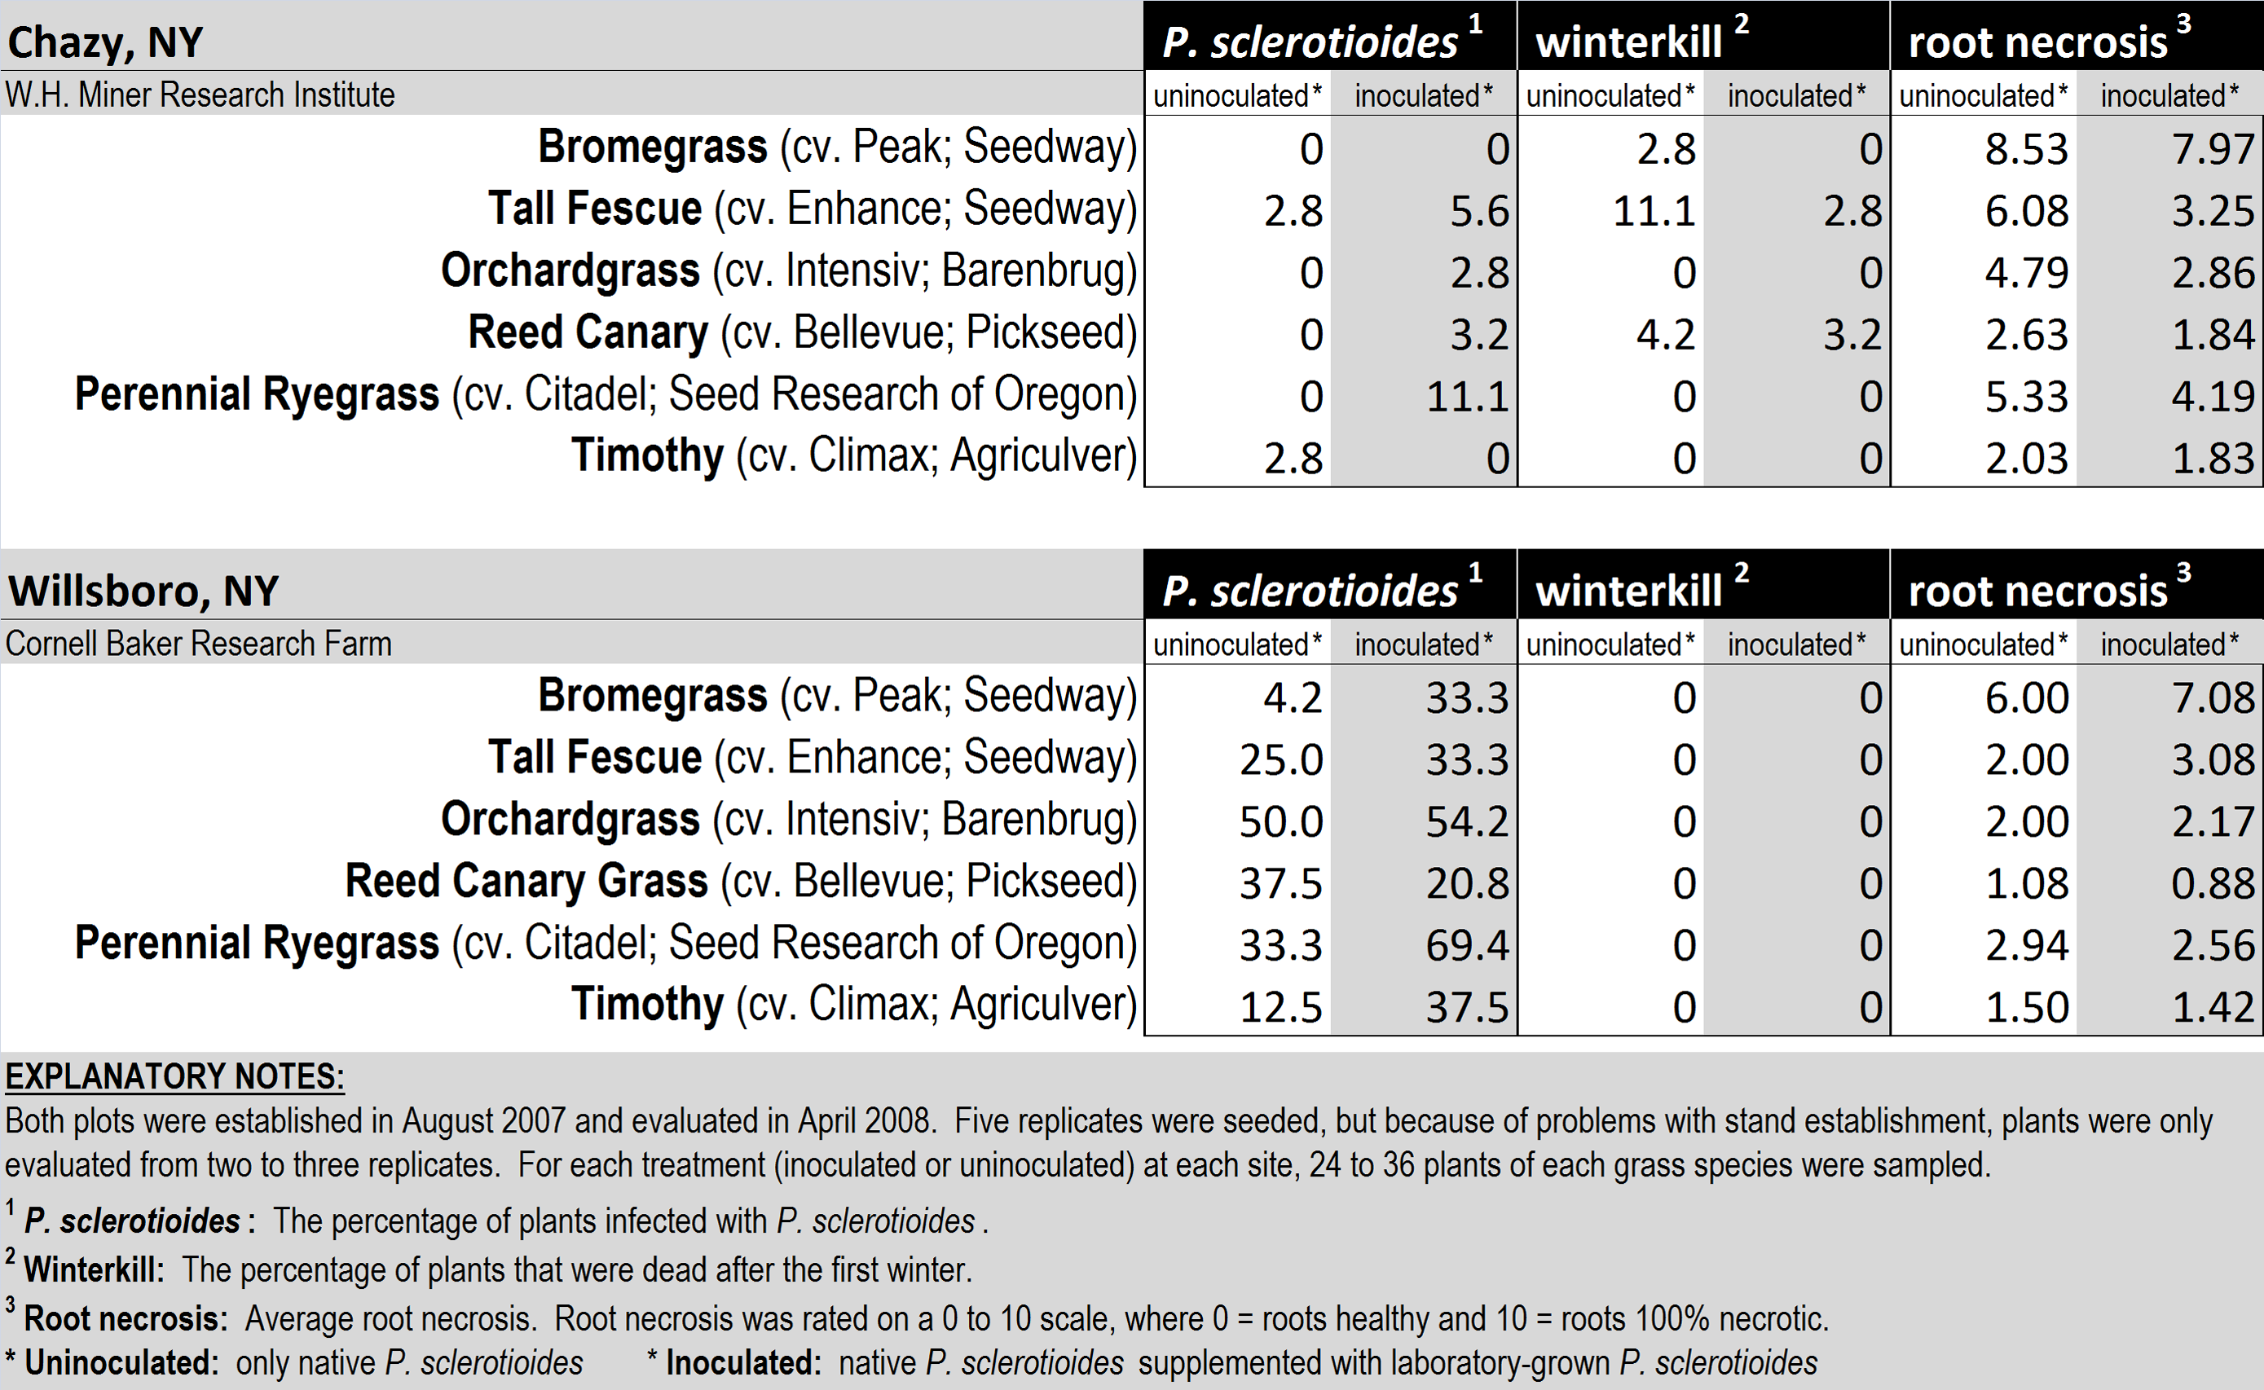

Table 3. Percentage of perennial forage grass plants infected by P. sclerotioides in northern New York production fields.


