

NNY Agricultural Development Program
2007-08 Project Report

Reducing Phosphorus and Nitrogen Loss
with Aerway Incorporation of Manure

Project Leader(s): Quirine M. Ketterings, Nutrient Management Spear Program (NMSP), Cornell University

Collaborator(s):
- Cornell University: Anne Place (NMSP graduate student;) Greg Godwin, Kevin Dietzel, and Chie Miyomoto (NMSP staff;) Karl Czymmek (PRODAIRY.)
- Cornell Cooperative Extension: Joe Lawrence (CCE of Lewis County)
- Consultants: Peter Barney (Barney Agronomic Services;) Peg Cook, (Cooks Consulting)

Cooperating Producers:
- Jake Ashline, Miner Institute (Clinton County) Darren McIntyre (Lewis County)
Dave Fisher (St Lawrence County) Dan Chambers (St Lawrence County)

Background: Phosphorus (P) and nitrogen (N) runoff, leaching and/or volatilization are of great concern to our farming community and their neighbors. In addition, soil erosion loss can greatly impact soil productivity and more producers are exploring reduced tillage option. A better quantification of such P and N losses and best management practices that can reduce losses without negatively impacting crop production is needed.

In discussions with NNY stakeholders, questions were raised about manure management options that are compatible with reduced-till corn systems and reduce runoff, leaching (tile drain) and volatilization risks.

The manure application method of most interest is surface application followed by partial incorporation with an Aerway. A 3-yr trial in central NY (Lawrence et al., 2008) showed Aerway incorporation following spring manure application for corn resulted in N conservation and subsequent yields similar to those obtained with chisel plowing. Additional research was needed to see if the results at the central NY farm could be duplicated on farms throughout the state.

Methods: Four farm fields were selected, two in St Lawrence County, one in Lewis County and one at the Miner Institute. We compared surface application (no incorporation until 5+ days after application) with (1) Aerway incorporation or (2) chisel incorporation directly following manure application. Each trial was conducted in 4 replications resulting in 12 strips per field. Strips ranged in length (spreader pattern and planter/harvester determined) and, depending on the field, 300+ feet long. Each strip was monitored for N dynamics (sampling prior to manure application, at planting, at PSNT time, and after harvest), soil fertility, residue coverage, compaction (penetrometer readings), soil moisture content. With joint NYFVI and NNYADP funding, we were able to establish 10 on-farm locations, of which four were in NNY.

Results: Results for the four NNY locations are shown in the tables at the end of this report. At all sites, there was no significant difference in yield or quality between chisel and Aerway incorporation. At two sites, the surface application did result in a yield reduction although for one of the two sites, late harvest had resulted in lodged corn and yield loss. Given high PSNT and soil nitrate levels for this site, a yield response might not have occurred under more regular harvest conditions (to be evaluated in 2009). At a third site, that suffered from a late summer storm following water logged conditions early in the season, trends were the same but the differences between the surface application and the two incorporation treatments was not statistically significant. At the fourth location, nitrate levels were so high that nitrogen was not a production limitation as confirmed by the soil N levels, PSNT results and stalk nitrate results.

Conclusions/Outcomes/Impacts: An additional year of data is needed before we can draw final conclusions but these preliminary results suggest that Aerway incorporation is as effective as chisel plowing in conserving N and incorporation will result in higher yields under N limiting conditions. In situations where N is not limiting, incorporation will not benefit the crop. Stalk nitrate sampling seems an effective tool to evaluate the N status of the crop during the growing year.

Outreach: Preliminary results of the trial at Aurora were presented at winter meetings in NNY in 2008 (co-presented w/CCE field crops extension educators): “Tillage options for conserving manure N,” presented by Joe Lawrence at “Making the most of your fertilizer dollars” (2008). Series of 5 meetings in NNY, March 17-21, 2008. ~90 people.

Next steps if results suggest continued work is needed in the areas of research, demonstration and/or education. This was the first year of the project. All plots are marked to enable data collection for a second year so we have 2 years of data for all sites and so we can monitor changes in soil fertility levels over the 2 years. Farmer interviews will be done this winter, once final results are reported to all farms.

Acknowledgments: The project was funded through NNYADP and the NYFVI.

Reports and/or articles in which project results have been published. A Northeast DairyBusiness article by Anne Place, graduate student on the project, will appear in January 2009 with quotes from Dan Chambers, one of the participating farmers.

Person to contact for more information: Quirine Ketterings, Nutrient Management Spear Program, 323 Morrison Hall, Dept. of Animal Science, Cornell University, qmk2@cornell.edu or 607-255- 3061.
Table 1: Stand density, corn silage yield and moisture content at harvest as impacted by manure application method.
Treatment | Stand density at sidedress time | Corn silage yield (35% DM) | Moisture content at harvest
 | plant/acre | tons/acre | %
 | Farm A
Surface | 30,786 a | 17.4 b | 64.0 a
Chisel incorporation | 31,308 a | 19.4 a | 62.4 a
Aerway incorporation | 32,088 a | 19.4 a | 61.7 a
 | Farm B
Surface | 30,856 a | 20.7 a | 59.4 a
Chisel incorporation | 29,737 a | 20.1 a | 58.5 a
Aerway incorporation | 29,916 a | 21.1 a | 55.7 a
 | Farm C
Surface | 30,504 a | 11.8 a | 65.0 a
Chisel incorporation | 30,735 a | 12.9 a | 64.3 a
Aerway incorporation | 32,197 a | 13.5 a | 63.9 a
 | Farm D (grain in bu/acre; damage due to late harvest)
Surface | 34,107 a | 129.9 b | 24.3 a
Chisel incorporation | 34,843 a | 164.9 a | 25.0 a
Aerway incorporation | 33,606 a | 175.1 a | 24.7 a

Table 2: Forage quality at harvest as impacted by manure application method.
Treatment | Crude Protein | Soluble Protein | NDF | dNDF | Lignin | Starch
 | ---------------------------------% of DM -------------------------
 | Farm A
Surface | 5.9 a | 1.6 a | 46.3 a | 68.0 a | 3.3 a | 30.7 a
Chisel Incorporation | 6.4 a | 1.7 a | 45.4 a | 66.6 a | 3.4 a | 30.5 a
Aerway incorporation | 6.4 a | 1.6 a | 45.1 a | 67.0 a | 3.4 a | 31.1 a
 | Farm B
Surface | 7.1 a | 2.0 a | 44.5 a | 62.4 a | 3.2 a | 31.8 a
Chisel Incorporation | 7.3 a | 2.0 a | 41.3 a | 62.4 a | 3.1 a | 35.1 a
Aerway incorporation | 7.3 a | 1.9 a | 42.7 a | 62.2 a | 3.2 a | 33.6 a
 | Farm C
Surface | 6.0 a | 1.7 a | 40.4 a | 68.9 a | 2.7 a | 36.7 a
Chisel Incorporation | 6.1 a | 1.7 a | 40.5 a | 68.6 a | 2.7 a | 36.8 a
Aerway incorporation | 5.9 a | 1.6 a | 38.9 a | 67.5 a | 2.6 a | 39.1 a
 | Farm D
Surface | . | . | . | . | . | .
Chisel Incorporation | . | . | . | . | . | .
Aerway incorporation | . | . | . | . | . | .
†Average values with different letters (a,b,c) are statistically different (α = 0.05)

Table 3: Estimated milk production as impacted by manure application method.
Treatment | Milk per acre | Milk per ton
 | lbs per acre | lbs per ton of silage
 | Farm A
Surface | 20937 b | 3441 a
Chisel Incorporation | 23247 a | 3426 a
Aerway incorporation | 23402 a | 3439 a
 | Farm B
Surface | 23928 a | 3309 a
Chisel Incorporation | 23917 a | 3396 a
Aerway incorporation | 24806 a | 3346 a
 | Farm C
Surface | 14914 a | 3624 a
Chisel Incorporation | 16284 a | 3615 a
Aerway incorporation | 17250 a | 3643 a
 | Farm D
Surface | . | .
Chisel Incorporation | . | .
Aerway incorporation | . | .
†Average values with different letters (a,b,c) are statistically different (α = 0.05)

Table 4: Soil nitrate level (0-8 inch depth) at four sampling times as impacted by manure application method.
Treatment | Baseline | Planting | Sidedress | Harvest
 | -------------------------------- lbs/acre --------------------------------
 | Farm A
Surface | 17.5 a | 61.0 a | 53.0 a | 8.0 b
Chisel incorporation | 14.8 a | 72.8 a | 60.8 a | 18.5 a
Aerway incorporation | 16.8 a | 73.0 a | 69.0 a | 15.8 a
 | Farm B
Surface | 33.8 a | 68.8 b | 92.0 a | 37.3 a
Chisel incorporation | 36.5 a | 97.3 a | 107.8 a | 53.0 a
Aerway incorporation | 33.3 a | 85.8 ab | 91.3 a | 45.5 a
 | Farm C
Surface | 29.5 a | 42.5 a | 35.8 a | 20.3 a
Chisel incorporation | 29.8 a | 21.0 a | 32.0 a | 17.8 a
Aerway incorporation | 28.5 a | 39.0 a | 28.0 a | 22.0 a
 | Farm D
Surface | 31.8 a | 86.0 a | 114.8 b | .
Chisel incorporation | 32.3 a | 103.0 a | 145.3 a | .
Aerway incorporation | 32.0 a | 85.5 a | 124.5 ab | .
†Average values with different letters (a,b,c) are statistically different (α = 0.05)

Table 5: Illinois Soil Nitrogen Test (ISNT) (0-8 inch depth), Pre-Sidedress Nitrogen Test (PSNT) (0-12 inch depth), and Late Season Stalk Nitrate as impacted by manure application method.
 | Sidedress |  | Harvest
Treatment | ISNT | PSNT | Stalk N
 | ------------------------------------ ppm -------------------------------
 | Farm A
Surface | 346 a | 22.6 b | 191 a | L
Chisel incorporation | 354 a | 28.0 ab | 1,095 a | O
Aerway incorporation | 383 a | 32.8 a | 840 a | O
 | Farm B
Surface | 357a | 49.5 a | 8,171 a | E
Chisel incorporation | 378a | 48.0 a | 9,845 a | E
Aerway incorporation | 373a | 42.5 a | 8,134 a | E
 | Farm C
Surface | 355 a | 12.5 a | 30 a | L
Chisel incorporation | 351 a | 12.8 a | 9 a | L
Aerway incorporation | 363 a | 13.0 a | 21 a | L
 | Farm D
Surface | 466 a | 57.9 a | 2,535 a | E
Chisel incorporation | 472 a | 57.8 a | 2,751 a | E
Aerway incorporation | 471 a | 57.9 a | 1,795 a | O
†Average values with different letters (a,b,c) are statistically different (α = 0.05)

Table 6: Soil compaction readings taken at three sampling times as impacted by manure application method with rating from (0-5).
Depth | Treatment | Baseline | Side-dress time | Harvest
 |  | ----------------------------rating-------------------------
 |  | Farm A
3” | Surface | 0 a | 0 a | 0.0 a
3” | Chisel incorporation | 0 a | 0 a | 0.3 a
3” | Aerway incorporation | 0 a | 0 a | 0.0 a
6” | Surface | 0 a | 0 a | 1.5 a
6” | Chisel incorporation | 0 a | 0 a | 1.3 a
6” | Aerway incorporation | 0 a | 0 a | 1.0 a
9” | Surface | 0 a | 0 a | 2.8 a
9” | Chisel incorporation | 0 a | 0 a | 2.8 a
9” | Aerway incorporation | 0 a | 0 a | 2.8 a
12” | Surface | 0 a | 0 a | 3.0 a
12” | Chisel incorporation | 0 a | 0 a | 4.3 a
12” | Aerway incorporation | 0 a | 0 a | 3.8 a
 |  | Farm B
3” | Surface | 0 a | 0 a | 0 a
3” | Chisel incorporation | 0 a | 0 a | 0 a
3” | Aerway incorporation | 0 a | 0 a | 0 a
6” | Surface | 0 a | 0 a | 0 b
6” | Chisel incorporation | 0 a | 0 a | 0 b
6” | Aerway incorporation | 0 a | 0 a | 0.8 a
9” | Surface | 0 a | 0 a | 2.3 a
9” | Chisel incorporation | 0 a | 0 a | 2.3 a
9” | Aerway incorporation | 0 a | 0 a | 2.8 a
12” | Surface | 0 a | 1.3 a | 4.3 a
12” | Chisel incorporation | 0 a | 0 a | 3.8 a
12” | Aerway incorporation | 0 a | 0.3 a | 4.5 a
 |  | Farm C
3” | Surface | 0 a | 0 a | 0 a
3” | Chisel incorporation | 0 a | 0 a | 0 a
3” | Aerway incorporation | 0 a | 0 a | 0 a
6” | Surface | 0 a | 0 a | 0.3 a
6” | Chisel incorporation | 0 a | 0 a | 0 a
6” | Aerway incorporation | 0 a | 0 a | 0.3 a
9” | Surface | 0 a | 0 a | 2.3 a
9” | Chisel incorporation | 0 a | 0 a | 1.0 a
9” | Aerway incorporation | 0 a | 0 a | 2.3 a
12” | Surface | 0 a | 0.8 a | 3.3 a
12” | Chisel incorporation | 0 a | 1.3 a | 2.5 a
12” | Aerway incorporation | 0 a | 2.0 a | 3.3 a
 |  | Farm D
3” | Surface | 0 a | 0 a | .
3” | Chisel incorporation | 0 a | 0 a | .
3” | Aerway incorporation | 0 a | 0 a | .
6” | Surface | 0 a | 0 a | .
6” | Chisel incorporation | 0 a | 0 a | .
6” | Aerway incorporation | 0 a | 0 a | .
9” | Surface | 0 a | 0 a | .
9” | Chisel incorporation | 0 a | 0 a | .
9” | Aerway incorporation | 0 a | 0 a | .
12” | Surface | 0 a | 0.3 a | .
12” | Chisel incorporation | 0 a | 0 a | .
12” | Aerway incorporation | 0 a | 0.3 a | .
†Average values with different letters (a,b,c) are statistically different (α = 0.05)

Table 7: Soil moisture (%) at three sampling times as impacted by manure application.
Treatment | At planting | Side-dress time | Harvest
 | ----------------------------------- % ----------------------------------
 | Farm A
Surface | 20.3 a | 21.4 a | 19.8 a
Chisel incorporation | 20.9 a | 21.5 a | 19.9 a
Aerway incorporation | 21.5 a | 21.8 a | 20.0 a
 | Farm B
Surface | 23.2 a | 23.3 a | 22.7 a
Chisel incorporation | 22.4 a | 23.0 a | 22.1 a
Aerway incorporation | 22.2 a | 23.2 a | 22.4 a
 | Farm C
Surface | 22.2 a | 24.1 a | 22.4 a
Chisel incorporation | 21.0 a | 24.7 a | 22.9 a
Aerway incorporation | 21.7 a | 23.7 a | 22.6 a
 | Farm D
Surface | 26.3 a | 24.2 a | .
Chisel incorporation | 26.3 a | 23.9 a | .
Aerway incorporation | 26.2 a | 24.1 a | .
†Average values with different letters (a,b,c) are statistically different (α = 0.05)

Table 8: Percent surface residue coverage before and after manure application method.
Treatment | Baseline | After Manure Treatment
 | -------------------------------------%---------------------------------
 | Farm A
Surface | 18.0 a | 7.5 a
Chisel incorporation | 16.1 a | 5.3 a
Aerway incorporation | 15.7 a | 6.8 a
 | Farm B
Surface | 22.3 a | 14.1 a
Chisel incorporation | 19.2 a | 6.2 b
Aerway incorporation | 23.0 a | 8.3 b
 | Farm C
Surface | 49.1 a | 52.9 a
Chisel incorporation | 46.2 a | 7.6 c
Aerway incorporation | 50.8 a | 19.8 b
 | Farm D
Surface | 70.0 a | 34.4 a
Chisel incorporation | 67.8 a | 27.6 a
Aerway incorporation | 68.3 a | 32.6 a
†Average values with different letters (a,b,c) are statistically different (α = 0.05)
Photos:

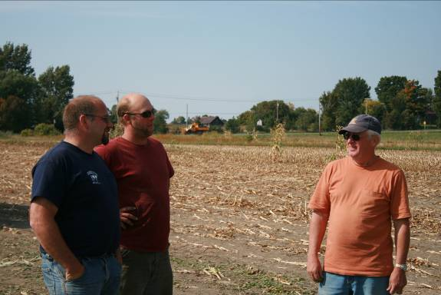
Dan Chambers (left) and Peter Barney (right) during harvest of the field trials at Chamber’s farm in St Lawrence County.

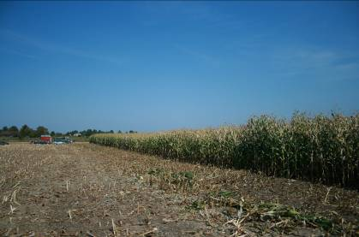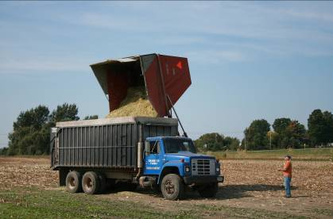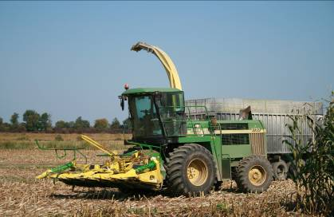
Harvest at Chamber’s Farm
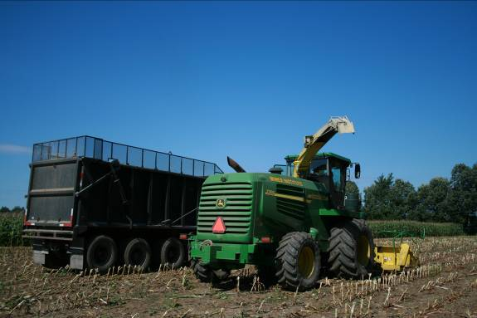
Getting ready for harvest at the Miner Institute.

