

NNY Agricultural Development Program
2007-08 Project Report

Treatment success and factors associated with treatment success of Klebsiella and E.coli mastitis in dairy cows in NNY
Project Leaders: Ynte Schukken, Ruth Zadoks and Gary Bennett; Quality Milk Production Services; Cornell University
Project Staff: Heidi Sharkey, Natalia Belomestnykh, and Brad Rauch
Collaborators: Eastern NNY – Franklin County: V. Bilow (producer), Western NNY - St. Lawrence County: D. Fisher (producer), A. Thompson (veterinarian); Jefferson County: Murcrest farms, M. Thomas (veterinarian), Lewis County: Demko farms, P. Ostrum (veterinarian), Washington County: Woody Hill farms, B Ceglowski (veterinarian).
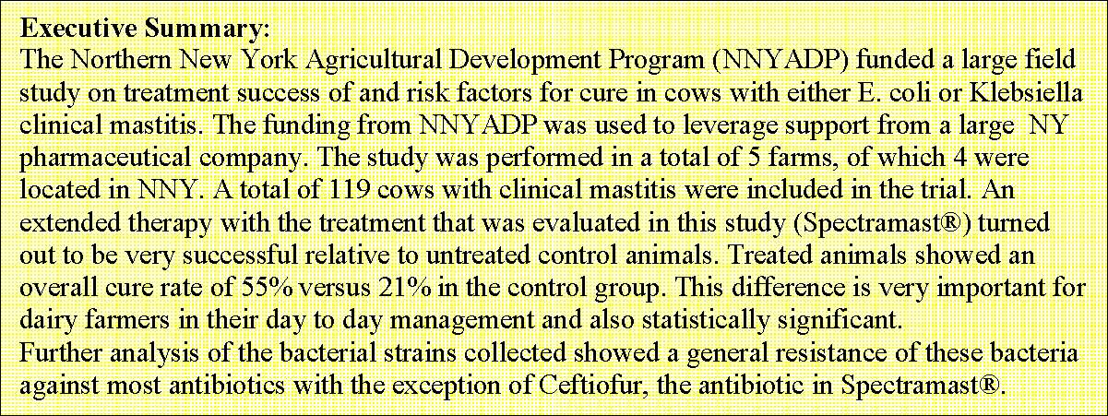
Introduction:
Mastitis is the most costly disease to animal agriculture in the U.S. and throughout much of the world. Mastitis is an inflammation of the mammary gland. It can be caused by many types of injuries, including infectious agents and their toxins, physical trauma, and chemical irritants.
In dairy cows, mastitis is nearly always caused by bacteria or other microorganisms that enter the mammary gland. Gram-negative bacteria, mostly coliforms, cause 40% of all clinical mastitis (CM) cases (González et al., 1990; Hogan et al., 1989) and up to 15-25% of cows in well-managed herds are annually diagnosed with CM caused by coliforms (Hogan and Smith, 2003).

The most common coliform species that cause CM are Escherichia coli and Klebsiella spp. (Erskine et al., 2002a, 2002b; Smith et al., 1985; Todhunter et al., 1991). In Northern New York, we have previously focused on Klebsiella mastitis and found it to be an important cause of both clinical and subclinical mastitis.

Treatment of E. coli clinical mastitis with Spectramast® has previously been shown to be effective. Currently, this is the only product that is registered to be used in gram-negative E.coli mastitis. However, no efficacy data against Klebsiella mastitis are available. QMPS data from antimicrobial sensitivity testing of Klebsiella isolates from cows with CM show that the vast majority of isolates (ca. 90%) are susceptible to ceftiofur, the active ingredient of Spectramast®. We have now secured funding for performing a treatment efficacy trial of Spectramast® in NNY. This trial provides us with the opportunity to collect information and additional samples to answer some further outstanding questions.

The further questions that we attempted to answer in this study were:
- What host level risk factors are present that predict the cure of Klebsiella and E.coli mastitis in cows?
- Is there evidence for strain differences in Klebsiella isolates from cows with mastitis versus isolated that are collected from the environment of the cow?

The research team has extensive experience with E. coli and Klebsiella infections in Northern New York dairy herds. In the past, the team has studied the effect of J5 vaccination on coliform infections (Wilson et al., 2007), and the impact of coliform mastitis on milk production and survival (Gröhn et al., 2004, 2005).

The team is currently completing farm studies on Klebsiella in NNY and found it to be abundant in the cow environment (Munoz et al. 2006, 2007, 2008). Results from these studies have dramatically altered our understanding of the ecology of Klebsiella in an around cows. More specific recommendations can be provided to dairy producers, resulting in a true impact on Klebsiella incidence on their farms. The farms that participate in the current studies continue to have an interest in this important disease and are eager to participate in the next phase of developing workable solutions for this important problem in NNY dairy herds.

Research activities:
Treatment trial with Spectramast® (externally funded, no funding from NNYADP)
This trial was a multi-location study conducted on multiple dairy farms. At each farm-location, lactating cows with gram-negative (Klebsiella and E.coli) clinical mastitis were be randomly allocated to the following treatment groups:
- Control group – Cows were not treated with an antibiotic. Normally, cows with Gram-negative mastitis would not receive any treatment other than frequent milk out on many farms.
- Treatment group – Cows were be treated with Spectramast® via intramammary infusion at 24-hour intervals according to label standards with 5 treatments during 5 subsequent days. Intramammary treatments will be administered by trained farm personnel.

Cows were sampled before the first treatment, i.e. upon observation of clinical symptoms and assessment of clinical severity. Quarter milk samples from all affected quarters were taken using standard procedures. In case of on-farm culture laboratories, the result of the farm laboratory was be used for cow inclusion in the trial. For participating producers that have milk samples tested through the 24-hr turn-around program at QMPS or another laboratory, the laboratory results were be used for inclusion decisions. After completion of the treatment, two follow-up samples were collected by QMPS personnel at approximately 7 + 2 days and 14 + 2 days after the last treatment. All follow-up samples were submitted to a QMPS laboratory. Standard bacteriology according to NMC recommendations were performed (NMC Handbook for bacteriological procedures). Farms and cows per treatment group that were included in the trial are shown in the table below:

Table 1. Characteristics of cows with clinical mastitis included in the study.
Farm | Number of Cows | Avg Days in  Milk | Avg Lactation  number | # Production  before mastitis
A  B  C  D  E  Total | 35  26  22  14  22  119 | 140  155  106  160  116  134 | 2.9  2.2  2.6  2.7  2.6  2.6 | 102  92  80  93  102  95

The distribution of bacteria causing clinical mastitis, and the cure rate in treatment and control group is shown in the table below:
Table 2. Number of organisms and cure in treatment and control cows per farm.
Farm | # Cows  E. Coli | % cure  Trt Control | Number Cows  Klebsiella | % cure  Trt Control | # Cows  Other | % cure  Trt Control
A  B  C  D  E  Total | 2  18  5  7  18  48 | 50% N/A  82% 14%  100% 0%  60% 0%  100% 67%  84% 41% | 17  10  15  7  1  50 | 55% 17% 67% 25% 50% 0%  40% 0%  N/A 0%  56% 14% | 15  0  1  0  1  17 | 80% 75% N/A N/A N/A N/A N/A N/A  0% N/A  68% 75%

Project activities: We have collected data on cow ID, date of diagnosis, dates of treatment, treatment product and duration of treatment, parity, DIM at diagnosis, days since last J5 vaccination, milk yield at last test day before diagnosis, most recent Linear S core (LS) and previous LS (to differentiate new vs. chronic infections), follow up data on linear score, milk production and herd survival. These data were routinely collected into computerized record systems (DC305®) on the farms that were included in the trial. Data were transferred to a spreadsheet and merged into a statistical analysis program (SAS®). Logistic regression was used to analyze the data and identify important risk factors for cure of infection. The table below shows the best fitting regression model predicting cure of infection:
Table 3. Result of logistic regression analysis of the probability of cure of mastitis.
Predictor | Coefficient | Standard error | Z -value | P-value
Constant  Lactation  E. coli present Klebsiella present Treatment  E.coli & treatment Kleb & treatment | 0.22  0.81  - 1.87  - 3.31  -1.28  4.59  4.23 | 1.54  0.33  1.31  1.52  1.68  2.01  2.09 | 0.14  2.50  -1.42  -2.18  -0.76  2.28  2.03 | 0.88  0.01  0.15  0.02  0.45  0.022  0.043

The results of the regression analysis indicate that older cows tend to cure better compared to heifers. Also, cows infected with E. coli and Klebsiella cure better when treated with Spectramast® compared to cows that are left untreated.

Additional milk samples were collected to precisely follow infection status in animals. Besides the samples taken for the treatment trial (before treatment and 7 and 14 days after last treatment), we collected samples every day during treatment, and 21 days after the last treatment.

Antimicrobial resistance.
We evaluated antimicrobial resistance in a proportion of the bacterial isolates obtained from the trial. These were only isolates obtained from the clinical cases before any treatment had taken place (day 1). Antimicrobial sensitivity data reported as the percent of strains resistant to the indicated antibiotic is shown below. We report here on the more important veterinary antibiotics:

Table 4. Antimicrobial resistance against common antibiotics in E. coli and Klebsiella bacteria.
Antibiotic | E. coli % resistant | Klebsiella % resistant
Ampicillin  Penicillin  Oxacillin  Pirlimycin  Tetracyclin  Ceftiofur | 47%  100%  100%  100%  29%  18% | 100%  100%  95%  100%  62%  9%

Presence of virulence factors: We evaluated the presence or absence of specific virulence factors in Klebsiella bacteria obtained from the dairy farms. We collected bacteria from the cases of clinical mastitis and identified a control group of similar size, consisting of bacteria that were found in the environment. The most important virulence factors that we evaluated were the so-called siderophores. These virulence factors allow bacteria to take up iron from the environment, even when the environment is relatively low in available iron. This is important since bacterial growth is dependent on iron availability. The siderophores that we evaluated were Enterobactin receptor (fepA), Aerobactin receptor (iutA), Yersiniabactin receptor (psn) and Yersiniabactin siderophore (irp2). These siderophores were evaluated using molecular methods that are shown in the figure below.
Figure 1. PCR testing of four siderophores: Enterobactin receptor (fepA), Aerobactin receptor (iutA), Yersiniabactin receptor (psn) and Yersiniabactin siderophore (irp2).
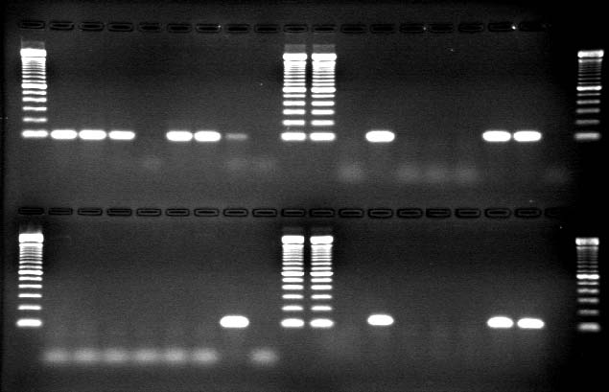
The results indicated that clinical mastitis Klebsiella isolated had a significantly different siderophore profile compared to environment isolates. All clinical isolates had at least one of the tested siderophores, whereas 16% of environmental isolates had no siderophores at all. Approximately 6% of isolates had at least three different siderophores, whereas none of the environmental isolates had more than 1 siderophore.

Discussion and conclusion
The results of this field research indicated a high cure rate of a 5 day ‘extended’ Spectramast® therapy compared to untreated controls. This result is very significant for the dairy farmers in NNY as gram-negative mastitis is a very important disease on the farms and current practice on most farms is to not treat affected cows with antibiotics.

It is important for the dairy farmers to work with their practicing veterinarians to implement this treatment protocol on their farms. Further analysis of the isolates obtained from the dairy farms in NNY indicated that isolates were multi-resistant against most currently used antibiotics, but generally sensitive to Ceftiofur, the antibiotic in our treatment product (Spectramast®).

The Klebsiella isolates that caused clinical mastitis showed a significantly different profile of siderophores. These siderophores are important virulence factors for Klebsiella, and these results would indicate that there is a specific selection of more virulent bacteria to cause mastitis.

Future research is aimed at identifying more detail on these virulence factors and evaluating the potential of preventative programs based on the identified virulence factor profile.

REFERENCE LIST
Barkema, H. W., Y. H. Schukken, T. J. G. M. Lam, M. L. Beiboer, H. Wilmink, G. Benedictus, and A. Brand. 1998. Incidence of clinical mastitis in dairy herds grouped in three categories by bulk milk somatic cell counts. Journal of Dairy Science 81(2):411-419.

Diancourt, L., V. Passet, J. Verhoef, P. A. Grimont, S. Brisse. 2005. Multilocus sequence typing of Klebsiella pneumoniae nosocomial isolates. J Clin Microbiol. 43(8):4178-82.
Erskine, R. J., P. C. Bartlett, J. L. VanLente, and C. R. Phipps. 2002a. Efficacy of systemic ceftiofur as a therapy for severe clinical mastitis in dairy cattle. J. Dairy Sci. 85(10):2571-2575.
Erskine, R. J., R. J. Eberhart, L. J. Hutchinson, S. B. Spencer, and M. A. Campbell. 1988. Incidence and types of clinical mastitis in dairy herds with high and low somatic cell counts. J. Am. Vet. Med. Assoc. 192(6):761-765.
Erskine, R. J., R. D. Walker, C. A. Bolin, P. C. Bartlett, and D. G. White. 2002b. Trends in antibacterial susceptibility of mastitis pathogens during a seven-year period. J. Dairy Sci. 85(5):1111-1118.
González, R. N., D. E. Jasper, N. C. Kronlund, T. B. Farver, J. S. Cullor, R. B. Bushnell, and J.
D. Dellinger. 1990. Clinical mastitis in two California dairy herds participating in contagious mastitis control programs. J. Dairy Sci. 73(3):648-660.
Gröhn, Y. T., R. N. González, D. J. Wilson, J. A. Hertl, G. Bennett, H. Schulte, and Y. H. Schukken. 2005. Effect of pathogen-specific clinical mastitis on herd life in two New York State dairy herds. Prev.Vet.Med. 71:105-125.
Gröhn, Y. T., D. J. Wilson, R. N. González, J. A. Hertl, H. Schulte, G. Bennett, and Y. H. Schukken. 2004. Effect of pathogen-specific clinical mastitis on milk yield in dairy cows. J.Dairy Sci. 87:3358-3374.
Hogan, J. S., K. L. Smith, K. H. Hoblet, P. S. Schoenberger, D. A. Todhunter, W. D. Hueston, D.
E. Pritchard, G. L. Bowman, L. E. Heider, B. L. Brockett. 1989. Field survey of clinical mastitis in low somatic cell count herds. J. Dairy Sci. 72(6):1547-1556.
Munoz, M. A., C. Ahlstrom, B. J. Rauch, R. N. Zadoks. 2006. Fecal shedding of Klebsiella pneumoniae by dairy cows. J Dairy Sci. 89(9):3425-30.
Munoz, M. A. and R. N. Zadoks. 2007. Short communication: Patterns of fecal shedding of Klebsiella by dairy cows. J. Dairy Sci. 90:1220-1224.
Munoz MA, Bennett GJ, Ahlström C, Griffiths HM, Schukken YH, Zadoks RN. 2008. Cleanliness scores as indicator of Klebsiella exposure in dairy cows. J Dairy Sci. 91:3908-16.
Munoz MA, Welcome FL, Schukken YH, Zadoks RN. 2007. Molecular epidemiology of two Klebsiella pneumoniae mastitis outbreaks on a dairy farm in New York State. J Clin Microbiol. 45:3964-71.
Schukken, Y. H., and H. A. Deluyker. 1995. Design of Field Trials for the Evaluation of Antibacterial Products for Therapy of Bovine Clinical Mastitis. Journal of Veterinary Pharmacology and Therapeutics 18(4):274-283.
Smith, K. L., D. A. Todhunter, and P. S. Schoenberger. 1985. Environmental mastitis: cause, prevalence, prevention. J. Dairy Sci. 68(6):1531-1553.
Todhunter, D. A., K. L. Smith, J. S. Hogan, and P. S. Schoenberger. 1991. Gram-negative bacterial infections of the mammary gland in cows. Am. J. Vet. Res. 52(2):184-188.
Wenz JR, Garry FB, Lombard JE, Elia R, Prentice D, Dinsmore RP. 2005. Short communication: Efficacy of parenteral ceftiofur for treatment of systemically mild clinical mastitis in dairy cattle. J Dairy Sci. 88:3496-9.
Wilson, D. J., Y. T. Gröhn, G. J. Bennett, R. N. González, Y. H. Schukken, and J. Spatz. 2007. Comparison of J5 vaccinates and controls for incidence, etiologic agent, clinical severity, and survival in the herd following naturally occurring cases of clinical mastitis. J. Dairy Sci. 90:42824288.

