Do your fields need lime?
Fall is a great time to apply lime
By Joseph R. Lawrence, Field Crops Educator
Cornell Cooperative Extension Lewis County, 315-376-5270
From Lewis County Ag Digest

I have listened to many wise crop people say that if you have $1 to spend and need lime and fertilizer; BUY THE LIME! Why? pH is the backbone to good soil fertility, many aspects of fertilization and crop growth depend on the proper pH.

Why do we need lime?
Lime is needed to raise and maintain the soil pH at the desired range for optimize crop growth. Many of our soils are naturally acidic and several fertilizers we use also add acidity to the soil.
Each nutrient has a pH range where it is most available to the crop. Most nutrients important to crop growth (N, P, K, etc.) are most available at a pH close to neutral (pH = 7). Even if there is a large amount of a nutrient in the soil if the pH is too high or too low the nutrient may be tied up in forms that are not available to the plant. In this case you can apply all the fertilizer you want but those nutrients will not be 100% available to the crop decreasing your fertilizer efficiency. Given the current prices of fertilizer, we need to make sure we are using them as efficiently as possible.

What affects liming rates?
Soil testing - When a soil test is performed the pH is measured and a lime recommendation is made based on the soil type and the crop to be grown. Liming without a soil test is just taking a shot in the dark. You may have an idea that the pH is lower than it should be but without information on the buffering capacity of the soil and the current pH there is really no way to know how exactly much lime is needed to properly adjust the pH.

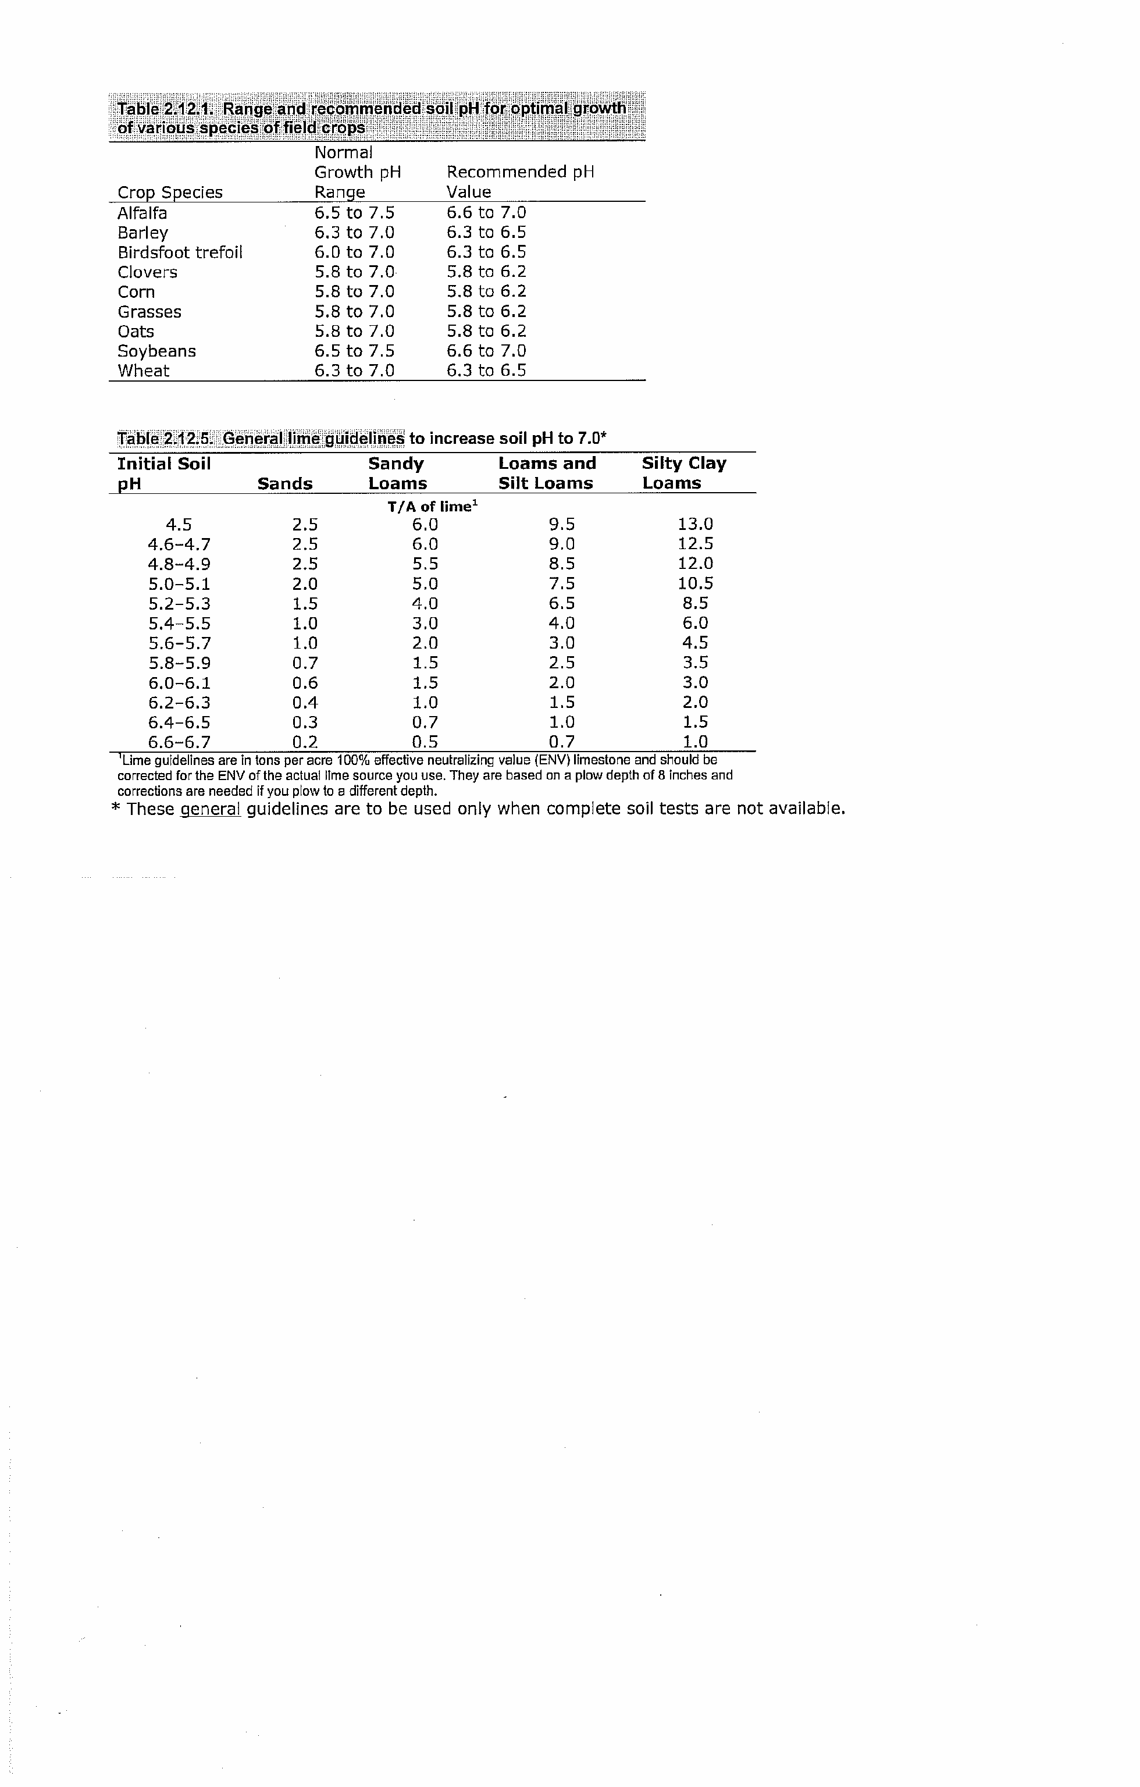
Grasses vs. Legumes - As you know legumes are capable of fixing their own nitrogen from the atmosphere. This is accomplished by bacteria that live in the roots of the plants and convert atmospheric nitrogen into a plant available form. These bacteria are typically sensitive to low pH and if they are not working properly the plant will be unable to fix the needed nitrogen. This is part of the reason the optimum pH for legumes is generally higher than grasses.

Soil type - Soils have varying abilities to buffer a change in pH. The more organic material and clay particles your soil contains the greater ability it has to buffer change. The sandier the soil the less lime it will take to overcome the buffering capacity and the quicker the pH change will occur; however, keep in mind that this also means that the pH will begin to drop much faster as well. In a soil with high clay content it will take a greater amount of lime to change the pH; however, it will take longer for the pH to drop again after the lime has adjusted the pH to the desired level.

Lime particle size - Lime is simply ground limestone. The smaller the limestone is ground the faster it will react in the soil due to greater surface area. In contrast, larger particles of lime will take longer to break down in the soil and provide the advantage of a longer lasting effect on raising the pH.
Not All Lime is Created Equal!

Liming materials vary in their ability to raise soil pH. This is reflected in their Effective Nuetralizing Value (% ENV). Each liming material, be it lime or wood ash, has its own % ENV which can be obtained from the supplier. When you take a soil sample and have the pH determined, the lime recommendation that you get back assumes a lime of 100% ENV. However, 100% ENV lime does not exist. To determine how much lime you really need to apply, divide the recommended amount by the % ENV (ask your supplier for this number).

For example, if lime is recommended at 1 ton/ac and you’re using is 66% ENV lime, then you’ll need to apply 1.5 ton/ac (1 ton divided by .66).

Limes movement in the soil - The rule of thumb is that lime will move down through the soil profile at a rate of ~1” per year will normal rainfall.

pH Management
Planning ahead – Young plants have enough obstacles to overcome without having to struggle with low pH, so it is important to have the pH correct before planting the crop. Often times we neglect our pH during the corn part of a rotation since the corn is not as sensitive to low pH, but the spring that an alfalfa seeding is planted is NOT the time to worry about raising the pH. You need to begin raising the pH towards the end of the corn rotation to make sure it is correct when the alfalfa is seeded the following spring. This makes fall a great time to apply lime in preparation for next spring’s crop. Not only does it reduce the number of jobs to be done in the spring it allows time for the pH change to start prior to planting the next crop.

Maintaining the proper pH – Once you have the pH in the proper range it is a very good idea to keep it there. Since the efficiency of so many nutrients is dependent on the proper pH, even with crops like corn that tolerate a lower pH you are affecting your nutrient efficiency and your check book anytime the pH is too low, not just when your growing alfalfa. It addition, the lower the pH, the more difficult and timely it will be to raise it back up to the proper levels. If more than 3 tons/acre is needed then a split application is recommended, generally with the 1st application being tilled in and the 2nd application being placed on the surface, this allows the lime to begin raising the pH throughout the soil profile instead of just on the surface.

Cation Ratios and Liming

Adapted from Ev Thomas, Miner Institute
Both calcium (Ca) and magnesium (Mg) are essential elements for crop production, needed in moderate to high amounts. Four tons of alfalfa, for instance, contains almost 80 lbs of Ca and 20 lbs of Mg. All agricultural limestone contains lots of Ca; most also contains varying amounts of Mg. There’s a bit of disagreement as to how to use Ca and Mg soil analyses to make fertilizer recommendations. Over 60 years ago a theory was proposed suggesting that there’s an ideal ratio of the cations Ca, Mg, hydrogen (H), and potassium (K) in the soil. A number of soil test labs started using this concept even though there was essentially no research data to support it. This has proved to be an expensive way to fertilize field crops, in some cases calling for pure calcitic lime (one containing no magnesium) to achieve the theoretically ideal ratios of Ca, Mg, and K in the soil. As you might expect, demanding anything “pure” is likely to cost more—as is the case with pure calcitic limestone.
Considerable research across the U.S. has shown that there’s a wide range in acceptable cations in the soil, and therefore no ideal ratio. Penn State looked at Ca:Mg ratios and found no difference in corn yield with Ca:Mg ratios from less than 2:1 to 37:1. It’s absolutely impossible to increase soil Mg levels too much by using a high-magnesium limestone (called “dolomitic” lime). (It’s highly unlikely that you’d increase soil Mg levels too much by fertilizing with magnesium simply because the stuff is so expensive.)
Seldom do we find low soil test Mg levels here in the Northeast. In almost all cases, the soil pH is low enough that using a dolomitic source of lime is enough to supply the necessary Mg. I can remember only two soil analyses—out of the literally thousands I reviewed during my former life as an Extension field crop specialist—where Mg was low while pH was high. In these extremely rare cases sulfate of potash magnesia (sul-po-mag) is probably the best source of Mg.

Questions on liming or soil sampling:
Call Joe Lawrence at CCE Lewis County, 315-376-5270.

