Northern NY Agricultural Development Program
2008-2009 Project Report

Project Title: Management of Brown Root Rot of Alfalfa in New York

Project Leader(s): Gary Bergstrom and Michael Wunsch, Dept. Plant Pathology/ Plant-Microbe Biology; Julie Hansen, Donald Viands & Jamie Crawford, Dept. Plant Breeding/Genetics;Cornell University, Ithaca, NY

Background:
Phoma sclerotioides, causal agent of brown root rot (BRR), is a soil-borne fungus causing root and crown rot of alfalfa, other perennial legumes, and overwintering grasses. Primarily active during late winter and early spring (Cormack 1934), it is associated with yield loss, winterkill, slow emergence from winter dormancy, and stand decline of alfalfa (Berkenkamp et al. 1991, Hollingsworth et al. 2003) and with winterkill of overwintering grasses (Larsen et al. 2007).
BRR was first detected in the eastern United States in 2003 in Clinton County, NY on alfalfa. The results of subsequent surveys of alfalfa production fields conducted in Clinton County in 2004 and in New York, Vermont and New Hampshire in 2005 suggest that BRR may be a serious factor impacting the health and persistence of alfalfa in the region. BRR was found on a high percentage of plants in many fields (Figures 1 and 2), and most of the lesions caused by the disease progressed into the cortical (internal) tissues of roots and crowns (Wunsch et al. 2007). The BRR incidence observed in northeastern United States is similar to that observed in Saskatchewan, Canada, where the disease has long been recognized as a serious problem for alfalfa production.

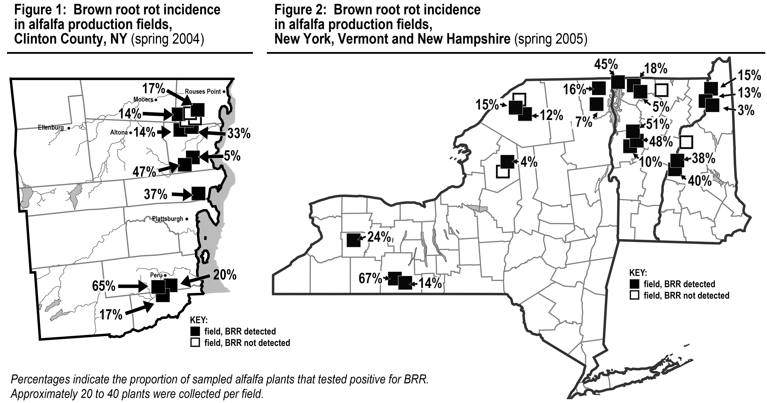

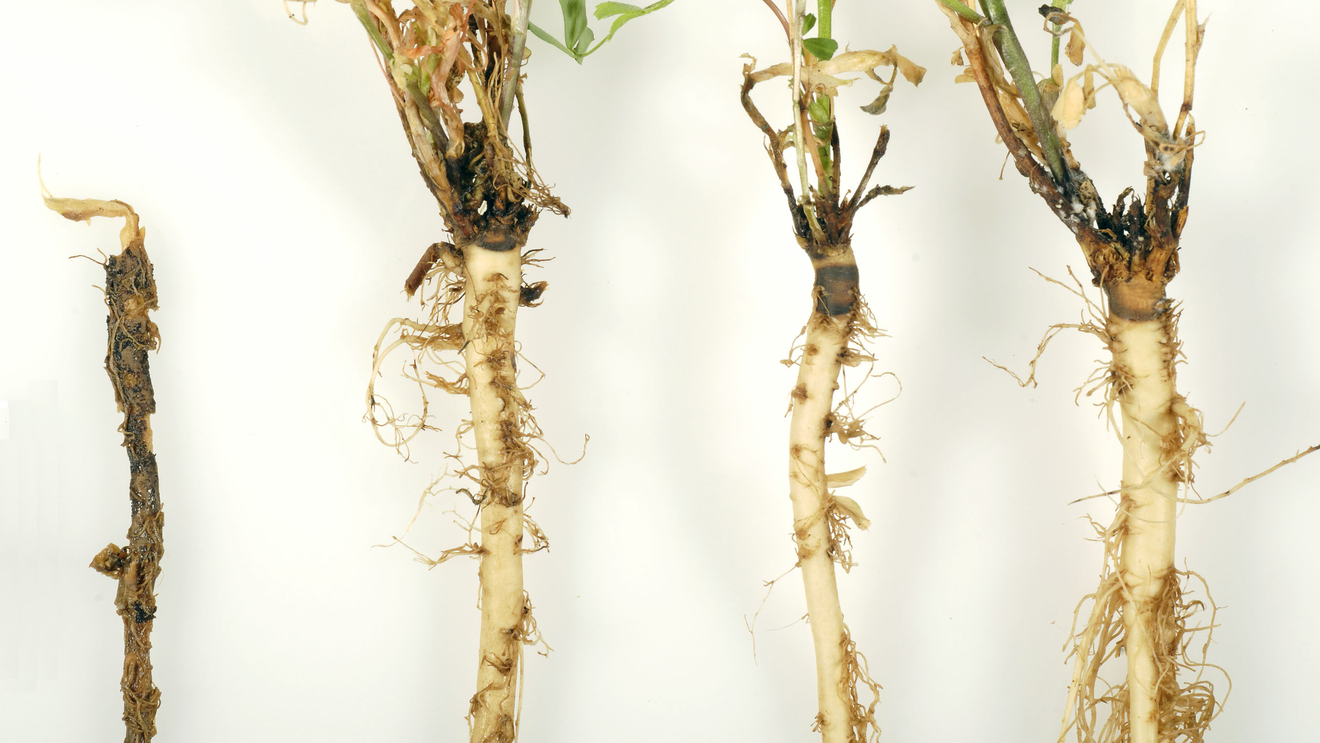

Photo 2: Typical brown root rot symptoms. Photo credit: Kent Loeffler, Department of Plant Pathology and Plant-Microbe Biology, Cornell University, Ithaca, NY.

BRR can have severe effects on alfalfa yields. In Saskatchewan fields with heavy BRR disease pressure, BRR-resistant alfalfa cultivars yield 40 to 65 percent higher than BRR-susceptible cultivars (second and third production years, three cuts per year); alfalfa cultivars with moderate BRR resistance yield 23 to 43 percent higher than BRR-susceptible cultivars (Berkenkamp et al. 1991).
No management tools currently exist for BRR in New York. Peace, the BRR-resistant alfalfa variety grown in Saskatchewan and Alberta, performs poorly in New York, as it is highly susceptible to other alfalfa root rots common in New York. Crop rotation is not an effective alternative; P. sclerotioides produces resting stuctures that can persist extended periods in the soil without a suitable substrate (Cormack, 1934), it has a very broad host range, and it can survive on organic matter in the soil (Davidson, 1990).
Significant differences in BRR resistance have been observed among alfalfa varieties grown in Saskatchewan and in Wyoming (Berkenkamp et al., 1991; Hollingsworth et al., 2005). If significant differences in BRR resistance are also observed among alfalfa varieties grown in New York, adoption of the most resistant varieties by growers in fields with high BRR pressure would be expected to increase forage yields. The most resistant varieties would also serve as sources of BRR resistance for alfalfa breeding.

Methods:
Alfalfa variety trial with yield assessment
A field plot trial was planted at The William H. Miner Agricultural Research Institute at Chazy NY on May 4, 2009. The soil type is a Roundabout silt loam. The trial design is a split-plot with BRR inoculated and uninoculated as the main plot treatments, and alfalfa cultivars as the sub-plots. Six main plots were planted. One-half of each main plot was inoculated with barley grains infected with Phoma sclerotioides prior to seeding. Inoculations were conducted with an equal mix of four genetically and morphologically divergent isolates of P. sclerotioides. The grains were raked into the soil. Plots were seeded with a 6-row Carter seeder that seeded plots that are 3.5 feet wide and 20 feet long. Sub-plots are 11 alfalfa cultivars / experimentals. Three cultivars are from seed companies. These cultivars were recommended by Deborah Samac, USDA-ARS Research Plant Pathologist, and have done well in other BRR trials in the Midwest. Six cultivars are from the Cornell Alfalfa Breeding Program and are currently or have been recently marketed in New York. One cultivar is a PLH-resistant alfalfa and one is ‘Vernal’ a standard check cultivar in alfalfa trials. Seed germinations tests were completed for each cultivar. The number of seeds that germinated ranged from 330 to 425 seeds per gram. The grams of seed per plot were adjusted so that about 80 live seeds per square foot were planted for each cultivar. Seeds per plot ranged from 14.9 to 19.2 grams. The plots were sprayed with herbicides and an insecticide in early July to control weeds and insects, and two harvests were taken the seedling year.

Alfalfa variety trial with BRR incidence assessment
In May 2007, a replicated field trial was established at the Cornell Baker Research Farm in Willsboro, NY to test the relative susceptibility of 11 alfalfa varieties to BRR. Nine alfalfa varieties commercially available in New York were tested: 54V46 (Pioneer), 361 HY (Preferred Seed), Guardsman II (Seedway), Mariner III (Allied Seed), ReGen (Seedway), Oneida Ultra (Seedway), Seedway 9558 (Seedway), Starbuck (Pickseed), and WL 347 LH (W-L Research). Two additional varieties, Peace (Richardson Seeds) and Vernal (University of Wisconsin), were included as resistant and susceptible checks. The plot was inoculated at seeding with a single isolate of P. sclerotioides of local origin. A parallel experiment (not funded by NNYADP) was established near Bath, NY in May 2006 and inoculated with a single isolate of P. sclerotioides collected near Bath. In April and May 2009, 150 plants of each variety were collected from the plot in Willsboro and 125 plants of each variety were collected from the plot near Bath and assessed for BRR in the laboratory. A plant was only considered positive for BRR if P. sclerotioides was successfully isolated from a root or crown lesion. Incidence of BRR was recorded.

Results:
Alfalfa variety trial with yield assessment Seed germination and seedling establishment at the field plot in Chazy was excellent.

Figure 3). 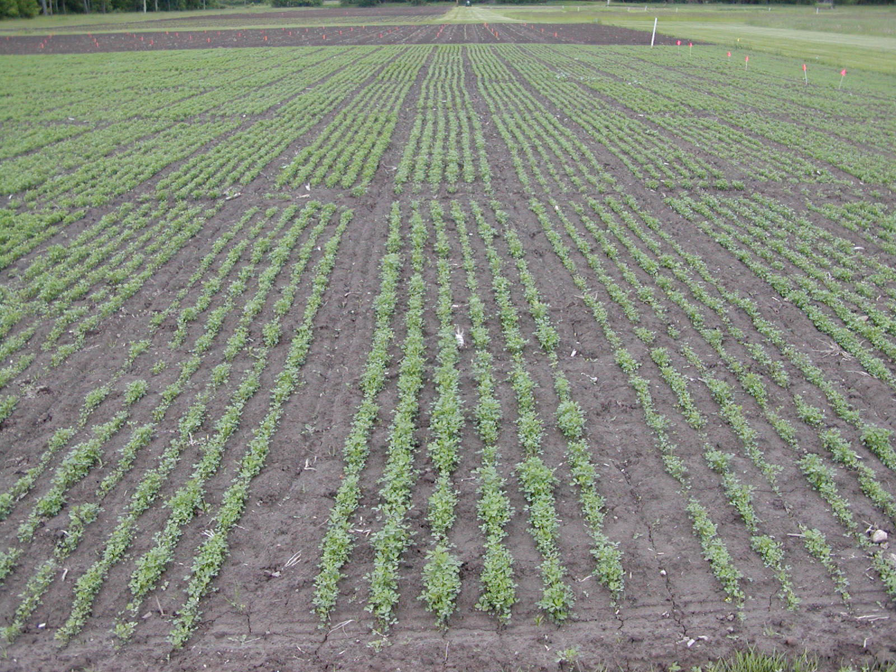

Photo 1: Alfalfa emergence in the Chazy, NY alfalfa variety trial assessing BRR resistance. Cited as figure 3. Photo credit: Julie Hansen, Department of Plant Breeding and Genetics, Cornell University, Ithaca, NY.

Yield difference between the inoculated and uninoculated plots is not expected until the first production year (2010) or later after the P. sclerotioides infects the plant roots. Within the part of the trial that was not inoculated, MsSunstra 536, Oneida Ultra, ReGen, and Ezra alfalfa were in the top yielding group of cultivars based on the LSD (0.05). Within the trial that was inoculated, MsSunstra 536, Oneida Ultra, ReGen, Ezra, Guardsman II and Vernal were in the top yielding group of cultivars based in the LSD (0.05).

(

Alfalfa variety trial with BRR incidence assessment
In spring 2009, 54V46, Peace, Seedway 9558, Oneida Ultra, WL 347LH, and Vernal exhibited significantly lower levels of infection by P. sclerotioides than Starbuck (Table 2). The results correspond to those observed in spring 2008; the relative BRR resistance of the varieties was similar both years, and Peace was significantly more resistant to BRR than Starbuck both years (Table 2).

The relative BRR resistance of Peace and Starbuck was reversed at the field plot in Bath (not funded by NNYADP). Starbuck was significantly more resistant to BRR than Peace in both spring 2007 and 2008 (Table 2). Peace and Vernal were not evaluated in spring 2009 because of inadequate numbers of surviving plants.
The differences in BRR resistance observed in Willsboro and Bath likely reflected biological variation in the pathogen present at these locations. Recent research indicates that P. sclerotioides is represented by at least five genetically and morphologically distinct biotypes in New York. In Willsboro, biotype 1 predominates, and plants were inoculated with an isolate of biotype 1. In Bath, biotype 5 predominates, and plants were inoculated with an isolate of biotype 5. The results from the variety trials suggest that some alfalfa varieties may be resistant to one biotype but highly susceptible to another. To confirm these results, an inoculation study involving alfalfa varieties Peace, Starbuck, and WL 347LH and all major biotypes is currently being conducted under controlled conditions.

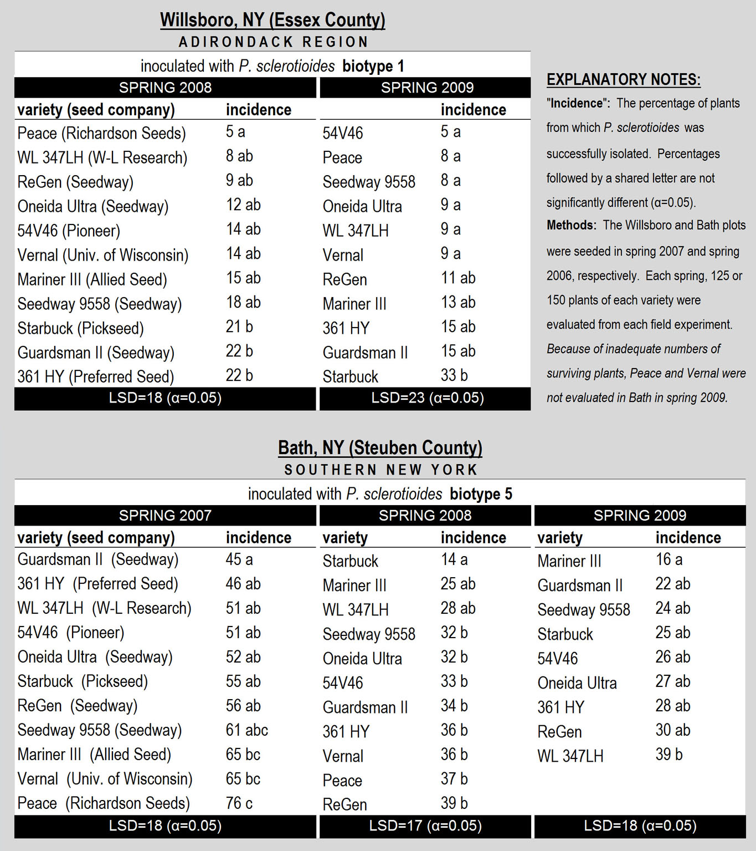

Conclusions/Outcomes/Impacts:
In most alfalfa production fields in northern New York, multiple biotypes of P. sclerotioides are present, and no single biotype predominates. The BRR variety trial planted in Chazy in 2009 should help identify alfalfa varieties that perform well in such fields. Surveys conducted in 2004 and 2005 suggest that the native population of P. sclerotioides in the field selected for the variety trial is representative of most fields in northern New York, with moderate to high levels of biotypes 1, 3, and 5 present. The split-plot design with supplemental inoculum of biotypes 1, 2, 3, and 5 as a main-plot treatment will permit evaluation of BRR resistance under conditions of high BRR pressure where multiple biotypes are present. Comparisons with the uninoculated main-plot treatment will also permit assessment of the yield effect associated with increased BRR pressure.
The results from the field trials in Willsboro and Bath will help inform breeding efforts. Alfalfa breeders currently use a single isolate of P. sclerotioides from biotype 1 to screen for BRR resistance. Peace, the variety that was relatively resistant to BRR in Willsboro but highly susceptible in Bath, is used by breeders as a moderately resistant check. If studies conducted under controlled conditions confirm that Peace is highly susceptible to biotype 5, breeders will need to include additional isolates representing other biotypes when screening for BRR resistance.

Outreach: The latest results of this project will be shared at the Crop Congresses in the norther New York communities of Carthage and Madrid in March 2010. Additional outreach on brown root rot was conducted for growers in northern New York at Crop Congresses in Chazy, Madrid, and Carthage in March 2009, and for Cornell Cooperative Extension field crop educators at in-service training sessions in March and November 2009. Also, a poster highlighting the ongoing alfalfa variety experiment in Chazy was distributed for display in the offices of Cornell Cooperative Extension Associations of Clinton, Essex, Franklin, Jefferson, Lewis, and St. Lawrence Counties.

Next steps if results suggest continued work is needed in the areas of research, demonstration and/or education.
Yield assessment should be made for at least three additional years at the field plot established in Chazy in spring 2009. Infection of alfalfa by P. sclerotioides does not occur until winter dormancy, and BRR is typically most severe in the third, fourth, and fifth years of alfalfa production.

Acknowledgments: In addition to NNYADP, partial funding support for this project was from Hatch project NYC153-433 and an award from the USDA-CSREES Northeast IPM Partnership Grants Program.

Reports and/or articles in which the results of this project have already been published.
Extension reports:
Brown-Rytlewski, Diane. Winterkill and brown root rot of alfalfa. April 16, 2009. Michigan State University IPM News. http://ipmnews.msu.edu

Publications in the popular press:
Farm briefs: Project aims to combat brown root rot. April 19, 2009. Plattsburgh Press-Republican. http://www.pressrepublican.com

NNY study to combat root rot. Aptil 18, 2009. Watertown Daily Times. http://www.watertowndailytimes.com

Person(s) to contact for more information (including farmers who have participated:
Michael J. Wunsch, graduate research assistant
607-255-8393 (lab), 607-351-4234 (cell), mjw55@cornell.edu
Gary C. Bergstrom, professor
607-255-8393 (lab), 607-255-7849 (office), gcb3@cornell.edu
Department of Plant Pathology and Plant-Microbe Biology, Cornell University,
334 Plant Science, Ithaca, NY 14853.

Literature Cited
Berkenkamp, B., Bittman, S., and McCartney, D. 1991. Resistance of alfalfa cultivars to brown root rot. Can. J. Plant Sci. 71:211-213.
Cormack, M.W. 1934. On the invasion of roots of Medicago and Melilotus by Sclerotinia sp. and Plenodomus meliloti D. and S. Can. J. Res. 11:474-480.
Davidson, J.G.N. 1990. Brown root rot. Pages 29-31 in: Compendium of Alfalfa Diseases, D.L. Stuteville and D.C. Erwin, eds. APS Press, St. Paul MN.
Hollingsworth, C. R., Gray, F. A., Koch, D. W., Groose, R. W., and Heald, T. E. 2003. Distribution of Phoma sclerotioides and incidence of brown root rot of alfalfa in Wyoming, U.S.A. Can. J. Plant Pathol. 25:215-217.
Hollingsworth, C. R., Gray, F. A., and Groose, R. W. 2005. Evidence for the heritability of resistance to brown root rot of alfalfa, caused by Phoma sclerotioides. Can. J. Plant Pathol. 27:64-70.
Larsen, J. E., Hollingsworth, C. R., Flor, J., Dornbusch, M. R. Simpson, N. L., and Samac, D. A. 2007. Distribution of Phoma sclerotioides on alfalfa and winter wheat crops in the North Central United States. Plant Dis. 91:551-558.
Wunsch, M. J., Schindelbeck, R. R., van Es, H. M., and Bergstrom, G. C. 2007. Distribution, impact and soil environment of Phoma sclerotioides in northeastern U.S. alfalfa fields. Plant Dis. 91:1293-1304.

