Northern NY Agricultural Development Program
2008-2009 Project Report

Project Title: Economic and environmentally sound manure management option for reduced till systems

Project Leader(s): Quirine M. Ketterings, Dept. of Animal Science, Cornell University.

Collaborator(s):
Cornell University:
- Anne Place and Greg Godwin, NMSP staff
- Karl Czymmek, PRODAIRY, Dept. of Animal Science
Cornell Cooperative Extension:
- Joe Lawrence (CCE of Lewis County)
- Tom Kilcer (CCE of Rensselaer and Columbia Counties)
- Brian Aldrich (CCE of Cayuga County)
Consultants/others:
- Peter Barney, Barney Agronomic Services
- Peg Cook, Cooks Consulting
- Scott Potter, Dairy Support Services

Cooperating Producers:
- Jake Ashline, Miner Institute (Clinton County)
- Darren McIntyre, Wyndamar Farms (Lewis County)
- Dave Fisher, Mapleview Dairy LCC (St Lawrence County)
- Dan Chambers, Chambers Farm LCC (St Lawrence County)
- Brian Chittenden, Dutch Hollow Farm LCC (Columbia County)
- Martha and Richard Place, Hohl Acres (Chenango County)
- Greg Rejman, Sunnyside Farm, Inc (Cayuga County)
- Bill Kilcer, Winnstott Farm (Cayuga County)
- Willard DeGolyer, Table Rock Farms, Inc (Wyoming County)
- Bill Cook, Aurora Ridge Farm (Cayuga County)

Background: In discussions with NY farmers and their advisors, questions were raised about manure management options that are compatible with reduced-till corn systems and reduce runoff, leaching (tile drain) and volatilization risks. The manure application method of most interest is surface application followed by partial incorporation with an aeration tool. A 3-yr trial at the Aurora Research Farm showed aerator incorporation following spring manure application for corn resulted in N conservation and subsequent yields similar to those obtained with chisel plowing. On-farm trials were conducted in 2008 and 2009 to see if similar results could be obtained under different soils/growing conditions.

Methods: The Aurora Research Farm trial was continued and nine farm fields were added (St Lawrence and Cayuga (2x), Lewis, Clinton, Wyoming, Chenango, and Columbia County (1x)). We compared surface application (no incorporation until 5+ days after application) with (1) aeration or (2) chisel incorporation directly following manure application. Each trial was conducted in 4 replications (except for two farms where we had 3 replications) resulting in 12 (or 8) strips per field. Strips ranged in length (spreader pattern and planter/harvester determined) and were 300+ feet long. Each strip was monitored for soil N (sampling prior to manure application, at planting, at PSNT time, and after harvest), soil fertility, residue coverage, compaction (penetrometer readings), and soil moisture content. Fields were harvested for silage or grain, depending on the farm and weather conditions and corn stalk nitrate tests (CSNT) were done at harvest.

Results: In none of the years or locations was there a significant difference in yield between the aerator shallow mixing and the more aggressive chisel incorporation (Table 1).

Table 1: Corn yield (35% DM for silage; 85% DM for grain), presidedress nitrate test (PSNT, 12 inches), and corn stalk nitrate test (CSNT) as impact by manure application method (chisel vs aerator incorporation).
Treatment | Silage/grain yield |  | PSNT |  | CSNT
 | tons/acre |  | ppm |  | ppm
 | 2009 | 2008 | 2009 | 2008 | 2009 |  | 2008
Chisel incorporation | 9.3 a | 12.9 a | 15 a | 13 a | 48 a | L | 9 a | L
Aeration | 9.7 a | 13.5 a | 10 a | 13 a | 50 a | L | 21 a | L
Chisel incorporation | 12.7 a | 22.7 a | 34 a | 17 a | 151 a | L | 363 a | O
Aeration | 13.3 a | 22.1 a | 29 a | 13 a | 109 a | L | 108 b | L
Chisel incorporation | 118.7 a | 179.9 a | 12 a | 55 a | 94 a | L | 517 ab | O
Aeration | 112.5 a | 177.9 a | 9 b | 46 a | 94 a | L | 327 b | O
Chisel incorporation | 18.2 a | 19.4 a | 18 a | 28 a | 332 a | O | 1,095 a | O
Aeration | 19.0 a | 19.4 a | 17 a | 33 a | 200 a | L | 840 a | O
Chisel incorporation | 18.6 a | 164.9 a | 23 a | 58 a | 879 a | O | 2,751 a | E
Aeration | 18.6 a | 175.1 a | 22 a | 58 a | 1,029 a | O | 1,795 a | O
Chisel incorporation | 14.2 a | 15.2 a | 42 a | 46 a | 1,150 a | O | 6,395 a | E
Aeration | 13.5 a | 14.9 a | 31 a | 27 b | 635 a | O | 3,545 b | E
Chisel incorporation | 24.6 a | 21.7 a | 22 a | 43 a | 3,407 a | E | 8,167 a | E
Aeration | 23.9 a | 21.6 a | 17 b | 41 a | 1,330 b | O | 4,516 a | E
Chisel incorporation | 26.8 a | 27.1 a | 45 a | 50 a | 4,287 a | E | 6,903 a | E
Aeration | 25.7 a | 27.1 a | 39 a | 51 a | 2,848 a | E | 6,458 a | E
Chisel incorporation | 20.0 a | 20.1 a | 51 a | 48 a | 8,209 a | E | 9,845 a | E
Aeration | 20.7 a | 21.1 a | 50 a | 43 a | 8,068 a | E | 8,134 a | E
†Average values with different letters (a,b,c,d) are statistically different (α = 0.05)
Aerator and chisel incorporation tended to result in similar levels of N conservation (Table 1). This is consistent with the previous three years of treatment comparisons at the Aurora Research Farm. Where N was limiting, the two incorporation treatments tended to yield more than the surface application in 2008. No yield differences were seen in 2009 because N was in excess or because of this season’s cool wet weather impacting overall crop growth, independent of the manure application treatment. Where there was excess N, as shown by PSNT and late season corn stalk nitrate (CSNT), results all three treatments generally yielded the same. Where significant rainfall occurred after sidedress time, CSNT’s were low, reflecting loss of N late in the season.
In general, locations where initial residue measurements were less than 25% no differences were seen between the two incorporation treatments whereas for higher surface residue sites, aerator incorporation of manure resulted in greater residue coverage than chisel incorporation.
There were no differences in compaction reading. Some compaction occurred towards harvest time for several of the fields in 2008, independent of treatment, but 2009 showed very little to no compaction throughout the season.

Conclusions/Outcomes/Impacts: For many of the sites in 2008 incorporation aided in the conservation of manure N, but did not show treatment differences in yields due to high soil N levels. Those sites in 2008 that did show treatment differences were N limited as seen by site A and possibly site D early in the season or the site was impacted by environmental stressors (Site G). In 2009, no yield responses were seen from incorporation either due to already high soil N levels or as a result of the past year’s cool, wet season that caused fields to be saturated for large parts of the season at several locations. We can conclude that aeration is no less effective than chisel incorporation of manure in regard to yields and has the same manure N conservation potential. Aeration does conserve more surface residue than the chisel incorporation treatment indicating less soil disturbance and does not appear to have had any significant impact on soil compaction over the two years of this study. The direct injection treatment appears to also be effective in conserving N and will need to be further studied to see if yield responses can be replicated in other locations.

Outreach:
A What’s Cropping Up? article appeared in 2009:
- Place, A., Q.M. Ketterings, G. Godwin, K. Czymmek, S. Bossard, P. Barney, J. Lawrence, B. Aldrich, T. Kilcer (2009). Comparing manure incorporation methods in reduced till systems. What’s Cropping Up? 19(2): 4-5.

The study was presented as part of numerous talks given in 2009 and 2010 (to date):
- NNY nutrient management projects (2010). Western NNY NNYADP meeting. Watertown, NY, January 25, 2010. ~20 people.
- Enhanced efficiency fertilizers (2010). January 19, 2010. Cargill Meeting. Fort Plain, NY. ~100 people.
- Optimizing nitrogen management of corn using rotations, cover crops, manure and/or fertilizer. Western New York Corn Congress. Batavia, NY, January 13, 20109. ~250 people. Waterloo, NY, January 14, 2009. ~200 people.
- Ketterings, Q.M., K.J. Czymmek, A. Place and G. Godwin (2009). Shallow incorporation of manure. Northeast Region Certified Crop Adviser training. Waterloo, NY. December 8-10. ~40 people.
- Ketterings, Q.M. (2009). Value of manure. Organic cropping systems. Aurora, NY. November 16, 2009. 10 people.
- Ketterings, Q.M. Enhanced efficiency fertilizers and research update (2009). 2009 Field Crop Dealer Meetings. October 27 (Latham, NY), October 28 (New Hartford, NY), October 29 (Batavia, NY) and October 30 (Auburn, NY). ~240 people.
- Manure basics. Wyoming County Dairy Institute (2009). Module 9 – Manure and Nutrient management. 2-hr evening session. April 9, 2009. Wyoming County Cooperative Extension Office, Warsaw, NY. 6 people.
- Making the most of your fertilizer dollars (2009). Oneida County Cornell Cooperative Extension and Clinton Tractor Winter Crops Meeting. Clinton, NY. March 18, 2009. ~65 people.
- Basic agronomy (2009). Water Quality Symposium (8 hours). March 12, 2009. Auburn NY. Co-presenters: Karl Czymmek and Patty Ristow. 29 people.
- Nutrient Management CNMP Training (2009). 2009 NRCS/DAM Water Quality Symposium (4 hours). Auburn, NY, March 11, 2009. Co-presenter: Karl Czymmek. 25 people.
- NNY nutrient management projects. Eastern NY NNYADP meeting. Chazy, NY, February 20, 2009. ~35 people.
- Getting the most from your manure. Madison County winter meeting. Cazenovia, NY, February 11, 2009. ~20 people.
- NNY nutrient management projects. Western NY NNYADP meeting. Watertown, NY, January 30, 2009. ~15 people.
- Nutrient management workshop. NYSDAM sponsored 2 day nutrient management training for AEM planners. Auburn, NY. January 12-13, 2009. 20 people. Co-presenters: Patty Ristow, Karl Czymmek, Brian Aldrich (CCE of Cayuga County).
- Nutrient management workshop. 1 day-intense nutrient management training for AEM planners. WNYCMA, Perry, NY. January 6, 2009. 5 people. Co-presenters: Patty Ristow and Karl Czymmek.

Next steps if results suggest continued work is needed in the areas of research, demonstration and/or education.
We are working on the summary of the project in the form of a peer-reviewed journal article and a What’s Cropping Up? article.

Acknowledgments: Funds to support this project were supplied by the New York Farm Viability Institute, the Northern New York Agricultural Development Program and the Cornell University Agricultural Experiment Station. In-kind contributions were mad by Cornell Cooperative Extension, private sector consultants and farmers

Reports and/or articles in which the results of this project have already been published.
This project was featured in several public press articles:
- "New York Farms in Statewide Project" (Gouverneur Times).
- "Shallow Incorporation Shaves Costs" (American Agriculturist).
- "Northern New York Research Evaluates Best Use of Dairy Cow Manure" (Progressive Dairyman).

Impact stories were written for all farms and posted to the project website:
- Musgrave Research Farm Key Site in Statewide Manure Incorporation Study. (1-18-2010)
- Western New York Farm Reaps Benefits of On-Farm Manure Incorporation Study. (1-18-2010)
- Timing is Right for Manure Incorporation Study at Mapleview Dairy LLC in St Lawrence County.
(10-23-2009)
- Lewis County Farmer Participates in Statewide Manure Incorporation Project. (8-27-2009)
- St Lawrence County Farmer Sees Promising Results from Manure Incorporation Trials. (7-22-2009)
- Cayuga County Dairy Tests Alternative Manure Incorporation Methods in On-farm Research.
(7-20-2009)
- Eastern New York Dairy Looks to Gain Economic Benefits from Manure Study.(7-1-2009)
- Diverse Team Researches Manure Incorporation on Cayuga County Farm. (6-18-2009)
- Miner Institute Participates in Statewide Manure Application Method Project. (6-9-2009)
- Central New York Dairy Farm Family Reaps Benefits of Manure Management Trials. (3-13-2009)
Person(s) to contact for more information (including farmers who have participated: For more information, contact Quirine Ketterings, Nutrient Management Spear Program, 323 Morrison Hall, Dept. of Animal Science, Cornell University (qmk2@cornell.edu or 607 255 3061).

Photos

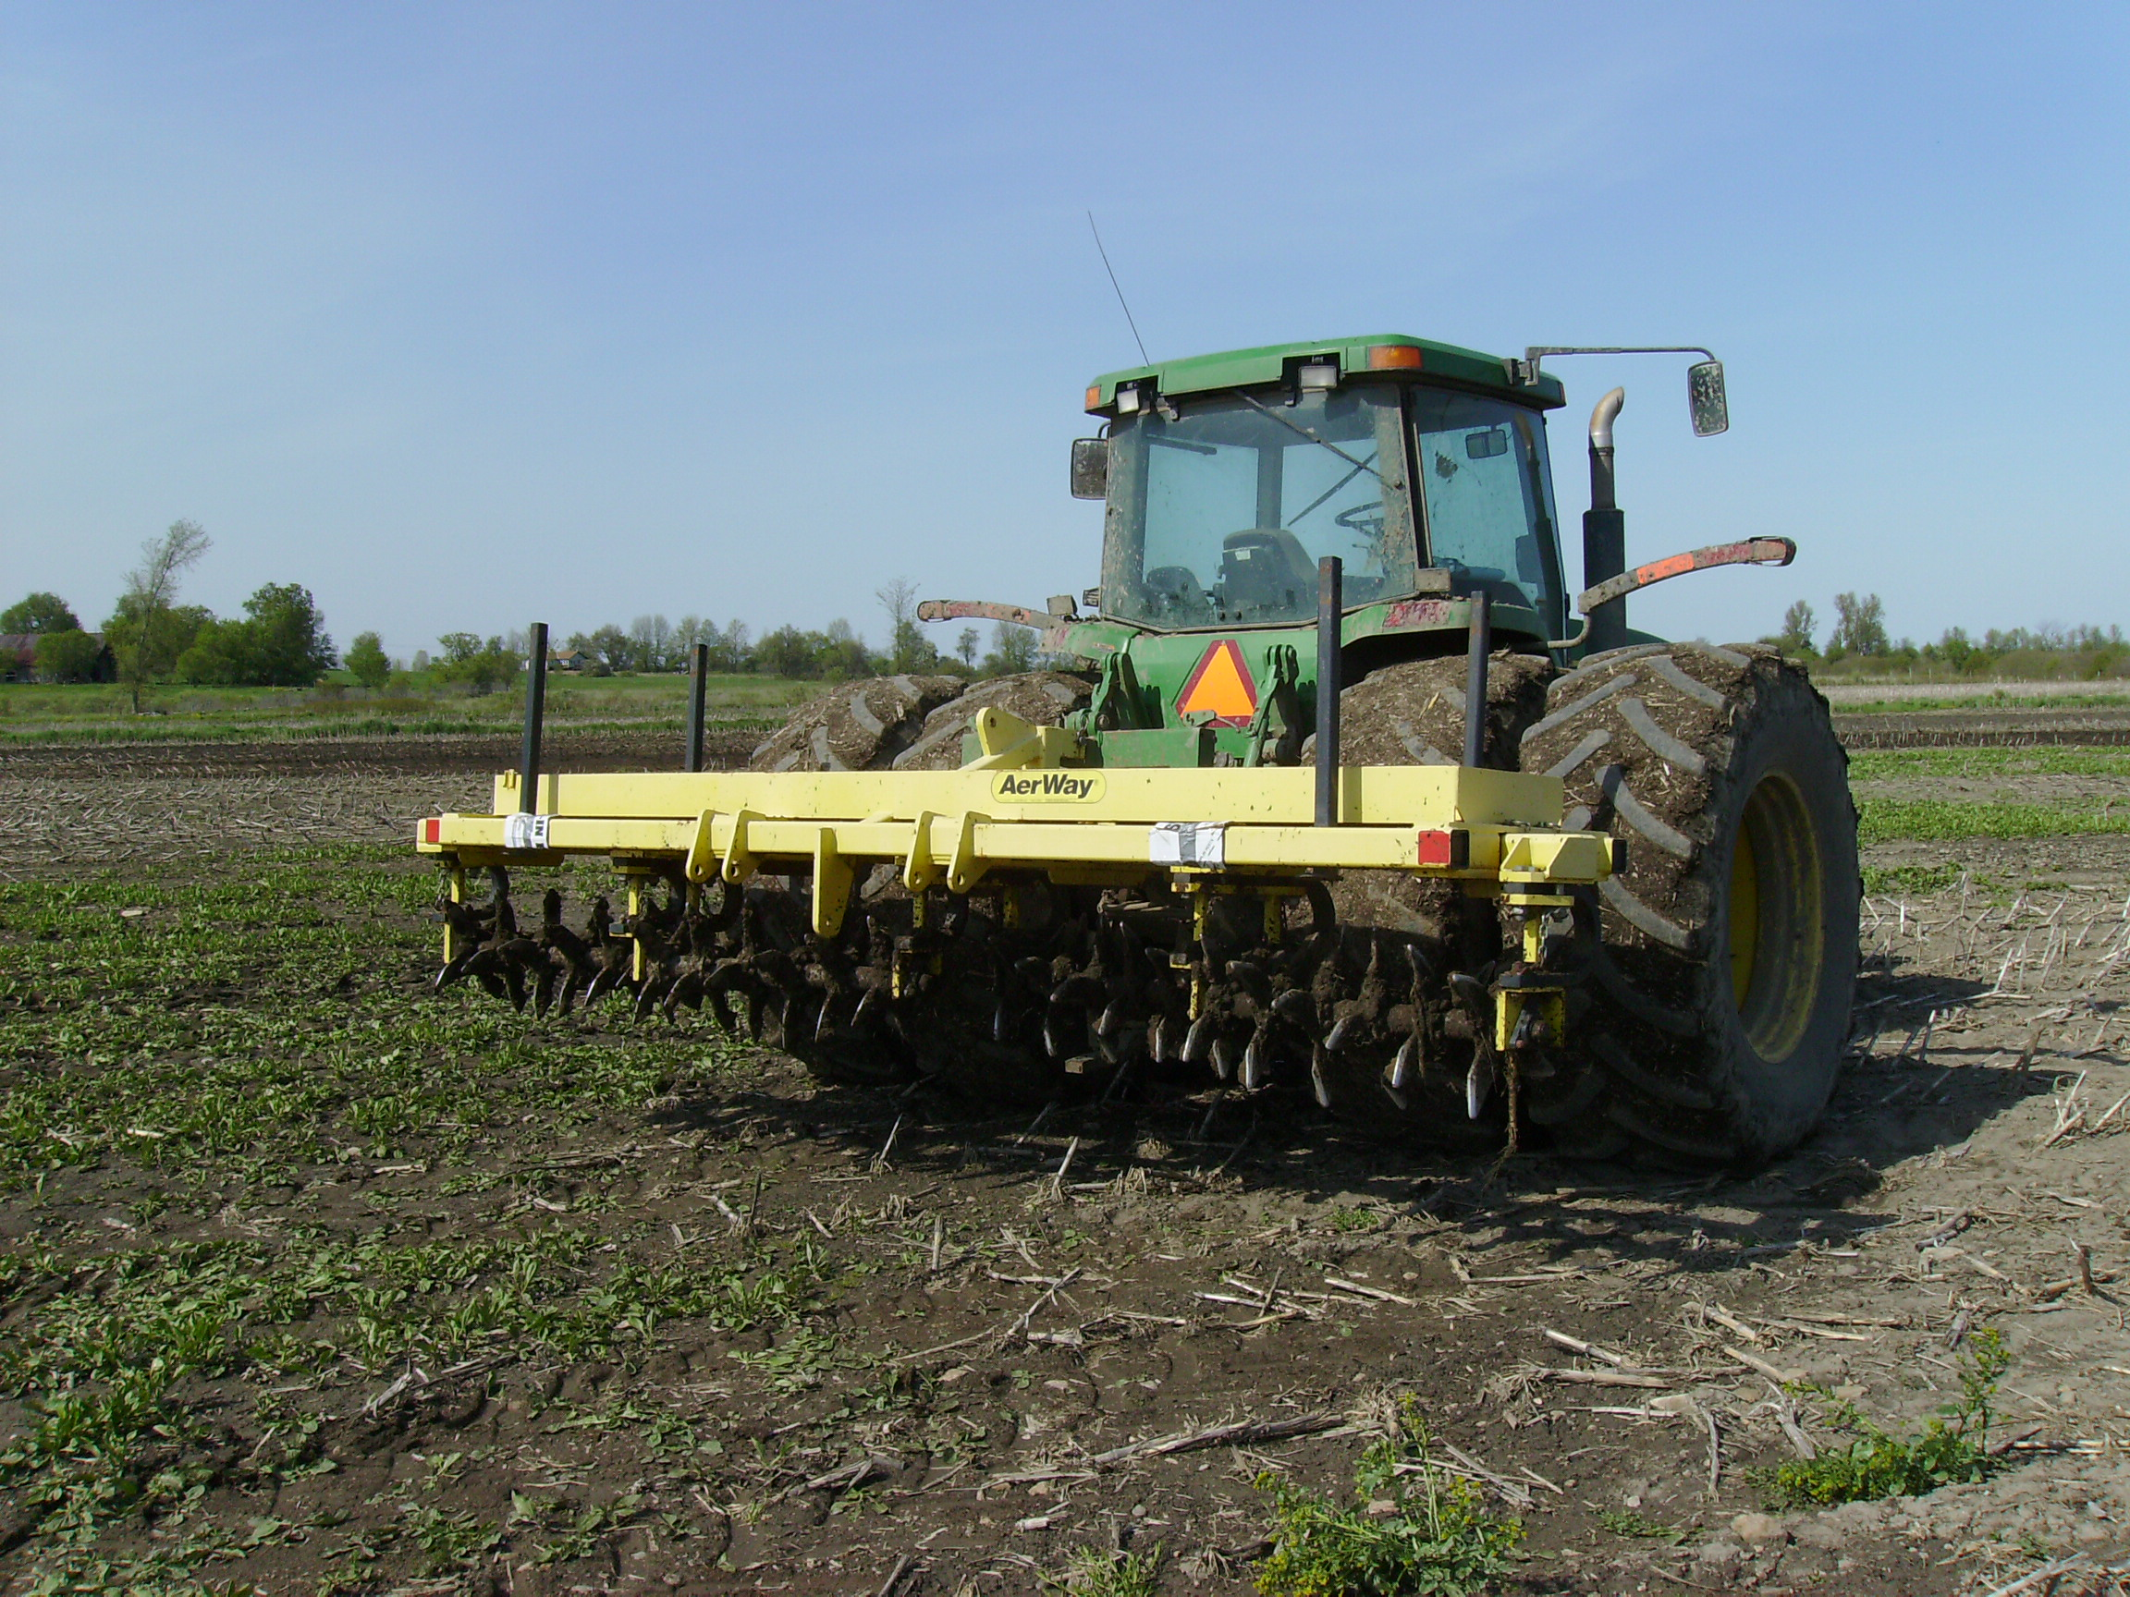

Aerator at Dan Chamber’s farm site.

