Northern New York Agricultural Development Program
2009 Project Report
Title of project
Improved Apple Orchard Management Systems and Rootstocks for Northern NY
Project Leader
Terence Robinson, Dept. of Hort. Sciences, Cornell University, Geneva, NY 14456, ph: 315-787-2227, e-mail: tlr1@cornell.edu
Collaborator
Kevin Iungerman, Cornell Coop. Ext., 50 West High Street, Ballston Spa, NY 12020, ph 518-885-8995, email: kai3@cornell.edu
Grower Cooperators:
Tom Everett, Everett Orchards, Peru NY
Donald Green III, Chazy Orchards, Chazy, NY
Seth Forrence, Forrence Orchards, Peru, NY
Mac Forrence, Forrence Orchards, Peru, NY
Adam Sullivan, Sullivan Orchards, Peru, NY
Hugh Gunison, Gunison Orchards, Crown Point, NY

Introduction
The Northern New York (NNY) apple industry is large (4,000 acres and a farm gate value of $16 million) and is an important segment of Northern New York agriculture. The industry has knowledgeable and progressive growers, an extensive infrastructure, and proximity to large markets. However, to remain competitive in the world apple market NNY apple growers need to continue to modernize their orchards to improve orchard production efficiency and fruit quality. Modern high-density orchard planting systems, will help improve efficiency, yield and fruit quality and will offer growers the opportunity to plant profitable new varieties. Replanting older orchards to new high-density orchards with popular new varieties will help the long-term viability of the Northern New York apple industry.
The goal of this project was to develop and extend to growers information on modern, competitive orchard systems that incorporate new high priced varieties, disease resistant rootstocks, high planting densities for early production and partial labor mechanization to reduce costs. Research results on high density orchards and new rootstocks conducted in other parts of NY state is not directly transferable to the colder climate of NNY. We have utilized on-farm orchard systems and rootstock experiments that the project leaders have already established in NNY. In addition new on-farm experiments were conducted in 2009 on improved chemical thinning with Honeycrisp, drop control strategies McIntosh and fruit quality with McIntosh and Honeycrisp. The project involved all of the apple growers in NNY through field days, workshops and winter fruit grower meetings.
Materials and Methods
We had previously established 4 on-farm trials in Clinton County that were used in this research project.
1) Chazy Orchards 2001 Rootstock Trial. This replicated field plot compares 16 rootstocks (G.16, G.30, B.9, B.118, O.3, Vineland 1, Vineland 3, Supporter 4, Mark, M.9T337, M.9Nic29, M.9/MM.111, M.26, M.7, MM.106, and MM.111) for survival, productivity and adaptability to the cold climate of NNY with Honeycrisp and McIntosh as the scion varieties. The experimental design is a randomized complete block 8 replications and 10 trees per experimental unit. We measured yield, fruit size and survival for each of the rootstocks. We will publish the final report on this trial at the end of 2010.
2. Everett Orchards 2002 Orchard Systems Trial. This replicated field plot was established at Everett Fruit Farm in Peru, NY and it compares 5 orchard system (Central Leader on MM.111, Slender Pyramid on M.26 and G.30, Vertical Axis on M.9, B.9 and G.16, Solaxe on M.9, B.9 and G.16 and Tall Spindle on M.9, B.9 and G.16). The objective of the trial was to develop realistic performance and cost data for the colder part of NY state to provide growers with practical examples of different orchard system performance and economics. Densities range from 218 trees/acre to 1307 trees/acre. Varieties include McIntosh and Honeycrisp. The experimental design is a randomized complete block split plot with 3 replications and 30 trees per experimental unit. We measured yield, fruit quality, and labor input requirements for each of the various tree forms and planting densities. We will perform an economic analyses of the trial utilizing the actual packout and labor costs in 2 more years when the trial is 10 years old.
3) Forrence Orchards 2002 CG Rootstock Trial: This replicated field plot compares 17 new rootstocks from the Geneva apple rootstock breeding program and 8 Malling stocks from England, 2 stocks from Russia, Ott.3 from Canada, P.22 from Poland and Supporter 4 from Germany with Honeycrisp as the scion. This trial is a comparison of many of the new disease resistant rootstocks from Cornell which have substantial potential in NNY. The experimental design is a randomized complete block 10 replications and 1 tree per experimental unit. We measured yield, fruit size and survival for each of the rootstocks.
4) Forrence Orchards 2008 CG Rootstock Trial: A new replicated field was planted with Mac Forrence at his Valcour farm which compares 34 new rootstocks from the Geneva apple rootstock breeding program and 3 Malling stocks from England, B.9 from Russia, Ott.3 from Canada, P.22 from Poland and Vineland 1 from Canada with Honeycrisp as the scion. This trial is a comparison of many of the newest disease resistant rootstocks from Cornell which have substantial potential in NNY We measured tree survival for each of the rootstocks in 2009. It will have its first crop in 2010.
In addition, we established 3 one year thinning, return bloom management trials with Honeycrisp and a pre-harvest drop control trials with McIntosh apple in 2008.
1) Thinning and Return Bloom of Honeycrisp (Chazy): In 2009 we conducted a replicated field study at Chazy orchards of timing and concentration of chemical thinners to managed cropload and return bloom on the new highly priced apple variety, Honeycrisp. This variety is proving to be difficult to manage and improved thinning strategies are essential to the long-term success of this variety. This study evaluated single vs. multiple sprays of NAA/Sevin for thinning efficacy and summer NAA sprays for improved return bloom of Honeycrisp. The experimental design was a randomized complete block with 4 replications and 2 trees per experimental unit.
2) Control of pre-harvest drop with McIntosh (Chazy): We conducted a replicated field trial where we evaluated ReTain, and NAA in 2009 to reduce pre-harvest drop of McIntosh. The trial was conducted at Chazy Orchards in cooperation with Tre Green. The objective was to determine the effect of Retain, or Retain combined with NAA, on preharvest drop of McIntosh apples in the Champlain Valley. The treatments were:
Trt No. | Treatment | Date of Application
1. | Untreated Control
2. | Retain 333 g/acre plus Silwet L-77 0.1% v/v | 28 days before anticipated harvest
3. | NAA 20 ppm | 14 days before anticipated harvest
4. | Retain 333 g/acre plus Silwet L-77 0.1% v/v plus NAA 20 ppm | 28 days before anticipated harvest
5. | Retain 333 g/acre plus Silwet L-77 0.1% v/v  NAA 20 ppm | 28 days before anticipated harvest  14 days before anticipated harvest
6. | Retain 333 g/acre plus Silwet L-77 0.1% v/v plus NAA 20 ppm | 14 days before anticipated harvest
7. | Retain 167 g/acre plus Silwet L-77 0.1% v/v plus NAA 20 ppm | 14 days before anticipated harvest

Results and Discussion
Orchard Systems Study (Table 1, Figures 1-8):
Our comparison of 5 orchard production systems has shown that the high density Tall Spindle system has been the most productive system in the Champlain Valley. The Tall Spindle had the earliest production with a small crop in the second year (Figs 1 and 2). The M.9 trees had more yield than either B.9 or G.16. M.26, G.30 and MM.111 had no crop in the second year. In the third and fourth years there was a linear relationship of density and yield with the M.9 rootstock having greater yield than any of the other stocks (Fig 5 and Fig. 6). In the fifth year (2006) frost and poor pollination reduced crop significantly with McIntosh but not with Honeycrisp. However, Honeycrisp suffered from biennial bearing and had less than a full crop. B.9 rootstock was the most productive rootstock with Honeycrisp in 2006 but M.9 and G.16 were the most productive with McIntosh. In 2007 and 2008 there was a large crop with both varieties. In 2009 there was the largest crop top date with both McIntosh and Honeycrisp. The tall spindle system again had the highest yield and with McIntosh on either M.9 or B.9 rootstocks, yields reached 1600 bushels/acre (Table 1). With Honeycrisp the most productive combination was the Tall Spindle on either M.9 or B.9 rootstock which had a yield of 1200 bushels/acre. There was little difference in yield between the Vertical Axis and the SolAxe systems. The lowest yielding system was the Central Leader.
The differences in yield between systems was largely the result of the planting density. At the end of 8 years, there was a strong positive linear relationship between tree planting density on cumulative yield (Fig.3). The Central Leader system which had the lowest tree density had the lowest yield, followed by the Slender pyramid, Vertical Axis, SolAxe and Tall Spindle.
Among rootstocks M.9 has the highest yield in most years with McIntosh followed by B.9, G.16, G.30, M.26 and MM.111 (Fig 7). With Honeycrisp, B.9 had the greatest cumulative yield followed by M.9, G.16, G.30, M.26 and MM.111 (Fig. 7). B.9 and G.30 rootstocks had less biennial bearing than either M.9 or G16.
Crop value was greatest with the tall spindle system in each year except 2006 when frost damage reduced crop value with the Tall Spindle more than any other system. Nevertheless, in 2007, 2008 and 2009 the tall spindle again had the greatest crop value. The Tall Spindle had the greatest cumulative crop value followed by the Vertical Axis and SolAxe which did not differ significantly, then the Slender Pyramid and lastly the Central Leader (Fig 4 and Fig. 8). The Tall Spindle exceeded the cumulative crop value of the Central Leader by 7.7 fold with McIntosh and 10 fold with Honeycrisp.
Honeycrisp trees on all rootstocks and systems yielded less than McIntosh (80% yield) but the cumulative crop value of Honeycrisp yield was 4 times that of McIntosh due to higher fruit price and larger fruit size. By the end of the 8th year the best Honeycrisp system had accumulated $84,347 in cumulative crop value compared to only $19,396 for McIntosh. This level of returns would essentially pay for the establishment cost of the Honeycrisp block by the end of the 5th year but it is likely to take 10 years with McIntosh.
This trial shows that much higher yields than previously thought possible can be achieved with the Tall Spindle system at a relatively young orchard age. This high yielding system when coupled with a high priced variety like Honeycrisp can dramatically change the orchard profitability potential for new orchards in NNY State.
Table 1. Performance of McIntosh and Honeycrisp apple trees on 6 rootstocks trained to 5 orchard systems in the Champlain Valley.
Variety | System | Stock | Yield/ Acre 2009 (bu) | Crop Value/ 2009 ($/ acre) | Cum Yield/ Acre (bu) | Av Fruit Size (g) | Cum Crop Value ($/ acre
Honeycrisp | Central Leader | MM.111 | 326 | 8375 | 546 | 231 | 12,939 e*
 | Slender Pyramid | G.30 | 1089 | 25924 | 2472 | 236 | 55,541 bc
 | Slender Pyramid | M.26 | 591 | 14146 | 1530 | 217 | 33,771 d
 | SolAxe | B.9 | 817 | 20494 | 2449 | 230 | 56,617 bc
 | SolAxe | G.16 | 796 | 19950 | 2382 | 231 | 54,683 bc
 | SolAxe | M.9 | 935 | 23342 | 2430 | 223 | 55,588 bc
 | Vertical Axis | B.9 | 854 | 20971 | 2675 | 227 | 60,479 bc
 | Vertical Axis | G.16 | 783 | 19180 | 2367 | 218 | 52,018 c
 | Vertical Axis | M.9 | 1007 | 24336 | 2871 | 224 | 63,733 bc
 | Tall Spindle | B.9 | 1261 | 31240 | 3725 | 223 | 84,347 a
 | Tall Spindle | G.16 | 1198 | 29554 | 3056 | 218 | 66,925 bc
 | Tall Spindle | M.9 | 1243 | 29381 | 3254 | 211 | 69,101 b
LSD | P≤0.05 |  | 279 | 5965 | 631 | 9 | 15163
McIntosh | Central Leader | MM.111 | 475 | 3167 | 804 | 164 | 5,308 g
 | Slender Pyramid | G.30 | 695 | 3202 | 2237 | 148 | 10,207 f
 | Slender Pyramid | M.26 | 603 | 3053 | 1575 | 150 | 7,170 g
 | SolAxe | B.9 | 1128 | 4708 | 2934 | 146 | 13,353 de
 | SolAxe | G.16 | 719 | 3213 | 2574 | 142 | 10,798 ef
 | SolAxe | M.9 | 1144 | 4683 | 3619 | 149 | 17,100 bc
 | Vertical Axis | B.9 | 794 | 2698 | 2644 | 143 | 10,580 ef
 | Vertical Axis | G.16 | 789 | 3451 | 2647 | 146 | 11,557 ef
 | Vertical Axis | M.9 | 1015 | 3875 | 3819 | 144 | 14,970 cd
 | Tall Spindle | B.9 | 1602 | 5800 | 4792 | 142 | 19,396 ab
 | Tall Spindle | G.16 | 1073 | 6195 | 3763 | 143 | 17,651 bc
 | Tall Spindle | M.9 | 1619 | 6616 | 5460 | 143 | 21,494 a
LSD | P≤0.05 |  | 279 | 5965 | 631 | 9 | 2964
*Means followed by the same letter do not differ significantly.

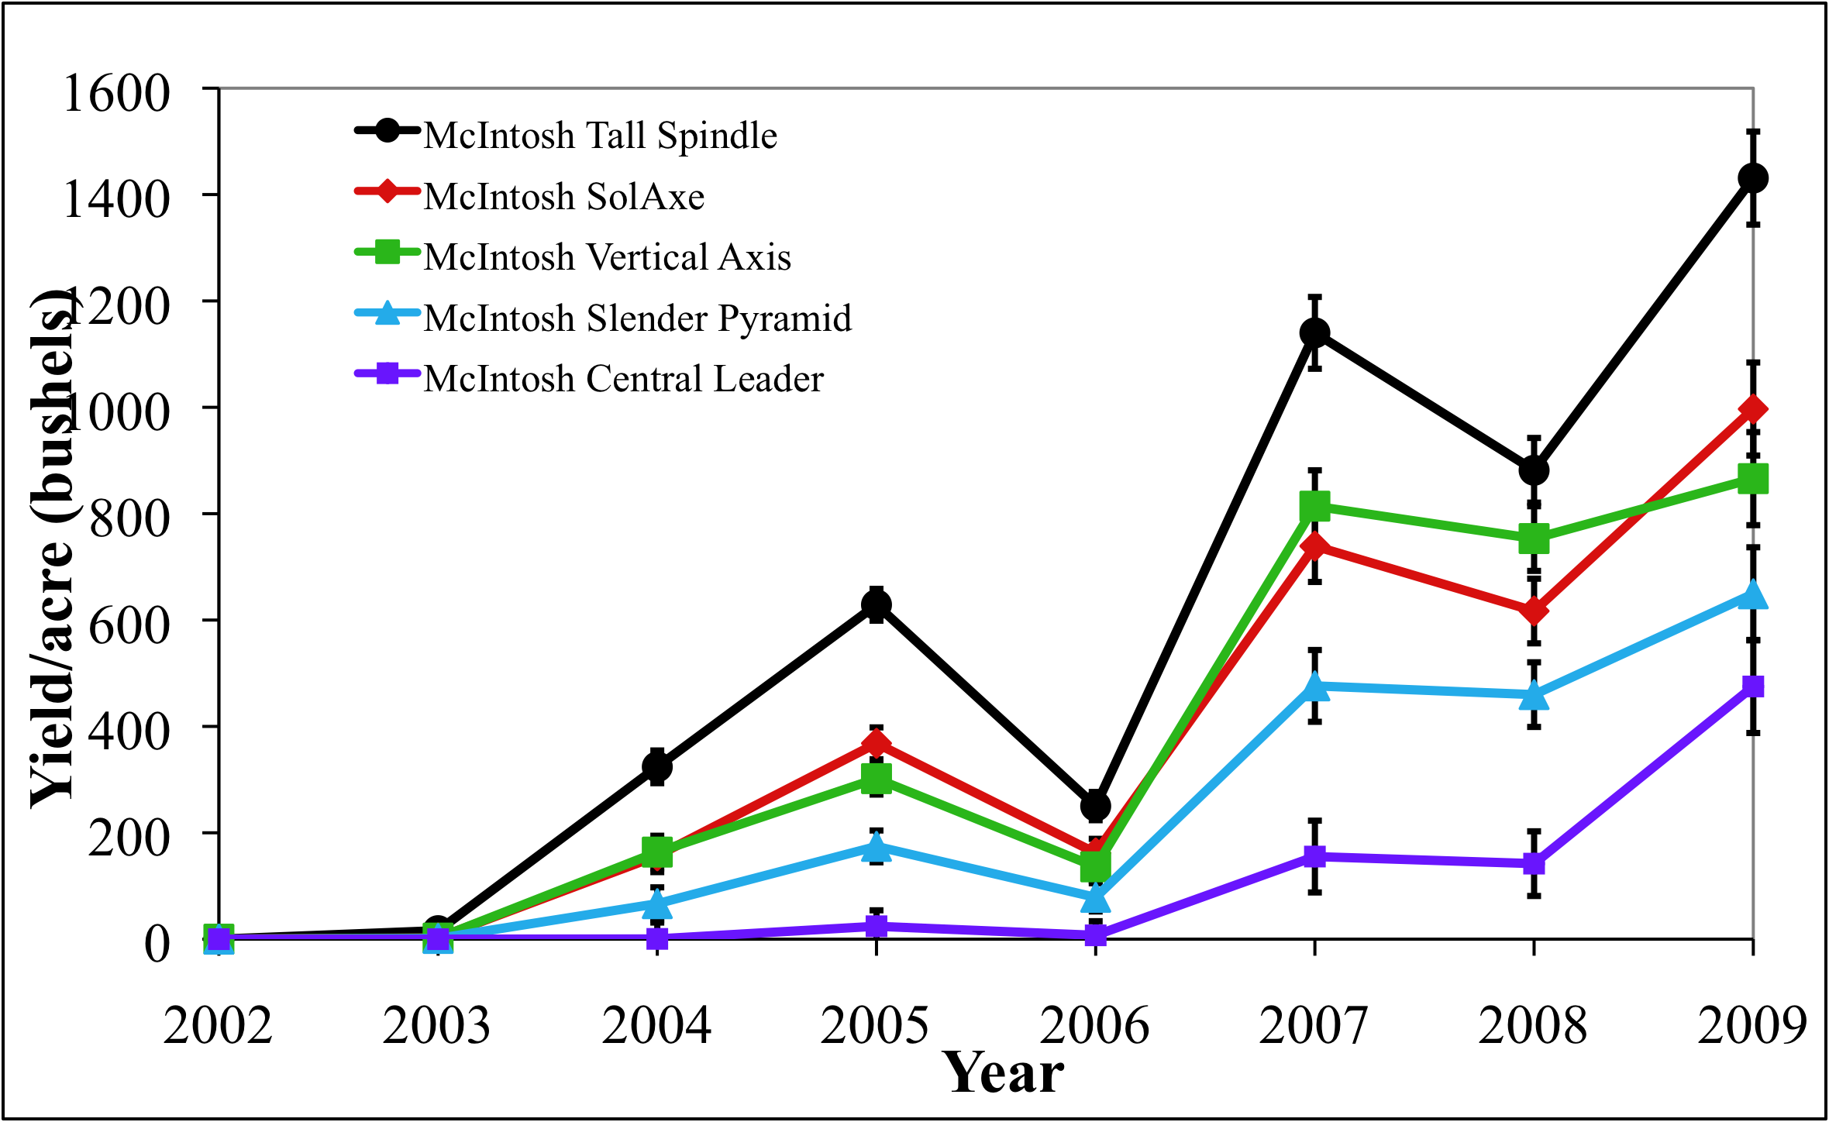
Figure 1. Annual yields of McIntosh apple trees trained to 5 orchards systems over the first 8 years in the Champlain Valley.
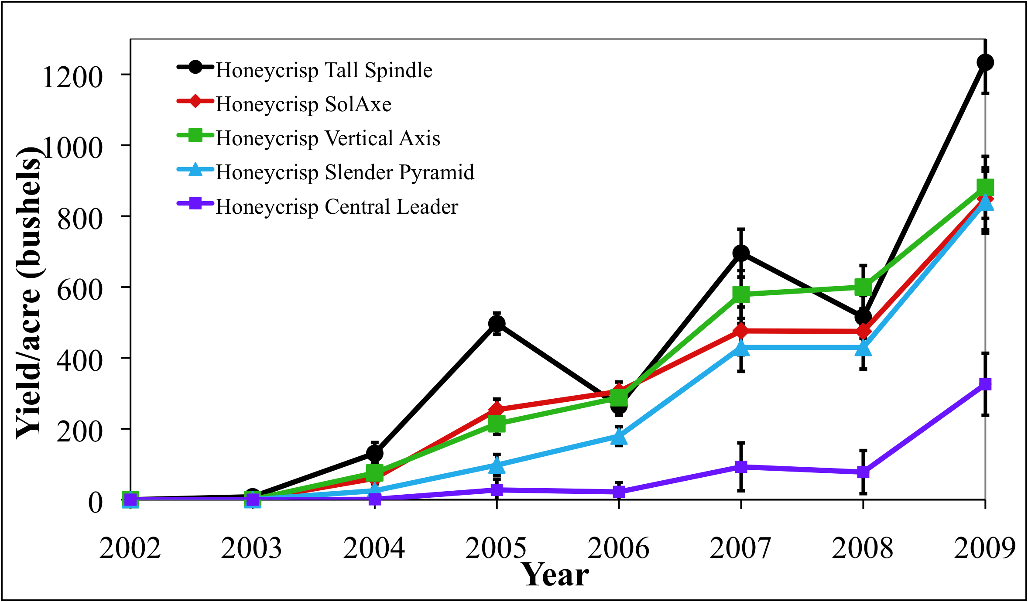
Figure 2. Annual yields of Honeycrisp apple trees trained to 5 orchards systems over the first 8 years in the Champlain Valley.
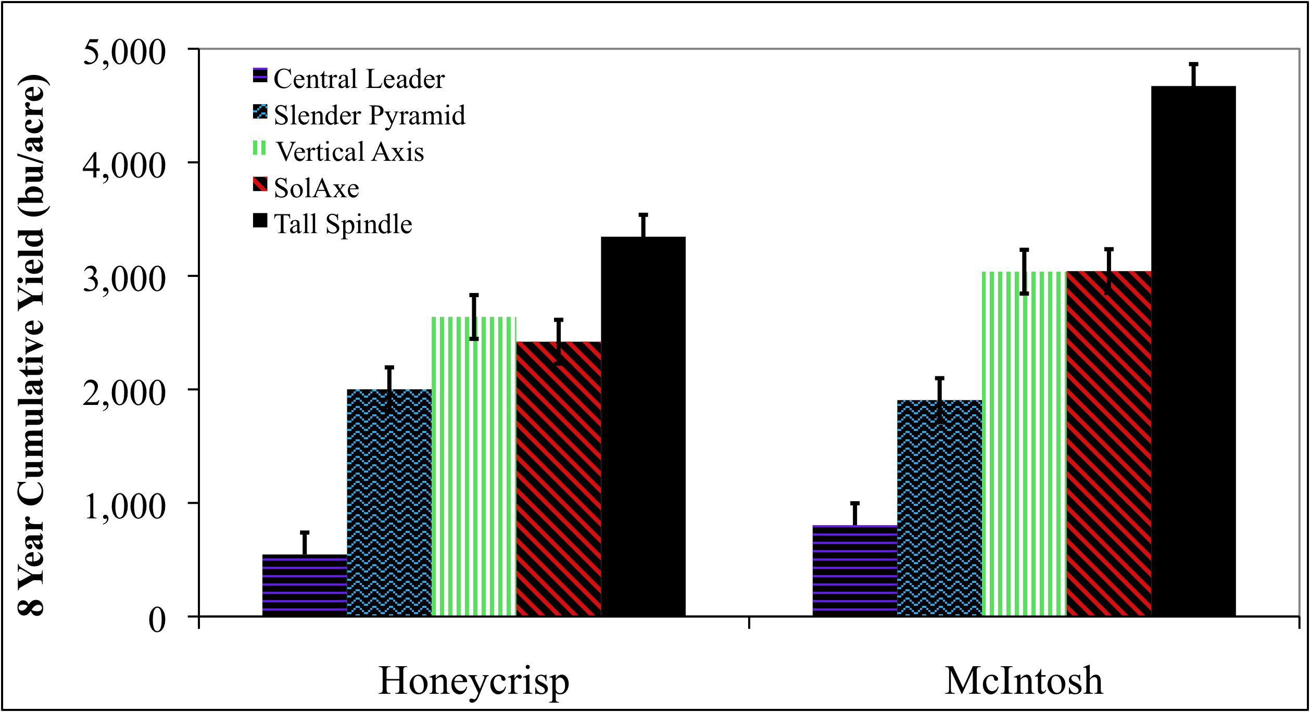
Figure 3. Cumulative yields of Honeycrisp and McIntosh apple trees trained to 5 orchards systems over the first 8 years in the Champlain Valley.
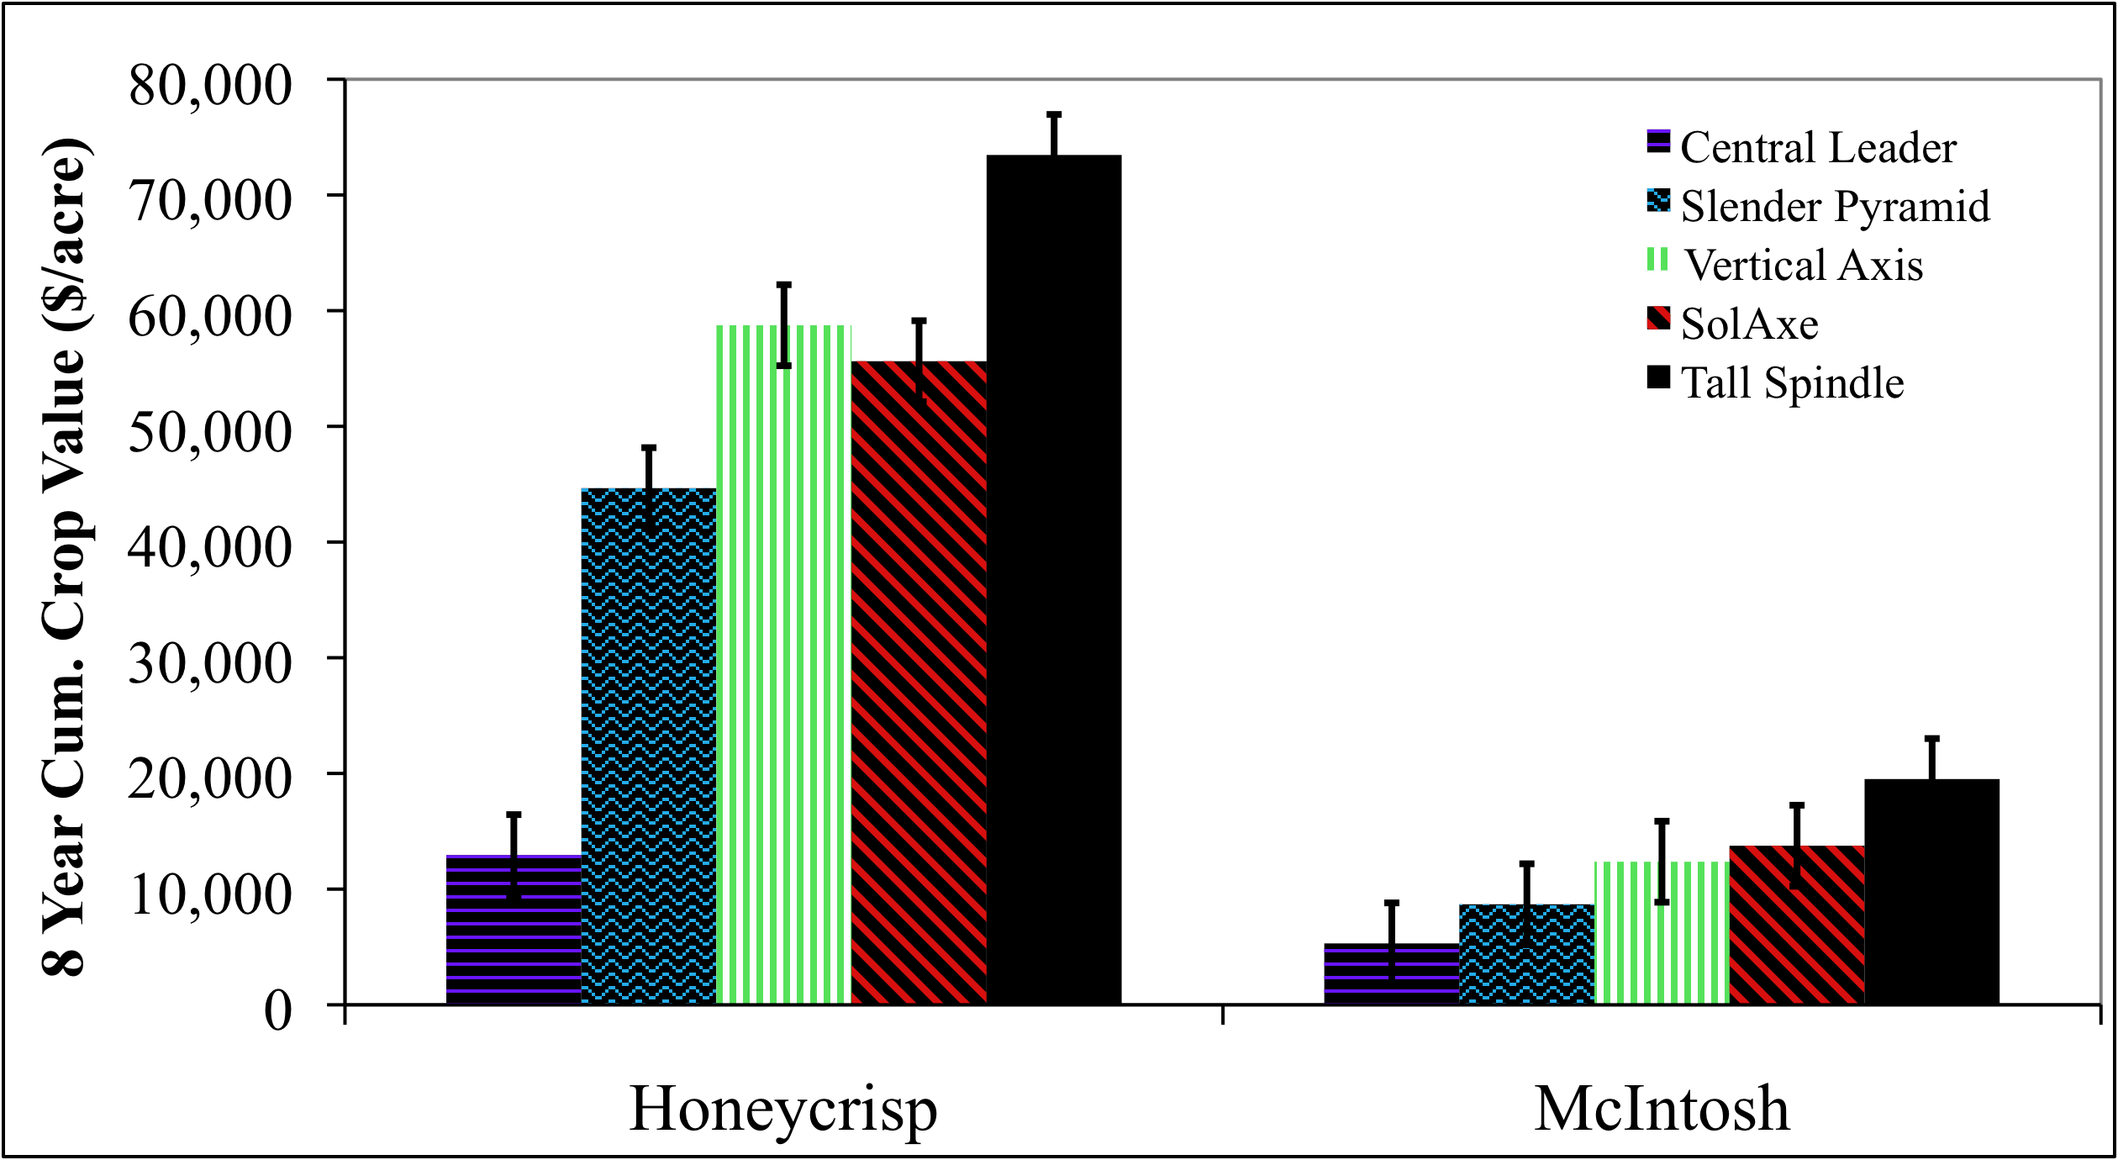
Figure 4. Cumulative crop value of Honeycrisp and McIntosh apple trees trained to 5 orchards systems over the first 7 years in the Champlain Valley.
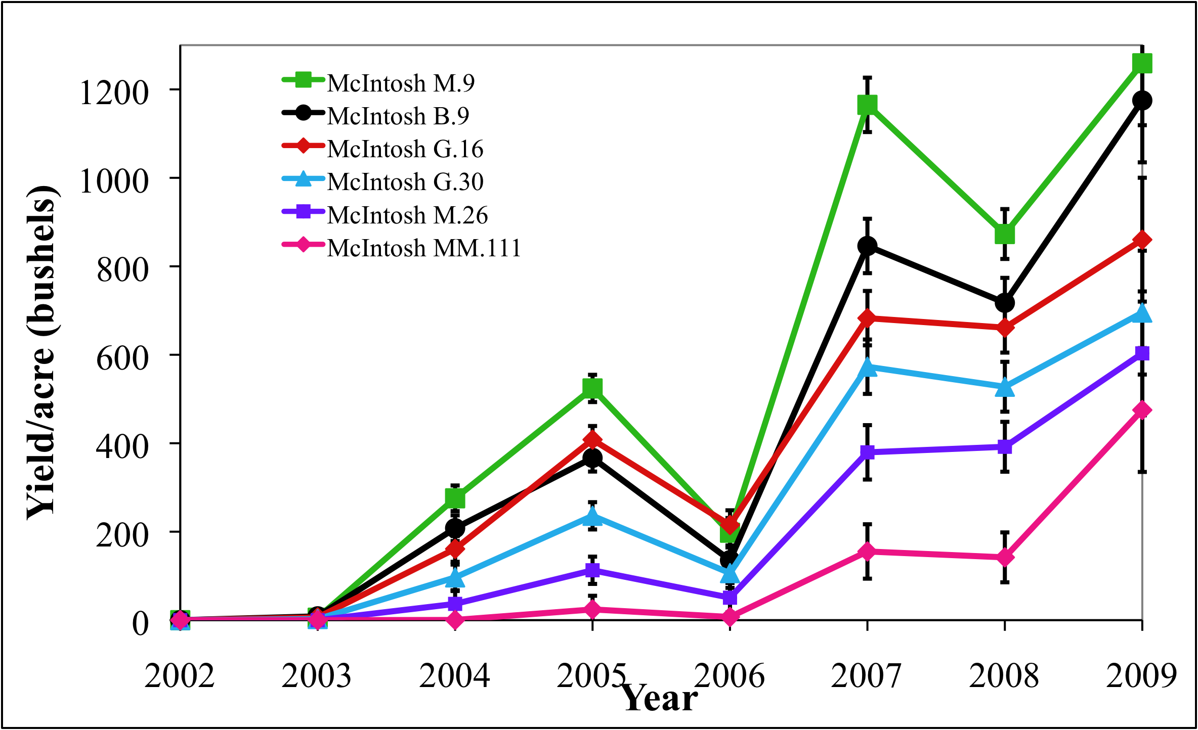
Figure 5. Annual yields of McIntosh apple trees grown on 6 rootstocks over the first 7 years in the Champlain Valley.
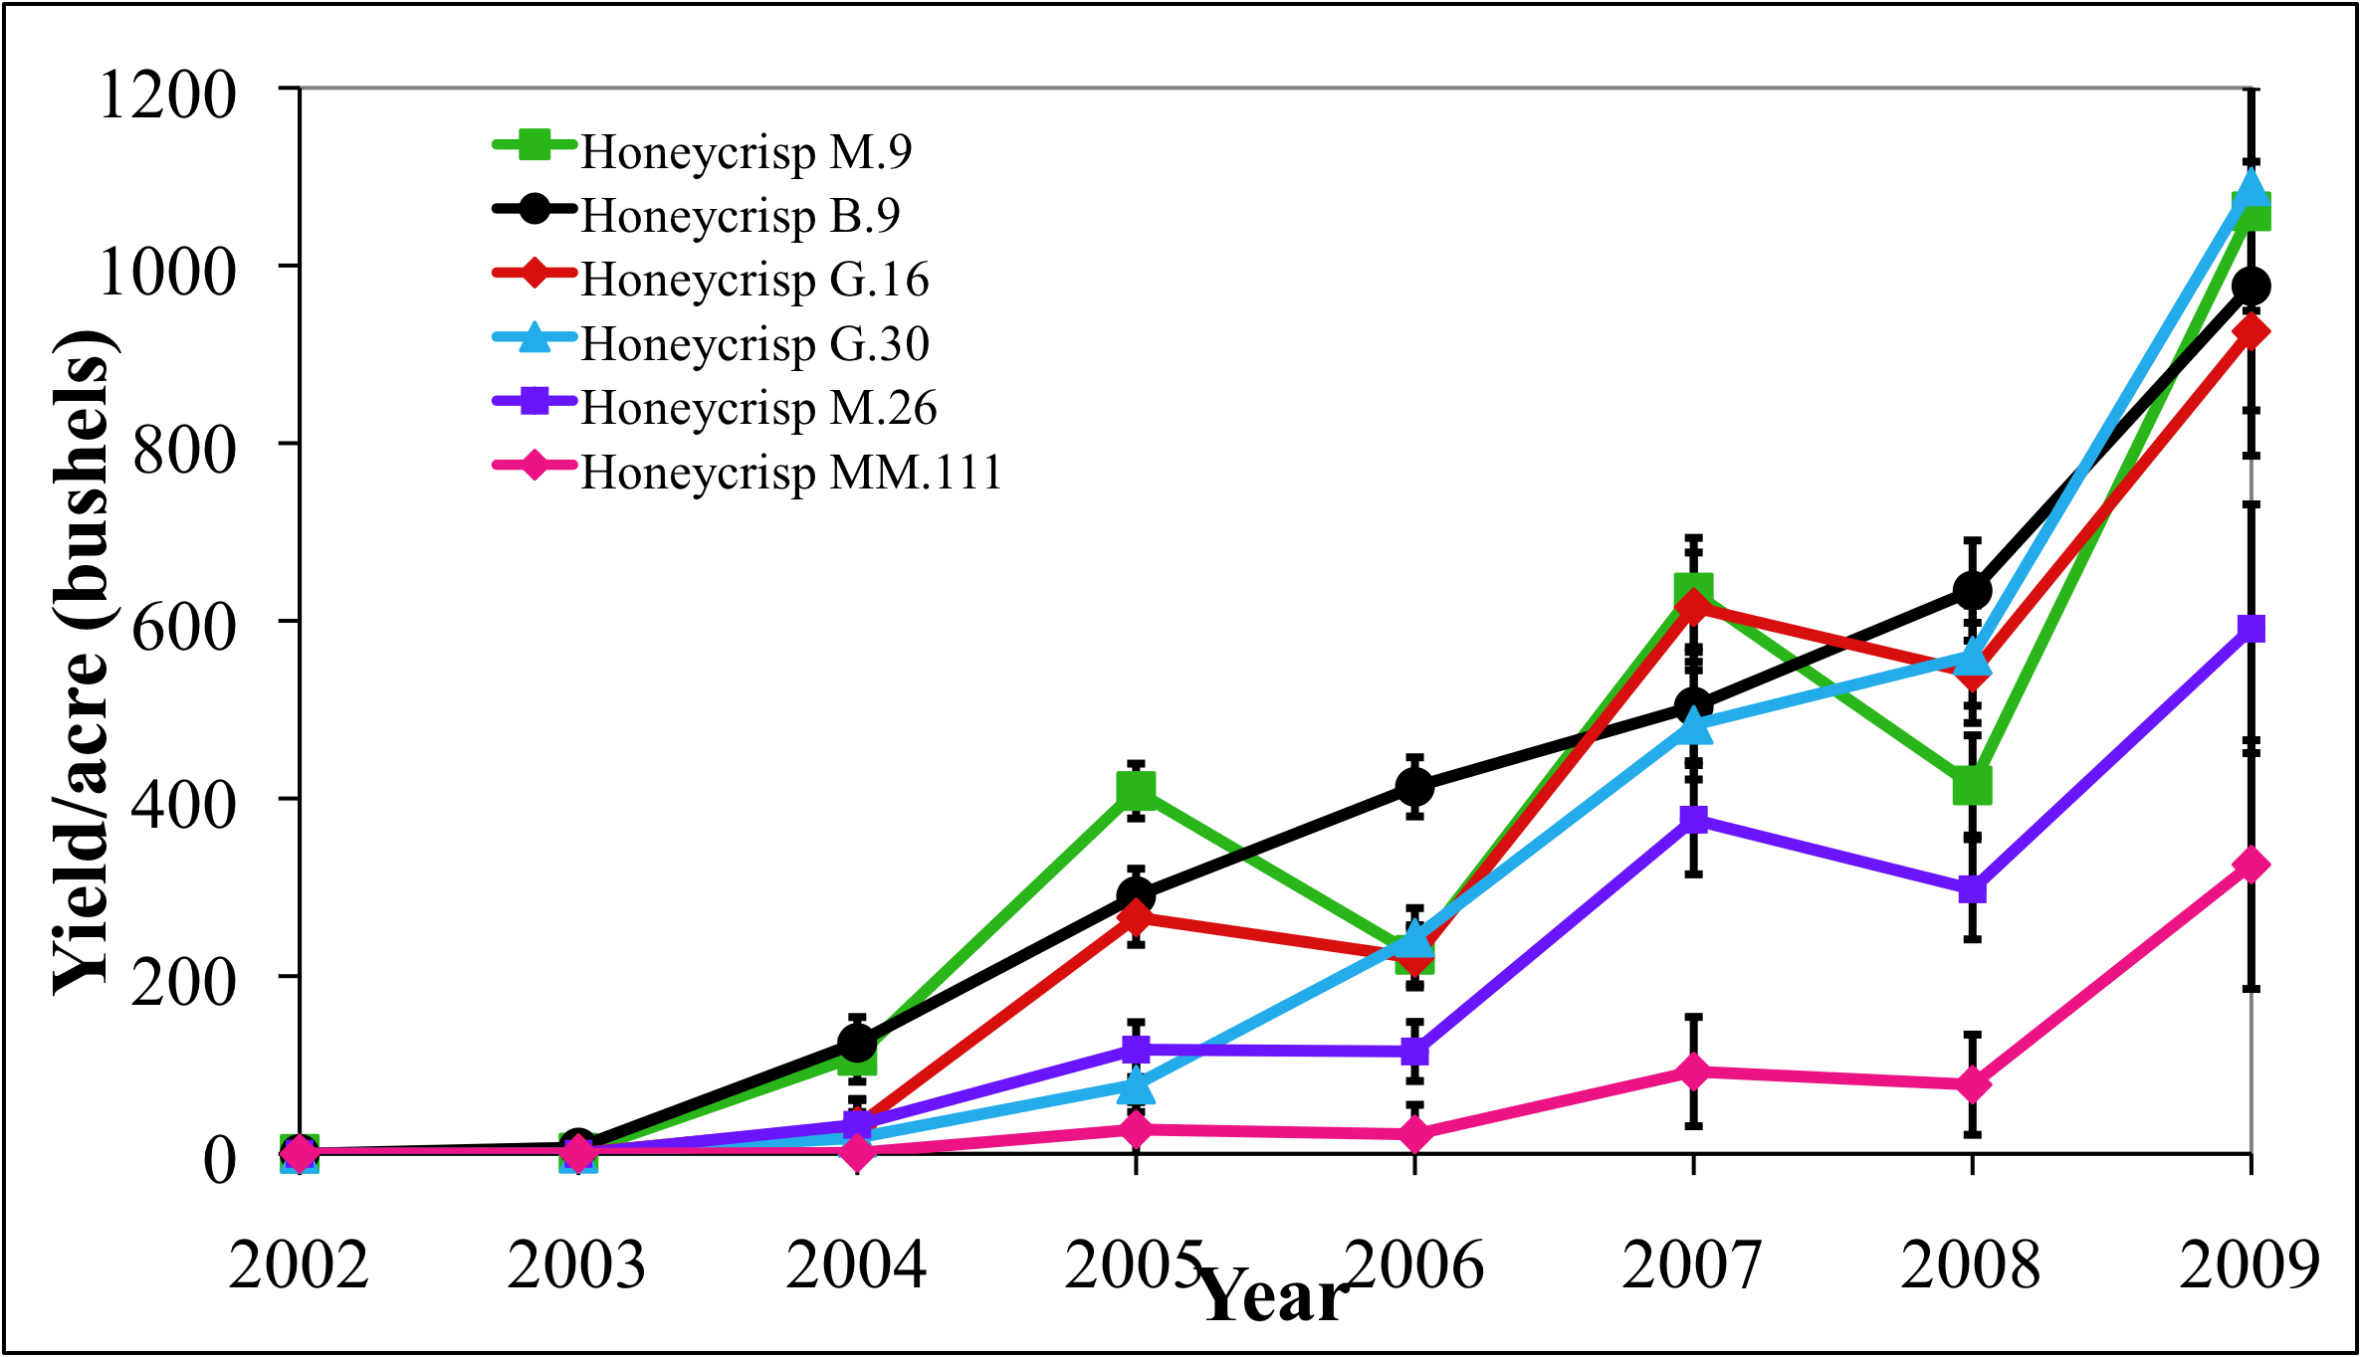
Figure 6. Annual yields of Honeycrisp apple trees grown on 6 rootstocks over the first 7 years in the Champlain Valley.
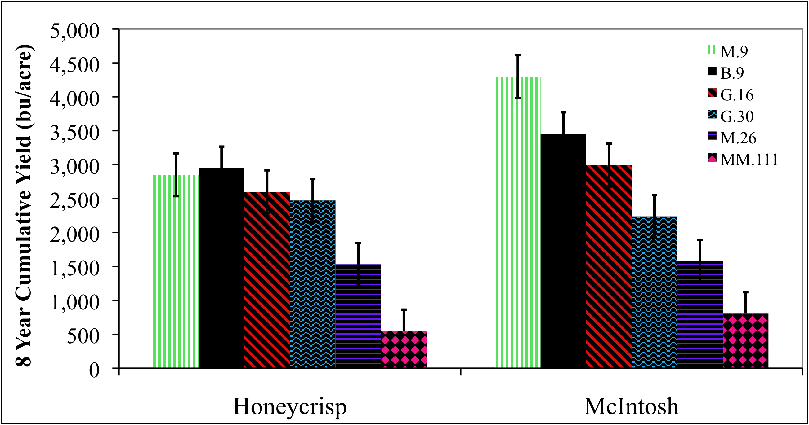
Figure 7. Cumulative yields of Honeycrisp and McIntosh apple trees grown on 6 rootstocks over the first 7 years in the Champlain Valley.
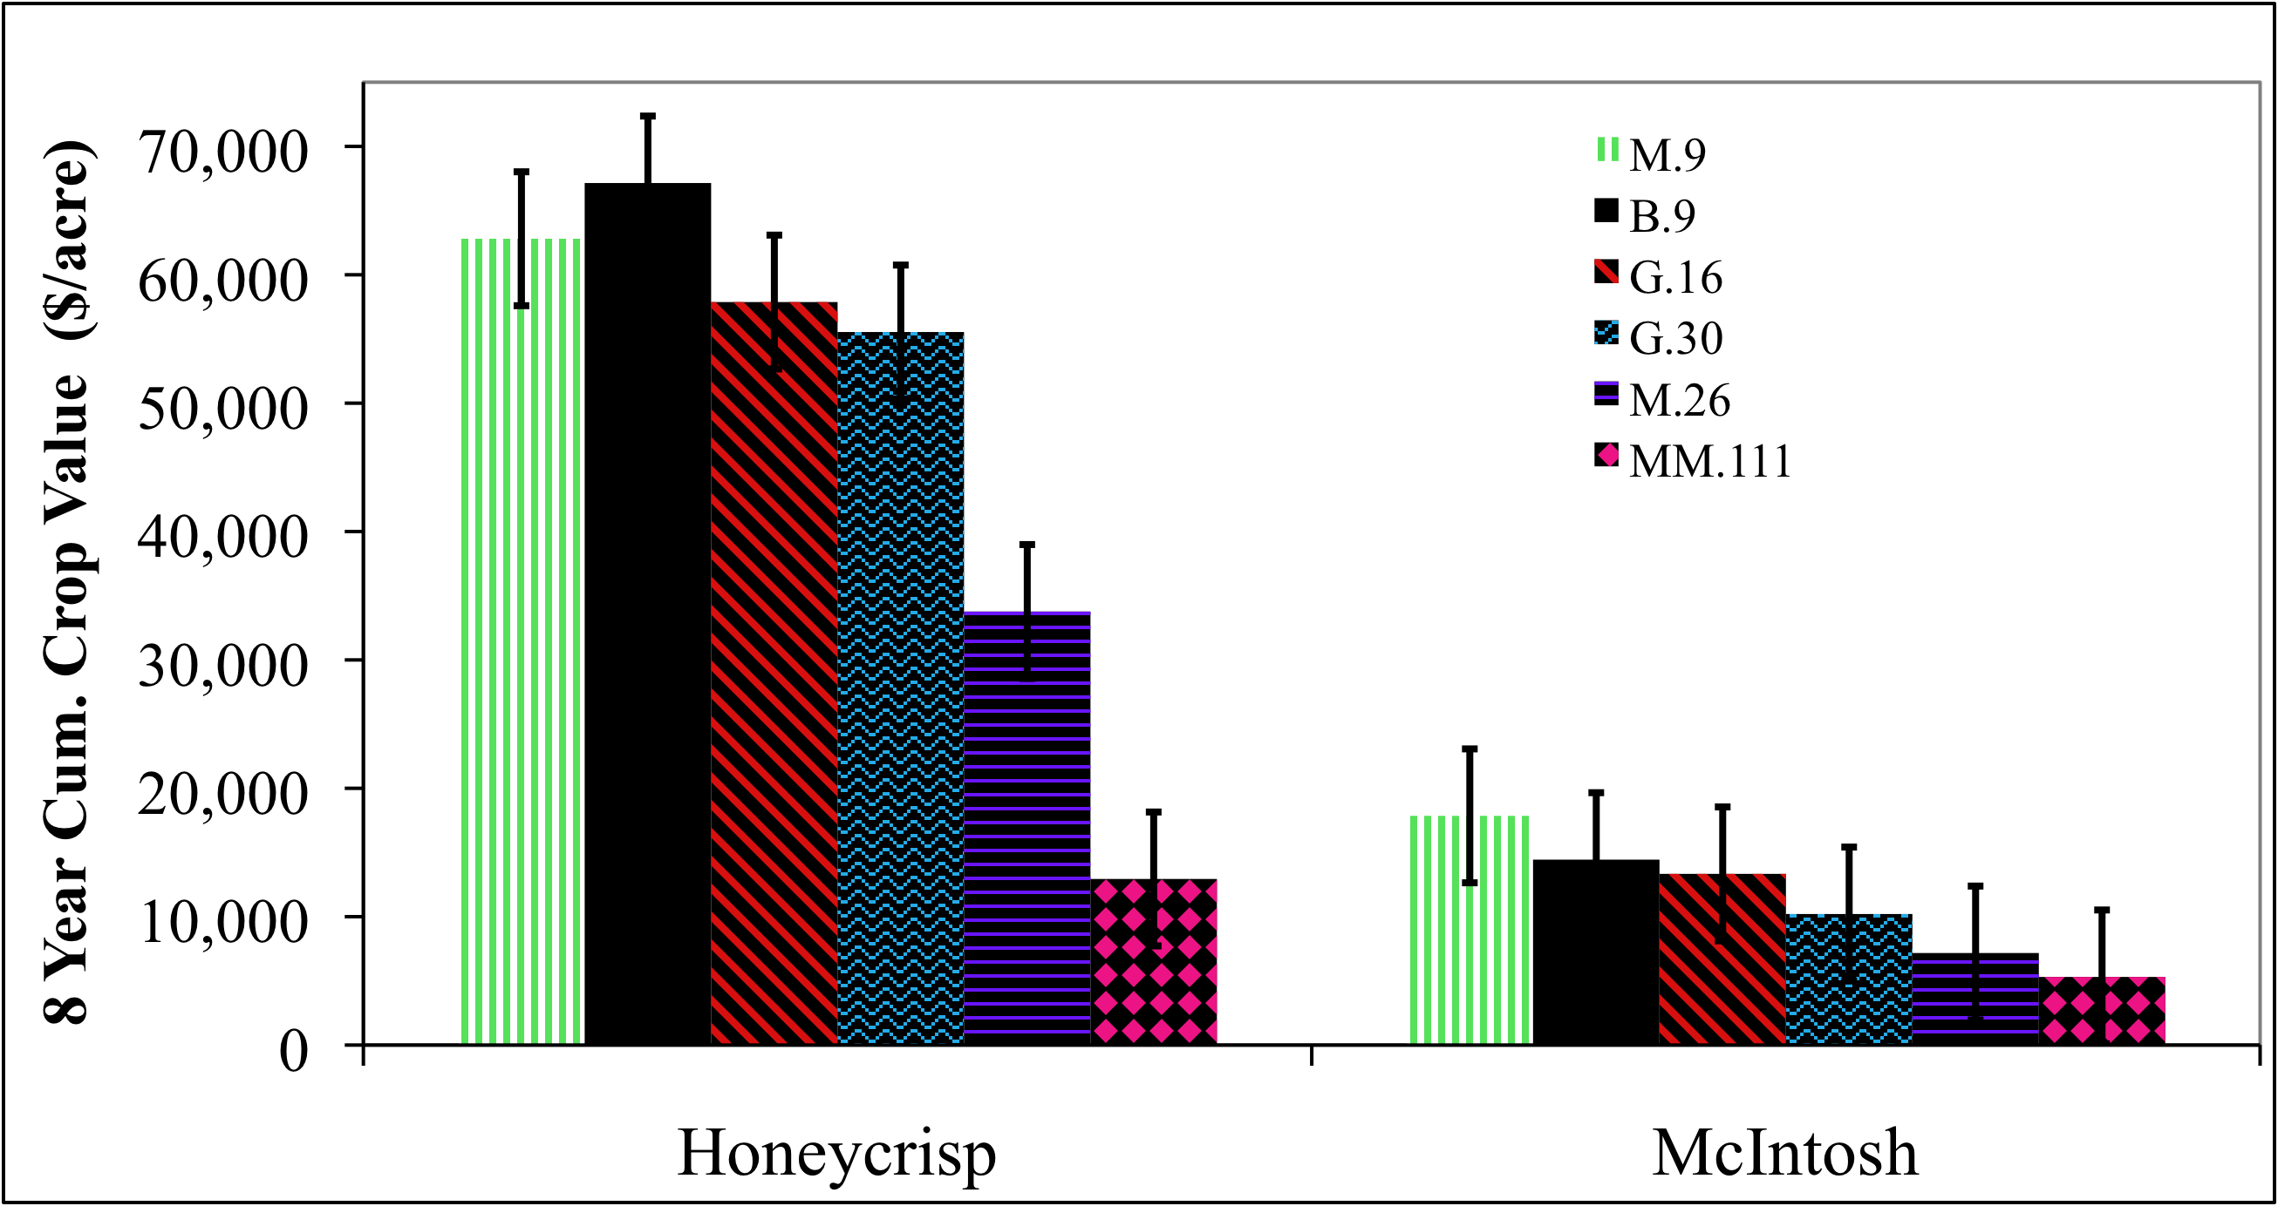
Figure 8. Cumulative crop value of Honeycrisp and McIntosh apple trees grown on 6 rootstocks over the first 7 years in the Champlain Valley.
Predicting Chemical Thinning study (Figures9):
We used a computer model and weather data from the weather station owned by Adam Sullivan of Sullivan Orchards in Clinton County to calculate in real time the carbohydrate status of trees in the Champlain Valley during the thinning period in late May and early June. This estimate of carbohydrate status was used to predict thinning response of apple trees in Clinton County. We presented the data in Figure 9 at the thinning meeting on Friday May 29.
We interpreted the 2009 data as follows:
1. The heat on Thursday May 21 and Sunday May 24 created a significant carbohydrate deficit. Any thinners applied just before or during the heat likely caused some thinning but not excessive thinning. For most of the Champlain valley this period was before petal fall sprays were applied

2. After petal fall there was a period of three days of carbohydrate deficit (Wed May 27- Sat May 30. Thinners applied on Wed May 27 likely gave moderate thinning.

3. Since Sunday there has been a period of carbohydrate surplus which is predicted to continue all week through Sunday June 8. This will result in a mild response from thinners applied during this period. Thus full rates of thinners should be during this period depending on fruit set and whether thinners were applied at petal fall. The best window appears to be Wed-Friday since it will be sunny with temperatures approaching 70. However, remember that the sunny conditions with mild temperatures make the trees have a carbohydrate surplus and will make them resistant to thinning action. Therefore full rates are recommended where set is good.

4. Beginning Tuesday June 8 we will enter a period of carbohydrate deficits caused by cloudy and rainy conditions. Thinners applied during this period are predicted to give aggressive thinning if fruit size is not larger than 16mm. Moderate rates are suggested for this period.

Summary. It appears that the best window for thinning is Wed-Friday of this week. Full rates should be used unless there was frost damage or bloom was light. All locations should be thinned before Tuesday June8 when we will enter a period of carbohydrate deficits.

Carbohydrate Supply Curves for Peru 5/28/09
Figure 9. Carbohydrate balance and maximum and minimum temperatures at Peru, NY in the Champlain Valley during the chemical thinning period. The gray box is the period when most commercial growers sprayed chemical thinners.
Fig. 10. Thinning index from full bloom to 3 weeks after petal fall for the Champlain Valley in 2009. The gray box is the period when fruit size was appropriate for chemical thinners.
Control of pre-harvest drop study (Figures 11-13):
In 2009, temperatures in August and September were cooler than normal. As a consequence fruit drop was low in the Champlain Valley until late in the harvest season.
At Chazy orchards in the Champlain valley pre-harvest fruit drop from untreated control trees remained low until late Sept. when significant drop began. In our plot drop did not exceed 20% until Oct 1 but by Sept 8 had reached 70% drop. NAA applied on Sep 8 did reduce drop at any date. Retain reduced fruit drop whether applied on Aug 21, (4 weeks before harvest) or Sep 4 (2 weeks before harvest) however the efficacy was much better when applied 2 weeks before harvest than 4 weeks before harvest. The addition of 20ppm NAA to the Retain sprays on Sep 4 improved the performance of Retain especially late in the season and was the best treatment. When the rate of Retain was cut in half (166g/acre) and NAA was added to the spray solution the efficacy in reducing drop was intermediate between the full rate or Retain without NAA and the full rate of Retain with NAA. The low rate of Retain on Sept 4 plus NAA had similar efficacy to the full rate of Retain applied on Aug 21. It appears that in the Champlain valley if Retain is applied too early its effects wear off by the time massive drop begins in late September. The impact of the NAA in the spray mixtures on fruit quality after storage has not yet been determined.
The results of this study indicate that Retain plus NAA applied 2 weeks before anticipated harvest gives excellent drop control and better results than either product applied alone.

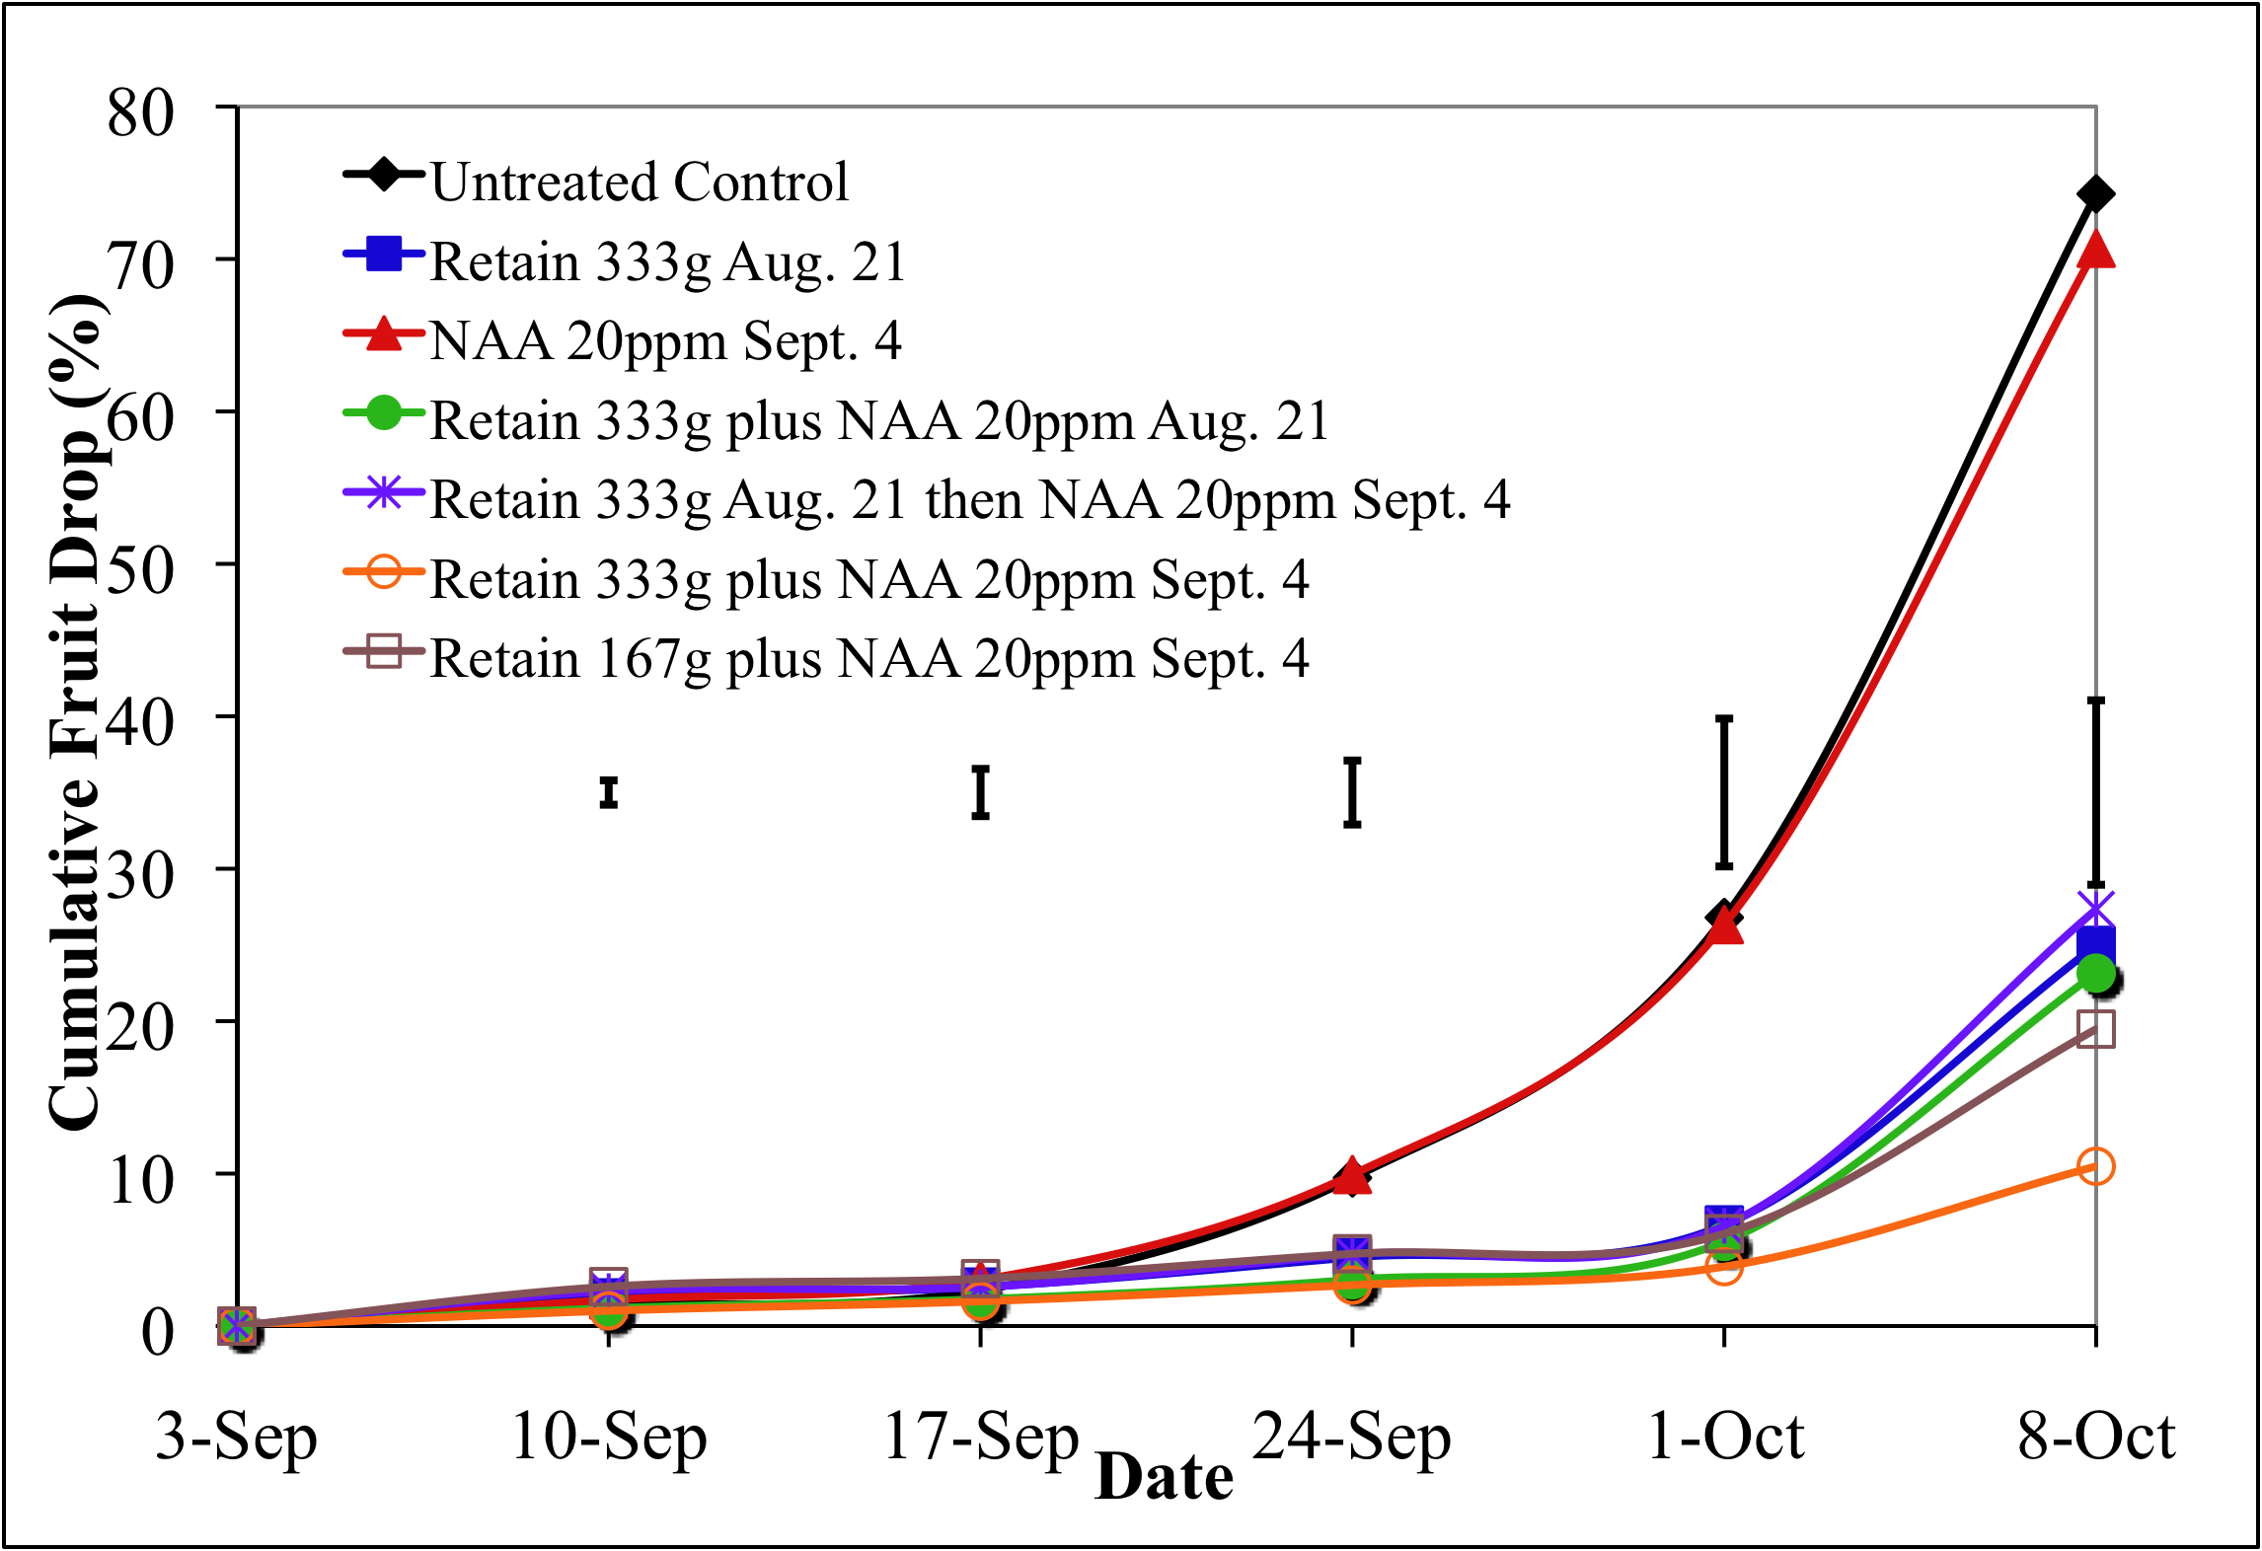
Figure 11. Effect of Retain, NAA and Retain+NAA on fruit drop of McIntosh/M.26 apple trees in the Champlain Valley, NY (2009).

Education and Outreach Efforts
In 2009 we conducted a vigorous extension and outreach program with this project. In March 2009 we conducted a winter pruning workshop in the orchard systems plot on Everett Fruit Farm to teach tree pruning and training for high density orchards. In May 2009 we conducted a chemical thinning workshop at Seth Forrences fruit farm. In Aug. 2009 we conducted a summer field day where the orchard systems and rootstock plots were featured. We published several articles in the NY Fruit Quarterly magazine which were sent to all tree fruit growers in the state.. We will make a presentation in Feb 2009 at the Statewide Hort Expo in Syracuse and later in Feb. 2009 at the Northern NY winter fruit schools on orchard modernization.
Publications in 2009 for growers from this project:
Marini, R.P. B. Black, R.M. Crassweller, P.A. Domoto, C. Hampson, S. Johnson, K. Kosola, S. McArtney, J. Masabni, R. Moran, R.P. Quezada, T. Robinson, and C.R. Rom. 2009. Performance of ‘Golden Delicious’ apple on 23 rootstocks at 12 locations: A five-year summary of the 2003 NC-140 dwarf rootstock trial. J. Amer. Pom. Soc. 63:115-127.
Oliver, J. E., J. Freer, R. L. Andersen, K. Cox, T. L. Robinson, and M. Fuchs. 2009. Genetic Diversity of Prunus necrotic ringspot virus Isolates Within a Cherry Orchard in New York. Plant Disease 93:599-606.
Robinson, T.L. 2008. Performance of pear and quince rootstocks with three cultivars in four high density training systems in the Northeastern United States. Acta Hort. 800:793-801.
Fazio, G., D. Kviklys, and T. Robinson. 2009. QTL mapping of root architecture traits in apple rootstocks. HortScience 44:986-987 (Abstr.).
Lopez-Cuevas, S., T. Robinson. 2009. Effects of nitrogen, potassium, irrigation and crop load on ‘Honeycrisp’ fruit quality. HortScience 44:1011-1012 (Abstr.).
Robinson, T.L., G. Reginato, D. Kviklys and S.A. Hoying. 2009. Yield and fruit size independent of crop load of six peach planting systems. 7th International Peach Symposium Abstracts. p. 56.
Robinson, T. 2009. Performance of AVG and NAA in controlling pre-harvest drop of ‘McIntosh’ apples. 11th International Symposium on Plant Bioregulators in Fruit Production Abstracts. p. 41.
Kviklys, D and T. Robinson. 2009. Effect of temperature before and after application of chemical thinners on thinning of ‘Empire’ apple trees. 11th International Symposium on Plant Bioregulators in Fruit Production Abstracts. p. 144.
Robinson, T., S. Lopez and K. Iungerman. 2009. Thinning and summer PGR’s for consistent return bloom of ‘Honeycrisp’ apples. 11th International Symposium on Plant Bioregulators in Fruit Production Abstracts. p. 168.
Robinson, T.L., G. Bujdoso and G. Reginato. 2009. Influence of Pruning Severity on Fruit Size of ‘Sweetheart’ and ‘Lapins’ Sweet Cherry Grown on Gisela Rootstocks. 6th International Cherry Symposium Abstracts. p. x.
Robinson, T.L., and S. Hoying. 2009. Training System and Rootstock Affect Yield, Fruit Size, Fruit Quality and Crop Value of Sweet Cherry. 6th International Cherry Symposium Abstracts. p. x.
Robinson, T.L. 2009. The next frontiers in orchard systems. Proceedings Great Lakes Fruit Workers Annual Meeting 2009:12 (Abstr.)
Agnello, A.M., A. Landers, D.A. Rosenberger, T.L. Robinson, J.E. Carroll, L. Cheng, P.D. Curtis, D.I. Breth, and S.A Hoying. 2009. Pest management guidelines for commercial tree-fruit production 2009. Cornell University, Ithaca NY 252 pp.
Cheng, L. and T.L. Robinson. 2009. Honeycrisp leaf chlorosis: Causes and mitigation. Proc. of the 2009 Empire State Fruit and Veg. Expo. p. 37-39.
Robinson, T.L. 2009. Improved Apple Orchard Management Systems and Rootstocks for Northern NY. Northern New York Agricultural Development Program Final Report 2008. pp 156-170.
Robinson, T.L. 2009. Fertigation of apple trees in humid climates. Proceedings of In-depth Fruit School on Apple Mineral Nutrition. pp 53-65
Robinson, T.L. and S.A. Hoying. 2009. Fine points to consider when making planting system decisions. Proc. of the 2009 Empire State Fruit and Veg. Expo. p. 1-4.
Robinson, T.L., and S.A. Hoying. 2009. Fine points to consider when making planting system decisions. Ohio Produce Growers and Marketers Association Today Fall issue p.xx-xx
Robinson, T.L. and A.N. Lakso. 2009. Predicting and understanding chemical thinner response in real time. Proc. of the 2009 Empire State Fruit and Veg. Expo. p. 43-45.
Robinson, T.L. and S. Lopez. 2009. Cropload management for consistent Honeycrisp apples. Proc. of the 2009 Empire State Fruit and Veg. Expo. p. 40-42
Robinson, T.L., R.L. Andersen and J. Freer. 2009. Promising new rootstocks for cherries, peaches and plums. Proc. of the 2009 Empire State Fruit and Veg. Expo. p. 10-13.
Robinson, T.L., S.A. Hoying and R.L. Andersen. 2009. Growing High Density Sweet Cherries in the East. Ohio Produce Growers and Marketers Association Today Fall issue p.3-5.
Robinson, T.L., A.N. Lakso, and S.A. Hoying. 2009. Chemical thinning and return bloom of apple. Ohio Produce Growers and Marketers Association Today Summer issue p.4-6.
Robinson, T.L., S. Lopez, K. Iungerman, and G. Reginato. 2009. Cropload and nutrition affect Honeycrisp apple quality. Proceedings of In-depth Fruit School on Apple Mineral Nutrition. pp 87-95.
Robinson, T., S. Lopez, K. Iungerman and G. Reginato. 2009. Crop load management for consistent production of ‘Honeycrisp’ apples. NY Fruit Quarterly 17(1): 24-28.
Robinson, T., and S. Lopez. 2009. Crop load and nutrition affect ‘Honeycrisp’ apple quality. NY Fruit Quarterly 17(2): 25-28.
Robinson, T., M. Miranda-Sazo, C. Kahlke. 2009. Suggestions for use of Retain on apples in WNY. Lake Ontario Fruit Newsletter 2009(17):6-8.
Robinson, T. and S. Hoying. 2008. High-density planting systems and dwarfing rootstocks for sweet cherries in the Northeast: Progress Report. Compact Fruit Tree 41:24-36.
Robinson, T.L. and S.A. Hoying. 2008. Successful high density apple orchards. Journée Pomicole Provinciale 2008:23-31.
Robinson, T.L. and A.N. Lakso. 2008. Predicting and understanding chemical thinner response in real time. Journée Pomicole Provinciale 2008:34-41.
Robinson, T.L. and A.N. Lakso. 2008. Predicting and understanding chemical thinner response in real time. Proceedings Great Lakes Fruit Workers Annual Meeting 2008:15-18.
Robinson, T., G. Fazio and S. Hoying. 2008. Intermediate stage evaluation of Cornell-Geneva and other promising rootstocks: Progress Report. Compact Fruit Tree 41:27-32.
Lopez-Cuevas, Sergio. 2009. Effect of ground and foliar fertilization, irrigation and cropload on yield, fruit quality at harvest and after cold storage of 'Honeycrisp' apple. Ph.D. Thesis. Cornell University, Ithaca, NY.

