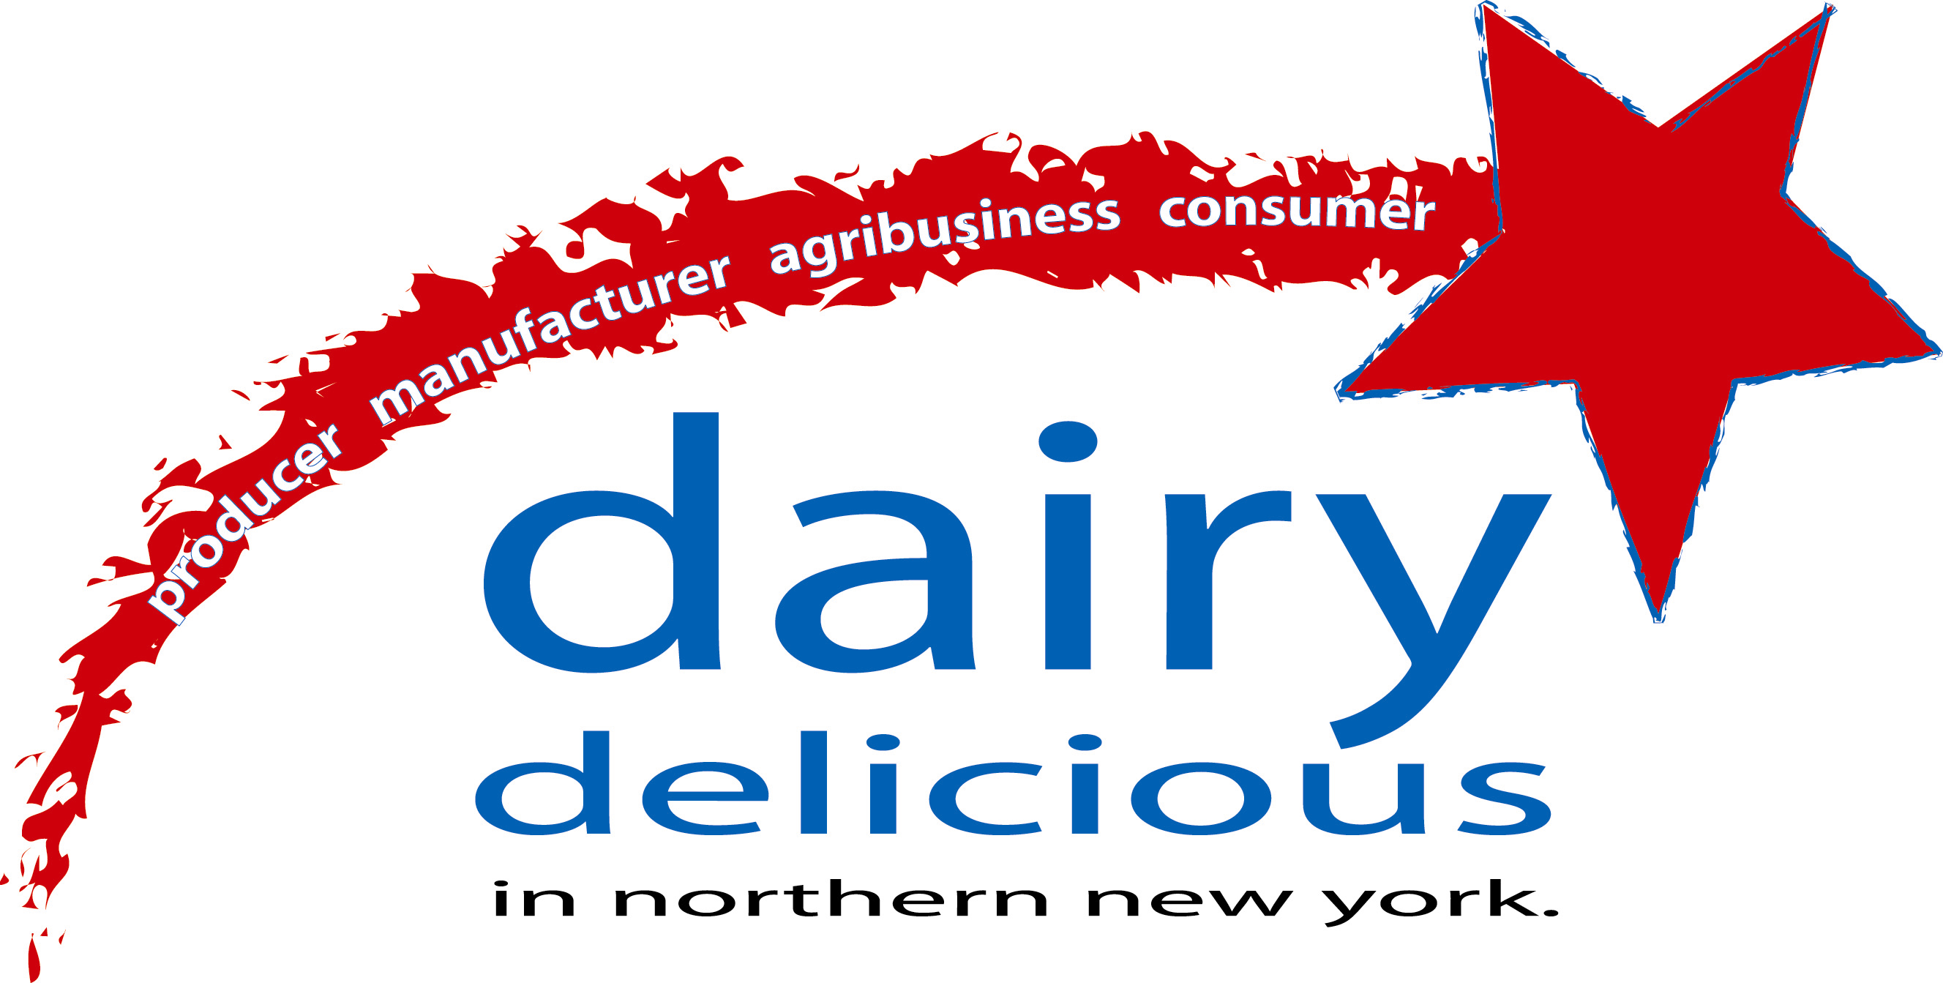

Thriving Dairy Farms: the Cornerstone of a Thriving Dairy Industry in the North Country!

Dairy farm businesses continue to be impacted by many changes occurring both locally and nationally. It is often difficult to sort out fact from emotion to determine the reality facing dairy business owners and managers. This article attempts to put into perspective some of the seeming contradictions in the trends impacting the industry as a whole and arrive at some essential truths that should be understood by serious business owners and managers. It is important to look at the situation from a system perspective since dairy producers, while at the core of the industry, are a part of a larger picture that includes processors, manufacturers, supporting businesses and ultimately consumers.

- Surplus or Shortage?

  - As evidenced by CWT, a program implemented by national dairy cooperatives to reduce the surplus of milk supply that exists in some regions, individual producers are negatively impacted by low prices created when imbalances exist between demand and supply. This program was considered by most to be effective in removing milk supply and did so in areas of the country that is not blessed with the fluid market that we have. The northeast has the largest Class I market in the country. That gives us opportunities that do not exist anywhere else in the country.

  - While there is strong demand for fluid milk here, some manufacturers and processors are sometimes running plants under capacity. This fact disadvantage these firms in relation to competitors located in areas where there is plenty of milk supply but less demand for fluid milk. It discourages these firms from updating and expanding their facilities. While it is seemingly a contradiction, most industry experts agree that we need to increase the milk supply in the northeast to maintain a solid industry as a whole. Otherwise we will be increasingly at a competitive disadvantage in relation to other areas of the country. Even with a growing supply in the northeast, milk prices will continue to be volatile, responding to relatively small changes in supply and demand, but the alternative is worse. The prospect of losing a manufacturing plant means lost jobs, having to find a home for the milk that supplied that plant and potentially a decrease in the milk price to the farms closest to the plant. Of course there will be changes; plants will change hands, outdated facilities will be renovated or shut down and new, unexpected players will come on the scene. If we act proactively, the North Country can continue to benefit from its enviable position in the Northeast.
- How do we get more milk? Does that mean more large farms? Do profitable dairy farm businesses have to be large? Just because a farm is large, are they profitable?

  - Profitable farms come in all sizes and shapes. Numerous studies have shown that there is not a cookie cutter answer to dairy farming. It is not a “one size fits all” profession. Each owner and manager must determine their own strategy for generating profits sufficient to meet their business goals. What is clear is that production per cow in NY State is lagging behind the national average. What is clear is that many businesses could improve their profitability by increasing production per cow and increasing net profit per cow AND put more money in their own pocket at the end of the day. Yet only a relatively small portion of dairy farms participate in some farm of benchmarking, either with their lender or Extension. Why? Many farms do not utilize the existing resources available to them to maximize their returns. Why?

- What can any one individual do? Are all these factors outside the control of the owner or manager? Can a commodity dairy farm have a strategy? Farm businesses, dairy included, arguably require some of the most entrepreneurial skills imaginable. It requires a full range of skills from production and technical to marketing and decision making. And yet dairy farm owners and managers can easily get discouraged into thinking they have little or no control over their destinies. While much of the trends impacting dairy farm businesses are global or national, there are a myriad of details that go into profitability, all of which are very much within the control of the owner and manager. These details can be managed if they are monitored. “If you can’t measure it, you can’t manage it.”

Benchmarking: Measure, Monitor & Compare

The best and brightest dairy farm managers and experts will never agree on what factors to measure and monitor but here are some basic facts that every dairy farm owner and manager should measure.

  - Income over feed costs – (I suggest using a constant milk price)
  - Milk income per cow at $12 per cwt
  - Some form of a Pregnancy rate
  - Some form of a Mastitis rate
  - Average cost of raising a replacement heifer to calving age

Notice that milk production per cow is not on my list. It is there behind the scenes. Each of these factors involves production per cow but they are kept grounded in the bottom line profitability of the business. Armed with information, owners and managers can make a comparison to an industry average. If there is room for improvement, which there almost always is, then the fun begins. By narrowing down what areas need investigation, the owner or manager can then investigate the underlying causes. There is plenty of support and assistance available to the process.

I often wonder whether owners and managers that do not measure, monitor and compare would drive their car without any gauges, meters or a map. Would they set off on a trip without any destination in mind? If they got lost, would they stop and ask directions? Another analogy is to a person who suspects they are ill but puts off going to the doctor. They are afraid of information. Yet doing nothing does not delay the outcome and the fear and uncertainty can be depressing and debilitating.

The dairy farm business managers that do monitor and measure inevitably begin to make improvements. They set goals and objectives which, sometimes with very little effort, they begin to achieve. You often hear coaches encourage their athletes to “visualize success.” In Stephen Covey’s book “Seven Habits of Highly Effective People” he suggests, “Begin with the end in mind.” Whatever the outcome, you need to be clear on what outcome you are looking for. By planting those desired outcomes firmly in your mind, you become a lot more likely to recognize and take advantage of opportunities that support achievement of your goals. Over time, the business will steadily move closer and closer to what you want it to be. If you want more information on benchmarking feel free to call me, Molly Ames at 788-8450. I can help you get started.

For more information on agricultural research, Cooperative Extension and the milk supply in the North Country:

Northern New York Agricultural Development Program’s web site is:
http://www.nnyagdev.org/index.htm

North Country Dairy Viability Initiative’s website is: http://www.nnyagdev.org/nnydairyfacts.htm

For information on strategies of successful small farms: http://www.nnyagdev.org/dairyfarmprofiles.htm

champions of the northern new york’s dairy industry
North Country Dairy Industry Viability Project PO Box 72, Outer Stowe Street Lowville, NY 13367
Peggy Murray, Project Manager Phone: 315-376-5270 Fax: 315-376-5281 E-mail: mlm40@cornell.edu

