

NNY Agricultural Development Program
2007-08 Project Report

Precise Nitrogen Management for Corn Production

Project Leader(s):
- Jeff Melkonian. Sr. Research Associate; Crop & Soil Sciences, Cornell University, Ithaca NY 14853; Tel: (607) 227-9172, E-mail: jjm11@cornell.edu
- Harold van Es. Professor and Chair, Crop & Soil Sciences, Cornell University; Tel: (607) 255-5459, E-mail: hmv1@cornell.edu
- John Idowu. Research Associate, Crop & Soil Sciences, Cornell University; Tel: (607) 255-1706, E-mail: oji2@cornell.edu
- Robert Schindelbeck. Extension Associate, Crop & Soil Sciences, Cornell University; Tel: (607) 255-1706, E-mail: rrs3@cornell.edu

Collaborator(s): Michael Davis: Manager, Cornell E.V. Baker Agricultural Research Farms at Willsboro and Cornell plots at W.H. Miner Agricultural Research Institute at Chazy. Anita Deming (CCE Essex County), Michael Hunter (CCE Jefferson County), and Carl Tillinghast (CCE Franklin County)

Background:
Deep placement of nitrogen (N) fertilizer for corn production.
Successful new soil tillage management practices for corn production include the use of ‘strips’ or ‘zones’ that involve deep localized soil loosening with minimal surface disturbance. These methods maintain crop residue cover, conserve soil, and increase soil health and crop yields. With these, farmers may also apply N fertilizer through deep placement (10-12”) at tillage prior to planting.

A three-year replicated on-farm study in western NY has demonstrated that the combination of zone tillage and the deep N placement boost corn yields and improve soil health, increasing average profit by $57/acre. In this study, UAN was applied at planting (deep N placement) and contained both a urease inhibitor (slows conversion of urea to ammonium for up to two weeks to reduce ammonia volatilization) and a nitrification inhibitor to slow the conversion of ammonium (less susceptible to leaching) to nitrate (more susceptible to leaching) for up to 6–8 weeks, approximately when corn begins rapid growth and N uptake. Both the deep N placement and nitrification inhibitor also may reduce denitrification losses on fine-textured soils as suggested in a Minnesota study. There have not been any controlled trials that evaluated the N dynamics associated with deep vs. shallow N placement on different soil types, nor determined the potential for reduced N rates with increased soil health. We established such a trial in 2007 and continued the trial in 2008.

Precision N application.
Nitrogen management for both silage and grain corn production continues to be a challenge for economic, agronomic and environmental reasons. Year-to-year variability in weather can affect the optimum fertilizer rate to meet crop N needs without over-fertilizing. Off-farm N losses from crop (particularly corn) production are receiving increased attention. Improving crop N use efficiency is, therefore, important for maintaining or improving farm incomes, and can also reduce N losses to the environment.

From past research, we quantified the effects of various fertilizer N and manure management practices on N losses associated with corn production (see Appendix 1). This research has shown a year-to-year variation in optimum N rates for corn of up to 80 lbs/acre that is due, in part, to variability in soil N as affected by early season weather. This range in optimum N rates represents an opportunity for more efficient use of N fertilizer. Based on this research, we have developed and calibrated a decision support tool (Adapt-N; url: http://adapt-n.eas.cornell.edu) that is based on the Precision Nitrogen Management (PNM) computer model.

The Adapt-N/PNM model decision support tool accounts for the impact of early season weather on soil N to provide more precise sidedress N recommendations for corn production. Dairy farmers are especially interested in such predictions, as fields are often manured based on estimated N availability, but may still require costly additional sidedressing in wet years.

Given the high N fertilizer prices and the increased regulatory pressure to reduce agricultural N losses, there is a need for improved N management for corn production in northern New York. This project seeks to encourage adoption of PNM-generated recommendations in the NNY region.

Estimating the N supplied by the soil is a critical component of the Adapt-N tool. The N supplied by the soil in a given year depends on the readily mineralizable portion of root zone soil organic matter (SOM) and on early season weather conditions. Tillage practices can potentially affect the amount of soil N supply for corn production by altering the amount of readily mineralizable SOM. For example, no till plots in a long-term tillage experiment at the E.V Baker Farm in Willsboro, NY have significantly higher SOM in the top soil layers compared to plow till plots. In early June 2007, we measured approximately 35 lbs/ac more available N in these no till plots compared to the plow till plots. Greater N mineralization from SOM combined with improved soil quality in the no till plots resulted in higher N use efficiency in those plots in 2007 (i.e., higher no till plot yields compared to the plow till plot yields for the same N application). Because of year-to-year variability in both temperature and precipitation, we continued collecting these data in 2008 to develop a more complete understanding of the tillage x SOM x N mineralization interaction. These data should help improve Adapt-N.

Methods:
Deep placement of N fertilizer for corn production.
This study was conducted on sandy loam and clay loam plots at the Willsboro farm. For each soil texture plot, there were subplots representing long-term continuous corn and corn after grass under plow till and no till. The crop was planted on 5/7/08 (Pioneer 39D80, 86 d RM at 37,500 seeds/acre; 6-24-24 starter (banded) at 250 lbs/acre; 8.7 lbs/acre Empower® insecticide applied through the planter). On the no till plots, additional N (125 lbs N/acre of nitan) was applied (i) at planting through deep placement (10-12”) associated with deep tillage using a two row ripper with attached tubes behind the ripper shanks for deep N placement (Photo 1a,b) and (ii) conventional sidedress (6/16/08). On the plow till plots, additional N (125 lbs N/acre of nitan) was applied as (i) broadcast/incorporated at planting using the same two row ripper but with N applied on the surface and immediately incorporated (Photo 2), and (ii) conventional sidedress (6/16/08). A nitrification/urease inhibitor (Agrotain Plus®) at the recommended rate was added to the deep N placement (no till) and broadcast/incorporated N (plow till) treatments. The same total N (140 lbs N/acre: 125 lbs N/acre (nitan) + 15 lbs N/acre through the planter) was applied in all treatments. We tracked N in the soil, crop and in subsurface drainage water from the subplots. Soil samples were collected for soil health measurements prior to planting and samples for soil N (0-12”) were collected periodically from planting to sidedress. All subplots were harvested on 9/04/08 for silage yield and crop N uptake.

Precision N application.
We established two studies at the long-term no till and plow till experimental site at the Willsboro farm. The first study was designed to track N mineralization from SOM in fallow plots (i.e., bare soil) in order to compare ‘N supplying power’ of the soils in the two tillage systems. Soil samples (0 – 12”) for crop available N determination were collected from these plots over the growing season. In the second study, we established different sidedress N treatments in the no till and plow till plots at the long-term tillage site. The objectives were to determine if optimum sidedress N rate varied with tillage and to compare the measured optimum N rate with the optimum N rate predicted by the PNM model Soil samples were collected for crop available soil N (0-12”) were collected over the growing season. All plots were planted on 5/7/08 as described above. Subplots were established with different levels of sidedress N (nitan) (0, 65, 95, 125, 155 and 185 lbs N/acre) (applied on 6/27/08) in each of the tillage plots. The 95 lbs N/acre treatment corresponded most closely to the PNM-model adjusted sidedress recommendation for this date, location and soil type. All subplots were harvested on 9/04/08 for silage yield and crop N uptake.

Results:
Deep placement of N fertilizer for corn production.
Sandy loam plots. Preplant crop available soil N (0 – 12”) was similar across all plots (30 - 35 lbs N/acre). Crop available soil N (0 – 12”) increased 30 – 50 lbs N/acre between planting and sidedress due to SOM mineralization combined with low N losses (precipitation was below normal from May to mid-June at Willsboro). We measured higher crop available soil N at sidedress in the no till plots (approximately 80 lbs N/acre) compared to the plow till plots (approximately 60 lbs N/acre) consistent with the higher SOM levels measured in the no till compared to the plow till plots.

There were no significant differences in harvest populations or silage yield among the main treatments, or related to previous cropping history (continuous corn, corn after grass). Average silage yields (65% moisture) ranged from 22.6 tons/acre for the plow till/sidedress treatment to 25.2 tons/acre for the no till/sidedress treatment (Appendix 2, Fig. 1). As in 2007, May and June 2008 rainfall at the Willsboro research farm was below average. Since leaching is the main pathway for N loss in sandy loam soils, this indicates that, for a dry early season like in 2007 and 2008, N availability to the crop was similar regardless of the N management practice (deep N placement, broadcast/
incorporation at planting, sidedress). Crop available soil N levels at harvest were higher (10 – 25 lbs N/acre) in the no till/deep tillage and N plots and the plow till/early broadcast N plots compared to the sidedress N plots for both tillage treatments.

Clay loam plots. Preplant crop available soil N (0 – 12”) was similar across all plots (35 - 45 lbs N/acre) and was higher than in the sandy loam plots, consistent with the higher measured soil organic matter in the clay loam plots. As in the sandy loam plots, crop available soil N (0 – 12”) increased 35 – 40 lbs N/acre between planting and sidedress from SOM mineralization. We measured higher crop available soil N at sidedress in the no till plots (approximately 80 lbs N/acre) compared to the plow till plots (approximately 60 lbs N/acre).

There were no significant differences in final harvest population among the treatments, ranging from 28,000 to 30,000 plants/acre. Silage yields (65% moisture) were higher in the no till/sidedress (24.1 tons/acre) and no till/deep tillage and N (22.4 tons/acre) treatments compared to the plow till/early broadcast N (17.2 tons/acre) and plow till/sidedress N (19.6 tons/acre) (Appendix 2, Fig. 2) Crop N uptake was 60 – 70 lbs N/acre higher in the no till plots compared to the plow till plots. However, crop available soil N levels at harvest were similar among all plots (50 – 55 lbs N/acre in the top 12”). We will be using the PNM model to analyze our field data on N dynamics associated with N practice/tillage/soil type. This should help us better understand possible factors responsible for the reduction in yield associated with the plow till treatments.

We note that, in all treatments but one, lower stalk nitrate levels were optimal or close to optimal. The exception was the plow till sidedress N treatment in the clay loam plot which was suboptimal.

Precision N application.
Crop available N from no till and plow till fallow plots: Soil N in the top 12” in fallow subplots located in the no till and plow till plots were approximately 25 lbs N/acre higher at pre-plant, and approximately 50 lbs N/acre higher at pre-sidedress in the no till plots compared to the plow till plots (Appendix 2, Fig. 3). The large accumulation in soil N under both tillage practices indicates the capacity of the soil to supply N when soil N losses are low due to lower than average rainfall. The higher soil N accumulation in the no till plots was correlated with higher soil organic matter (5.3%) in the top 6” of the soil under that tillage practice compared with plow till plots (4.3%).

Optimum N rate: Both the no till and plow till plots showed an N response to the different sidedress N rates (Appendix 2, Fig. 4). Silage yields were 4 – 8 tons/acre higher in the no till plots compared to the plow till plots across all treatments. The apparent yield maximum occurred at sidedress N rate of 95 lbs N/acre in the no till plots (95 lbs N/acre was the PNM model recommended rate for this location), and 65 lbs N/acre in the plow till plots. Silage yield did not increase with sidedress N rates above 65 lbs N/acre in the plow till plots. In the no till plots, silage yields were more variable above 95 lbs N/acre but no clear trend was apparent. As in 2007, yields were much higher (approximately 8 tons/acre) in the no till check (no sidedress N) plots compared to the plow till check plots. Some of this yield difference was likely due to the higher N supplying power of the no till plots compared to the plow till plots (Appendix 2, Fig. 3). However, even at the highest sidedress N rate, plow till silage yields did not increase to the level of the no till silage yields in the check treatment. This indicates an interaction between tillage and N that increases the yield potential of corn relative to the plow till plots. This interaction needs further study.

Conclusions/Outcomes/Impacts:
Deep placement of N fertilizer for corn production.
In 2008, there was no significant yield advantage of deep tillage and N placement compared to sidedress N in the no till subplots. Deep tillage/urease and nitrification inhibitors would be expected to be an advantage in years with high early season precipitation since these practices are thought to reduce the likelihood of high N losses associated with precipitation. However, Willsboro experienced dry early season weather in both 2007 and 2008. Rainfall totals for May and June 2008 were low compared to the averages for these months so that soil N leaching losses were low. It is likely that early season N losses due to denitrification were also low (although this was not measured directly). We believe this resulted in no advantage or disadvantage of the deep tillage/deep N placement compared to the other treatments. We will continue this testing in 2009 as funding permits.

One suggested management practice from this study is that a cover crop should be considered in years where there was a dry early season and significant residual soil N after harvest. We measured 50 - 75 lbs N/acre in some of the subplots after harvesting. Past research has shown that most of this soil N is lost over the late fall-winter-early spring period when there is no crop cover and crop water uptake. Another suggested management guideline is to adjust sidedress N application rates for early season weather using tools like Adapt-N.

Precision N application.
Tillage practice, if well established, affects both crop available N and corn silage yields. In both years of this study (2007, 2008), we measured higher crop available N and higher silage yields on the no till plots compared to the plow till plots. The data also indicates that the yield improvement is the result of an interaction between tillage and N, possibly related to the improved soil health measured on the no till plots.

Based on our results at the Willsboro research farm in both 2007 and 2008, we recommend that growers who typically apply sidedress N use the PNM model for more precise N management in corn production. The PNM model-recommended sidedress N rate of 95 lbs/acre was the optimum sidedress rate for the no till and was somewhat higher that the optimum sidedress rate for the plow till plots. In both tillage plots, however, the PNM rate was below the recommended rate for that location as a result of incorporating the effects of early season weather on soil N availability.

We will be conducting further analyses of results from both experiments using the PNM model. Results of these analyses related to N management for corn production will be made available to NNY extension staff and growers.

Outreach:
Deep placement of N fertilizer for corn production. Results of the 2007 research were presented at meetings in Canton (1/30/08), Plattsburgh (2/7/08) and Malone (2/8/08) in conjunction with presentations on the Soil Health NNYADP 2007 project (van Es et al.). Anita Deming (CCE Executive Director, Essex Co.) and John Idowu (Dept. of Crop and Soil Sciences, Cornell) were the main organizers for these meetings.

Precision N application.
The Adapt-N tool for field or farm level N application recommendations for corn was offered for the first time in spring 2008. Adapt-N will continued to be offered for all New York State growers, including those in NNY, in 2009 and beyond. Training for CCE staff on the use of the interface will be held at a combined Soil Health/ PNM model workshop at Cornell University on Tuesday, March 16, 2009. Bob Schindelbeck, Jeff Melkonian and Larissa Smith (Dept. of Crop and Soil Sciences, Cornell) are the contact people for the workshop. We also offered PNM model-generated sidedress N recommendations by climate region for 2008. These were provided twice a week from late May to early July, 2008. As in the past, the recommendations were sent out as part of an email extension bulletin to CCE staff, including those in NNY.

Next steps: If we receive NNYADP funding in 2009, we will continue both projects (“Deep placement of N fertilizer for corn production” and “Precision N application”) at the Willsboro research farm. This will allow us to more thoroughly test deep N placement and the PNM model as N management tools for NNY.

Acknowledgements: We would like to acknowledge the Northern New York Agricultural Development Program for their generous support in 2008. We would also like to acknowledge Mr. John Altobelli (grower) and Chuck Bornt (CCE, Team Leader, Capital District Regional Vegetable Program) for their assistance with the deep ripper/deep N applicator. We would also like to acknowledge Mr. Harold Brecht (Agrotain International LLC) for kindly supplying the Agrotain Plus urease/nitrification inhibitor.

Reports: Handouts on our 2008 NNYADP-funded research were provided by Bob Schindelbeck as part of the Field Crops Soil Management Update at the 2008 CCE Agricultural and Food Systems Inservice, 11/12/08, at the Ramada Inn in Ithaca.

Contacts: Jeff Melkonian, Senior Research Associate, Department of Crop and Soil Sciences
Cornell University, phone: (607) 227-9172, Email: jjm11@cornell.edu, FAX: (607) 255-2106

Photographs
Photo 1a. Two row ripper unit with nitrogen (UAN) delivery hoses. (Photo courtesy of Bob Schindelbeck).
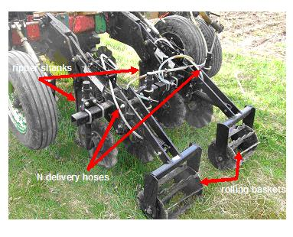
Photo 1b. Side view of ripper shank with deep N placement tube. (Photo courtesy of Bob Schindelbeck).

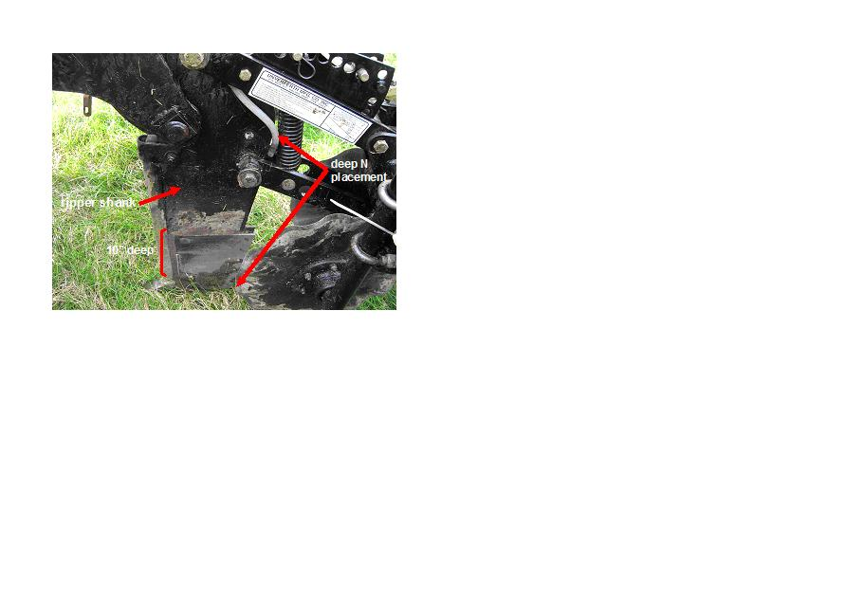

Photo 2. Broadcast N application at planting: UAN sprayed under rolling baskets (plow till subplots) . (Photo courtesy of Bob Schindelbeck).

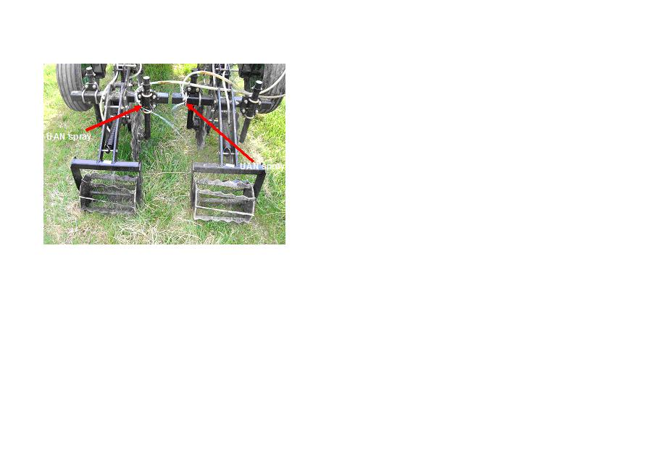

Appendices:

Appendix 1: Nitrogen-related publications from research conducted in Northern NY

Poe, G., H.M van Es, T. vanderBerg, and R. Bishop. 1998. Do participants in well testing programs update their exposure and health risk perceptions? J. Soil and Water Cons. 53:320-325.
Sogbedji, J.M., H.M. van Es, J. Melkonian, and R.R. Schindelbeck. 2006. Evaluation of the PNM model for simulating drain flow nitrate-N concentrations under manure-fertilized maize. Plant and Soil 282: 343-360
Sogbedji, J.M., H.M. van Es, J.L. Hutson, and L.D. Geohring. 2001. Fate of N fertilizer and green manure in clay loam and loamy sand soils: I Calibration of the LEACHM model. Plant and Soil 229(1): 57-70.
Sogbedji, J.M., and H.M. van Es. 2001. Fate of N fertilizer and green manure in clay loam and loamy and soils: II Validation of the LEACHM model. Plant and Soil 229(1): 71-82
Sogbedji, J.M., H.M. van Es, S.D. Klausner, D.R. Bouldin, and W.J. Cox. 2001. Spatial and temporal processes affecting nitrogen availability at the landscape scale. Soil & Tillage. Research 58 (3-4) 233-244.
Sogbedji, J.M., H.M. van Es, C.L. Yang, L.D. Geohring, and F.R. Magdoff. 2000. Nitrate leaching and N budget as affected by maize N fertilizer rate and soil type. J. Environm. Qual. 29:1813-1820.
Tan, I.Y.S., H. M. van Es, J. M. Duxbury, J. J. Melkonian, R. R. Schindelbeck, L.D. Geohring, W.D. Hively, and B. N. Moebius. 2009. Nitrous oxide losses under maize production as affected by soil type, tillage, rotation, and fertilization. Soil&Tillage Research 102:19-26.
van Es, H.M., J.M. Sogbedji, and R.R. Schindelbeck. 2006. Effect of manure application timing, crop and soil type on nitrate leaching. J. Environmental Quality 35(2):670-679.
van Es, H.M., J.M. Sogbedji, and R.R. Schindelbeck. 2006. Nitrate leaching under maize and grass as affected by manure application timing and soil type. J. Environmental Quality 35:670-679.
van Es, H.M, C.L. Yang, and L.D. Geohring. 2005. Maize nitrogen response as affected by drainage variability and soil type. Precision Agriculture 6:281-295.
van Es, H.M, and J.E. Delgado. 2004. Nitrate Leaching Index. In: R. Lal (Ed.). Encyclopedia of Soil Science. Marcel Dekker.
van Es, H.M., K.J. Czymmek, and Q.M. Ketterings. 2002. Management Effects on N leaching and Guidelines for an N Leaching Index in New York. J. Soil Water Conserv. 57(6): 499-504.

Appendix 2. Figures

Figure 1. Mean subplot silage yields in the sandy loam plots at the Willsboro research farm in 2008. NT_DeepN = no till deep tillage and N (125 lbs N/acre) placement at planting (5/07/08) and 15 lbs N/acre applied through the planter; NT_SidedressN = no till sidedress N (15 lbs N/acre) applied through the planter and 125 lbs N/acre applied as sidedress on 6/16/08); PT_BroadcastN = plow till, N (125 lbs N/acre) broadcast and incorporated at planting, and 15 lbs N/acre applied through the planter; PT_SidedressN = plow till sidedress N (15 lbs N/acre) applied through the planter and 125 lbs N/acre applied as sidedress on 6/16/08). Note that a nitrification/urease inhibitor was added to the deep N placement (no till) and broadcast/incorporated N (plow till) treatments. (Error bars: ± s.e.)

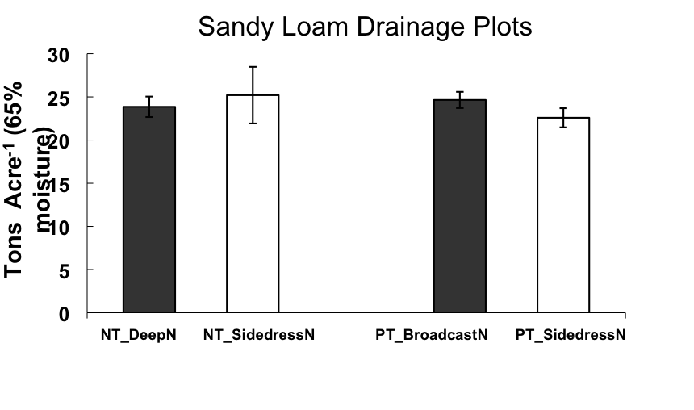

Figure 2. Mean subplot silage yields in the clay loam plots at the Willsboro research farm in 2008. NT_DeepN = no till deep tillage and N (125 lbs N/acre) placement at planting (5/07/08) and 15 lbs N/acre applied through the planter; NT_SidedressN = no till sidedress N (15 lbs N/acre) applied through the planter and 125 lbs N/acre applied as sidedress on 6/16/08); PT_BroadcastN = plow till, N (125 lbs N/acre) broadcast and incorporated at planting, and 15 lbs N/acre applied through the planter; PT_SidedressN = plow till sidedress N (15 lbs N/acre) applied through the planter and 125 lbs N/acre applied as sidedress on 6/16/08). Note that a nitrification/urease inhibitor was added to the deep N placement (no till) and broadcast/incorporated N (plow till) treatments. (Error bars: ± s.e.)

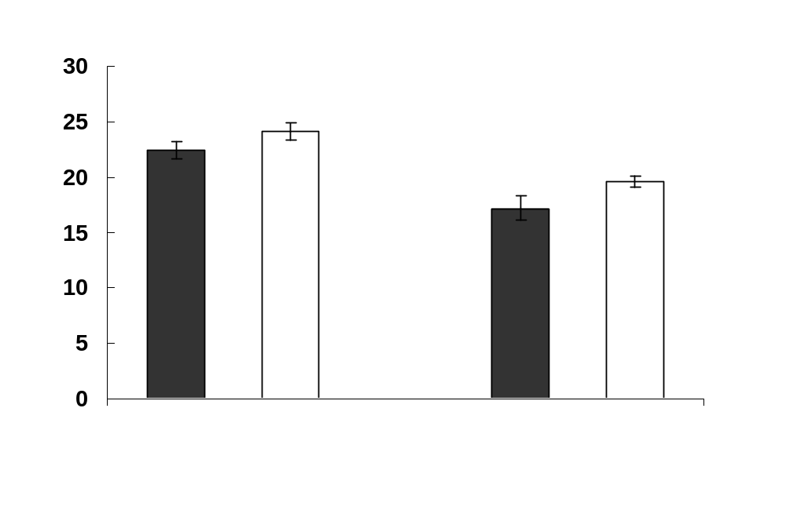

Figure 3. Crop available soil N (nitrate-N and ammonium-N; lbs N/acre) in the top 12” of the root zone of fallow subplots in the no till and plow till plots at the Willsboro research farm at pre-plant (5/05/08), pre-sidedress (6/05/08) and harvest (9/03/08).

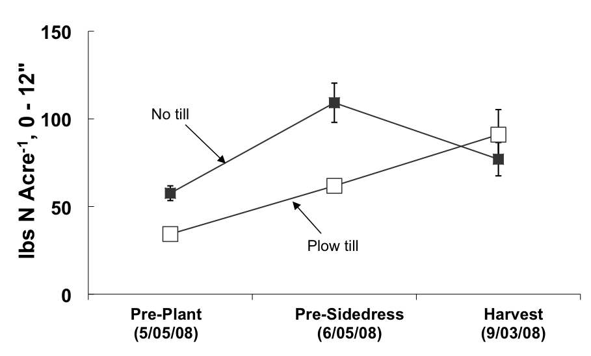

Figure 4. Mean sidedress N subplot silage yields (tons (65% moisture)/acre) in the no till plots and plow till plots at different sidedress N rates in 2008. The plots are part of a long-term tillage experiment at the Willsboro research farm. (Error bars: ± s.e.).
farm. (Error bars: ± s.e.).

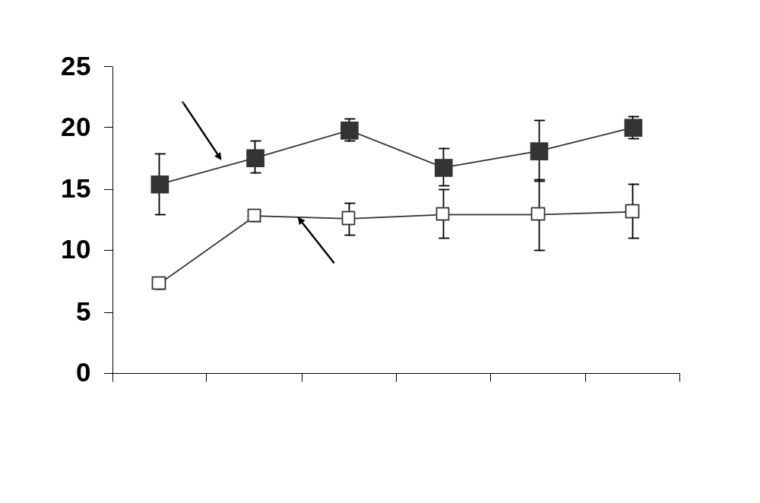

Helena Chemical Company
Agrotain International LLC

