Northern NY Agricultural Development Program
2008-2009 Project Report

Project Title: Biological Control of Alfalfa Snout Beetle

Project Leader(s): Elson Shields, Tony Testa and John Knecht, Department of Entomology, Cornell University

Collaborator(s): Mike Hunter, CCE Jefferson Co.; Joe Lawrence, CCE Lewis Co.;
Steve Canner, CCE St. Lawrence Co. ; Amy Ivy, CCE Clinton Co.; Anita Deming, CCE Essex Co.; Eric Bever CCA, Certified Nutrient Management Planner, Clinton Co.
Pete Barney, Consultant, St. Lawrence Coutny

Cooperating Producers:

Jefferson Co.: Lisa Bullock, John Hansen, Michael Kiechle, Elizabeth Lassen, Ron Porter, Doug Shelmidine

Lewis Co.: Jerome Demko, Bernie Golhert, Mark Karelus, Gary Sullivan

St. Lawrence Co.: Peter Braun, David Fisher, Richard Hobkirk, Steven McKnight, “Skip” Putney

Franklin Co.: Carolyn McNamara/ Dick Eakins, Jason Fox, Clinton Martin, Peter Poupore

Clinton Co.: Eric Bever, Bruce Dimock, Jon Rulfs

Essex Co.: Lee Garvey, Dave Lincoln, George Sayward, Paul Stephens

Background:

Alfalfa snout beetle, within the infested counties, continues to be the single most contributing factor to alfalfa death and stand loss in NNY. Snout beetle related stand loss is often mistakenly identified as winter kill because the majority of plant death occurs after the growing season during the fall and early winter. This insect was introduced into NNY at the port of Oswego between 1848 and 1896, when the first individual was collected and identified. Snout beetle became a major pest problem after alfalfa was introduced into NNY in the 1920s. Attempts were made to control this insect from the 1940s to 1972 with the widespread distribution of poison baits. During this time, snout beetle continued to spread. Widespread baiting ended in 1972, due to environmental concerns and the snout beetle population exploded in the early 1980s. Research focused on the use of biological control to suppress snout beetle was initiated in 1990 and has been supported in part by NNYADP since its initiation.

In 2002 and 2003, the snout beetle population on the Peck Farm (Great Bend, Jefferson Co.) crashed from about 1 million beetles per acre to an extremely low level. Subsequent research has shown that the entomopathogenic (insect attacking) nematodes (EPNs) released on the farm in a series of small plots during 1993-98, have been moved throughout the farm by farming practices and caused the population crash of snout beetle. A small rebound of beetles was observed in a field bordering a neighbor’s heavily infested farm in 2007. John Peck’s farm has progressed from having the alfalfa stands completely killed out during the first production year from snout beetle feeding to actually plowing alfalfa plants down at the end of an alfalfa stand’s life (5 years). With the establishment of 6 different small test plots on the Peck farm, it required nearly 10 years for the nematodes to spread throughout the farm and control snout beetle.

The question is: “How can we move the biological control success on the Peck Farm to the rest of the infested farms in the NNY?”

Since the entomopathogenic nematodes used as the biological control for snout beetle are adapted to NNY, a farm or field only needs to be inoculated once for the establishment of the nematodes in the field. If only a single field per farm is inoculated, the farmer will move the nematodes around the farm with the movement of soil during normal farming operations, but it will take years for the nematodes to become established in all of the affected fields on the farm and control the population of snout beetle on the farm. However, if a farmer friendly method could be developed to rear the nematodes on the farm and a method of application be developed compatible with on-farm equipment to inoculate individual fields, then each farmer could more rapidly spread the biocontrol nematodes throughout their fields for faster control of snout beetle.

In 2009, the focus and goal of the projects was shifted to develop the necessary components which would allow the ASB-Biocontrol nematodes to be inoculated into fields throughout the 9 county infested region by farmers themselves or by commercial applicators. To achieve our goal, we extended our biocontrol nematode field applications to eastern Franklin, southern Clinton and Essex Counties while also continuing our efforts in Jefferson and St. Lawrence County.

Methods & Results:

Using a Commercial Applicator to Rear and Apply Biological Nematodes.

In spring 2009, we met with Miller Spraying in Lewis Co. to discuss our idea of using a commercial applicator to rear and apply nematodes. Prior communications during the summer of 2008 indicated that there was an interest to pursue this. At the meeting, we covered our reasons for this project, showed them our rearing tubs, went over our protocols, and discussed in detail the methods needed to begin rearing at their facility. The owners seemed to have renewed interest and were going to begin checking with their customers if the interest was there. They were going to do a cost analysis that could be presented to any interested farmer. Joe Lawrence, CCEA, also made efforts to spread the word about using Miller spraying as a biological nematode applicator.
Miller Spraying was unsuccessful finding any farmer interested in paying for Miller Spraying to apply nematodes. The farmer’s feedback stated because of the poor milk prices, they could not afford the projected application fee per field. In addition, since the Shields’ Lab had spent the previous year applying nematodes at no cost to 15 different fields in the county, the farmers expected continued free application in 2009 and were upset that they were expected to actually pay for nematode application by a commercial business.

Extending NYSFVI Biocontrol Nematode Applications.

Using our rearing technique developed in 2008, we reared approximately 9 billion nematodes for field application during the 2009 growing season. Based on results from our 2008 soil bioassays, we determined that a combination of Steinernema carpocapsae ‘NY-001’ and Steinernema feltiae ‘NY-04’ showed the most promise. The nematodes produced on campus were applied to 44 fields distributed throughout the NNY snout beetle infected region. Below is the breakdown on what was applied in the field during the past season:

Jefferson Co. – 11 field sites
St. Lawrence Co. – 15 field sites
Franklin Co. – 4 field sites
Clinton Co. – 7 field sites
Essex Co. – 7 field sites

Field Application Timeline – 2009:

Field application of nematodes required the alfalfa growth to be relatively short to allow the nematode laden stream of water from the spray nozzle to easily reach the soil surface. The nematodes, once applied to the soil surface, need to penetrate the soil before dying from desiccation or UV exposure. The ideal alfalfa field for application was a field with about 6” of re-growth after cutting. The ideal time of day for nematode application was late afternoon-evening which reduces nematode mortality from UV exposure and desiccation. Field applications were focused on the time intervals following 1st and 2nd cuttings. Project personnel spent May and June setting up the contacts, scouting the field locations and estimating the harvest dates for individual fields. Harvest estimates were required to facilitate the timely production of nematodes for field application.

Field applications focused on the 1st harvest were initiated during the second week of June and continued for the entire month. A total of 19 fields were inoculated during the 1st harvest interval with the field located in Jefferson and St. Lawrence counties. Field applications targeting the 2nd harvest interval were initiated mid-July and were located in St. Lawrence, Franklin, Clinton, and Essex counties. A total of 25 fields were inoculated with nematodes during the 2nd harvest interval.

Jefferson County | St. Lawrence  County | Franklin  County | Clinton  County | Essex  County
June 11  4 fields | June 22  3 fields | July 28  4 fields | July 22  7 fields | July 29  4 fields
June 18  4 fields | June 30  5 fields |  |  | July 30  3 fields
June 25  3 fields | July 1  4 fields
July 27
3 fields

Number of fields x # of farmers x counties.
Jefferson / Lewis County | St. Lawrence  County | Franklin  County | Clinton  County | Essex  County
14 fields | 16 fields | 4 fields | 7 fields | 7 fields
7 Producers | 5 Producers | 2 Producers | 2 Producers | 4 Producers

Nematode Persistence across Rotation.

During the 2009 field season, we scouted all fields that had been applied with biological nematodes during the 2007 and 2008 field season. Any field that was being rotated to corn was sampled for persisting nematodes in the spring just after corn emergence. If time allowed, fields were resampled in the fall after harvest. Fields missed in 2009 will be sampled in the spring of 2010 for persistence. The following is the breakdown of fields rotated to corn, producer/field season:

Jefferson Co. | Lewis Co. | St. Lawrence Co. | Franklin Co.
Shelmidine Truck Application 2007 | Gohlert Hand Boom  Application 2007 | *Demko Truck  Application 2008 | Eakins Truck  Application 2007
*Shelmidine Truck Application 2008 | Gohlert Truck  Application 2007 |  | *Poupore Truck  Application 2008
Karelus Hand Boom
Application 2007
* Fields sampled in Spring 2009 and Fall 2009

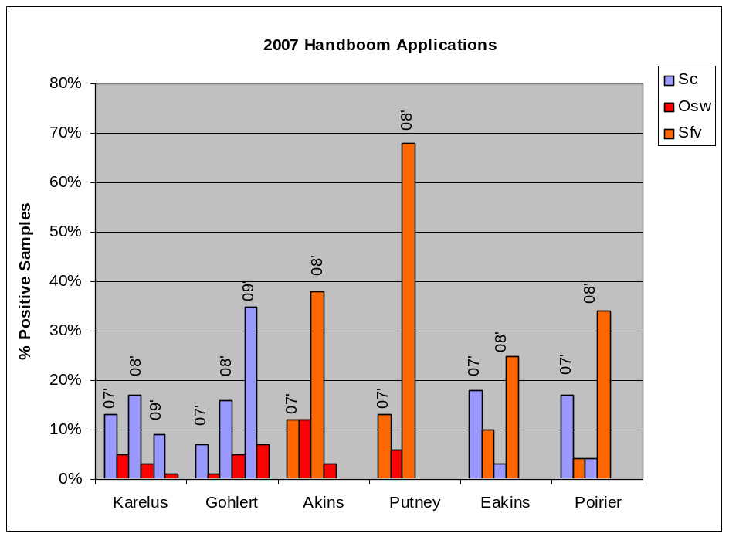

Fig 1. Field plots established in 2007 using hand-boom application method were sampled for persisting nematodes across rotation in 2009 were applicable. Year of sampling indicated at the top of bars. Colors represent type of nematode: blue, NY001; red, Oswego; orange NY04
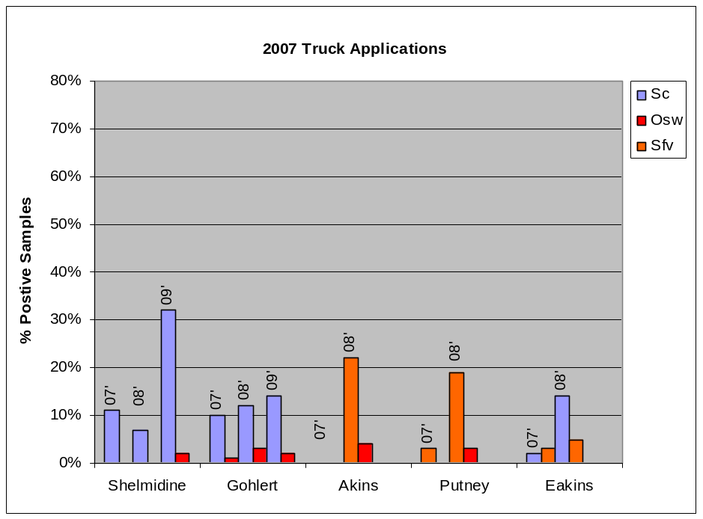
Fig. 2. Biological nematodes applied in 2007 using truck method were sampled in 2009 for persistence across rotation were applicable. Year of sampling indicated at the top of bars. Colors represent type of nematode: blue, NY001; red, Oswego; orange NY04

Conclusions/Outcomes/Impacts:

Field plots were established in 48 different fields located on 20 farms across 6 – NNY snout beetle infested counties. Also four collaborators successfully reared ASB-Biocontrol nematodes and applied themselves to infested fields. Previous introductions of EPNs were checked for persistence in alfalfa fields inoculated between 2007 and 2008 that had been rotated to corn in the spring of 2009.

Unless milk prices improve, it will be difficult to convince the farmers in each county to pay a commercial applicator to apply nematodes. We have developed and demonstrated a low-labor nematode rearing method compatible with on-farm rearing. Using modified commercial pesticide sprayers, we have successfully inoculated 96 alfalfa fields across NNY with biocontrol nematodes. Persistence of these nematodes have been long demonstrated in research plots and currently in fields inoculated in 2007 and 2008. Efforts are underway to evaluate the ability of the biocontrol nematodes to persist across a corn rotation.

The focus of the efforts in 2010 will be expanding field applications of nematodes and studying the persistence of nematodes when fields are rotated out of alfalfa and into corn.

Outreach:

2009 NNY meetings:
NNYADP – West committee – Jan 30, 2009
NNYADP – East committee – Feb 20, 2009

Miner Institute Extension Crop Meeting – March 3, 2009
St Lawrence Co. Extension Crop Meeting – March 4, 2009
Jefferson/Lewis Co. Extension Crop Meeting – March 5, 2009
Miller Spraying Training Session – March 13, 2009

On-Farm Demonstration - Nematode Rearing & Application , Lewis Co. July 2009

Next steps:
1) Expand the education and outreach plan for providing training for
interested producers.

2) Examine nematode persistence across corn rotation.

Acknowledgments:

We thank Northern New York Agricultural Development Project and New York Farm Viability Institute for their continuing support of our research and extension efforts.

Reports and/or articles in which results of this project have already been published.

Biological Control of Alfalfa Snout Beetle with a multi-species application of locally adapted persistent entomopathogenic nematodes: The first success.
E. J. Shields, A. Testa, G. Neumann, K. L. Flanders, and P. C. Schroeder.
American Entomologist • Volume 55: 250-257

Person(s) to contact for more information (including farmers who have participated:

Peter Braun Lisa Bulluck Jerome Demko
Woodcrest Dairy Bullock Farms Demko Farms
Wood Road 14978 County Route 85 6329 State Road 26
Lisbon, NY 13658 Mannsville, NY 13661 Lowville, NY 13367
    - 315.771.4038 315.523.2556

Dick Eakins Bruce Dimock David Fisher
Carolyn McNamara Eric Bever Maple Lane Farms
Malone Garden Apts. Dimock Farms 307 Jones Road
75 Pleasant St. 476 Pleasant St. Madrid, NY 13660
Malone, NY 12953 Peru, NY 12972 315.322.4467
518.483.0307 518.643.9773
518.643.2360
518.572.8760

Jason Fox Lee Garvey Bernie Gohlert
314 Gallup Road 495 Sunset Drive Hilltop Farm
North Bangor, NY 12966 Willsboro, NY 12996 6928 State Route 26
518.483.2576 518.963.7511 Lowville, NY 13367
315.486.4430

John Hansen Richard Hobkirk Mark Karelus
22000 Co. Rt. 47 15 County Route 31A 7013 State Rt. 26
Carthage, NY 13619 Lisbon, NY 13658 Lowville, NY 13367
315.493.8206 315.322.8939 315.376.6453
315.286.5052

Michael Kiechle Elizabeth Lassen Dave Lincoln
34764 Garden of Eden Rd 9303 County Rt. 75 246 West Road
Philadelphia, NY 13673 Adams, NY 13605 Willsboro, NY 12996
315.778.8110 315.846.5195 518.963.4168

Clinton Martin Steve McKnight Ron Porter
126 Gallup Road River Breeze Farm Poterdale Farms
North Bangor, NY 12966 54 McKnight Road 22326 Fralick Road
518.483.5913 Chase Mills, NY 13621 Watertown, NY 13601
315.788.8421 315.788.8421

Peter Poupore “Skip” Putney Jon Rulfs
385 White Road 382 Five Mile Line Rd. Eric Bever
Malone, NY 12966 Lisbon, NY 13658 38 Boulder Ledge Way
315.296.5476 315.393.5652 Keesville, NY 12944
518.572.1960
518.572.8760
518.643.2360

George Sayward Douglas Shelmidine Paul Stephens
Ainger Hill Road Sheland Farms Morrison Road
Essex, NY 12936 12043 Co.Rt. 79 Westport, NY 12993
518.963.7355 Adams, NY 13605 518.962.4407
315.846.5640

Gary Sullivan
3769 Deer River Road
Carthage, NY 13619
315.921.4375

Photos:

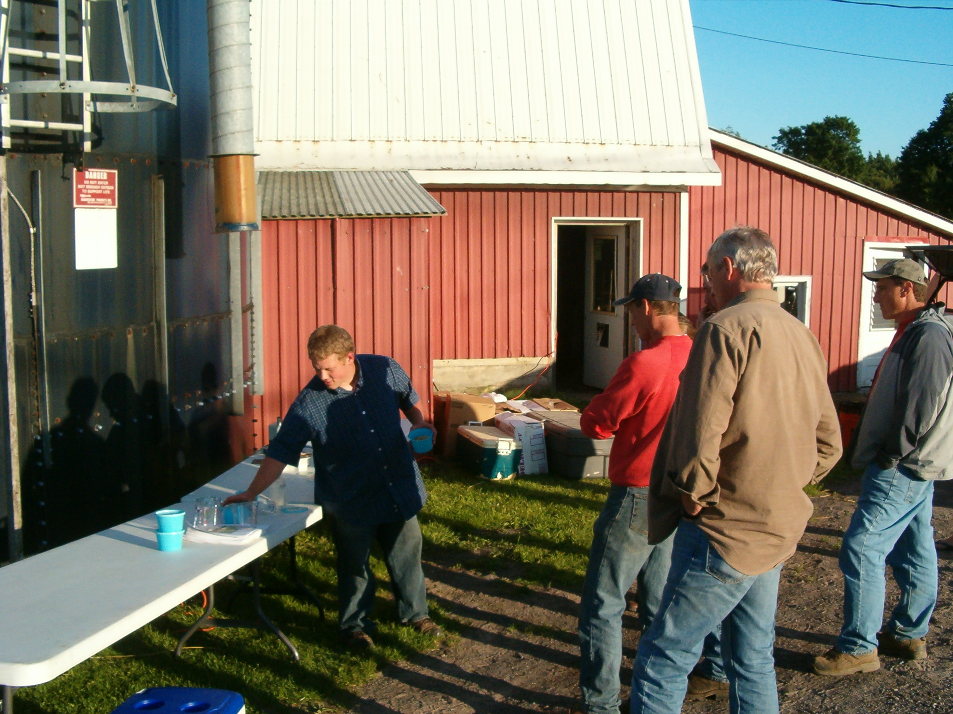

Josh Knect, CALS-CCE Summer Intern presenting On-Farm Rearing Techniques at Gary Sullivan’s Farm in Lewis Co.

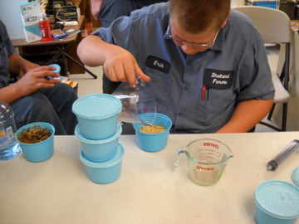
Eric Shelmidine, son of Doug Shelmidine, Jefferson Co., working on On-Farm Rearing Project.

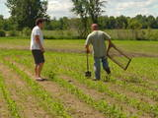
Soil bioassays in a corn field that was applied in 2008 with entomopathogenic nematodes.

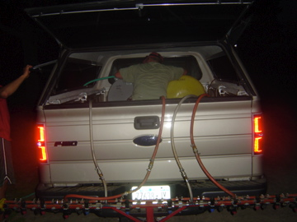
Applying nematodes late in the evening.

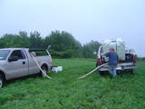
Spray tank getting filled with water provided in the field from alfalfa producer in St. Lawrence Co.

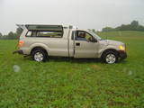
Applying nematodes in the field, Jefferson Co. 2009

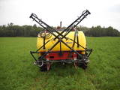Two different types of spray booms developed by producers.


